PEOPLE’S COMMITTEE OF BEN TRE PROVINCE
PROJECT MANAGEMENT UNIT OF CONSTRUCTION INVESTMENT WORKS FOR AGRICULTURE AND RURAL DEVELOPMENT
--------------o0o--------------

MEKONG DELTA INTEGRATED CLIMATE RESILENCE AND SUSTAINABLE LIVELIHOODS PROJECT (MD-ICRSL)

SUBPROJECT 5: INFRASTRUCTURE TO IMPROVE LIVELIHOODS IN NORTHERN THANH PHU AREA TO ADAPT TO CLIMATE CHANGE

ENVIRONMENTAL MANAGEMENT PLAN
Ben Tre, March 2021

TABLE OF CONTENTS
EXECUTIVE SUMMARY 8
PREAMBLE 11
1. SUBPROJECT BACKGROUND 11
1.1 General information 11
1.2 Subproject’s contents 11
1.3 Correlation of the subproject with other projects and development masterplans approved by competent state agencies 11
2. LEGAL FRAMEWORK 13
2.1 National legal framework 13
2.2 The World Bank (WB) safeguard policies 15
2.3 Organization of ESMP preparation 17
3. ENVIRONMENTAL IMPACT ASSESSMENT METHODS 17
3.1 Environmental impact assessment methods 17
3.2 Social assessment methods 18
3.3 Other methods 18
3.4 Institutional arrangement 19
3.5 Funding source and implementation progress 19
CHAPTER 1 SUBPROJECT DESCRIPTION 21
1.1 OVERVIEW 21
1.2 OBJECTIVES OF THE SUBPROJECT 21
1.3 SCOPE OF SUBPROJECT INVESTMENT 21
1.4 DESCRIPTION OF INVESTMENT WORKS 25
1.5 CONSTRUCTION METHODS 32
1.5.1 River embankment 32
1.5.1.1 Co Chien River Embankment Construction Method 32
1.5.1.2 Bang Cung River Embankment Construction Method 32
1.5.1.3 Consolidation of sea dike 33
1.5.2 Bridges 33
1.6 List of machinery and equipment 34
1.6.1 List of construction machinery and equipment for an embankment section 34
1.6.2 List of machinery and equipment for the construction of one bridge 35
1.7 Volume of earthworks 35
1.8 Demand on materials and fuels 36
1.9 Transportation routes 37
1.10 Disposal sites and transportation routes 38
1.11 Power and water supply 40
1.12 Management – operation technology 40
1.13 Implementation duration 40
CHAPTER 2 ENVIRONMENTAL AND SOCIO-ECONOMIC CONDITIONS 41
2.1 NATURAL CONDITIONS 41
2.1.1 Geological and topographical conditions 41
2.1.2 Climate conditions 43
2.1.3 Hydrological and oceanographical conditions 45
2.1.4 Saline intrusion 46
2.1.5 Extreme weather phenomena 47
2.2 ENVIRONMENTAL QUALITY AND BIOLOGICAL RESOURCES 49
2.3 SOCIO-ECONOMIC CONDITIONS 56
2.4 AQUACULTURE PRACTICES 67
CHAPTER 3 ASSESSMENT ON ENVIRONMENTAL AND SOCIAL IMPACTS 69
3.1 ASSESSMENT OF COMFORMITY OF THE SUBPROJECT'S LOCATION WITH ITS NATURAL AND SOCIO-ECONOMIC CONDITIONS 70
3.2 ASSESSMENT OF THE IMPACTS IN PRE-CONSTRUCTION PHASE 70
3.2.1 Land acquisition 70
3.2.2 Risks of mines and explosives (UXO) 72
3.3 ASSESSMENT AND FORECAST OF IMPACTS IN CONSTRUCTION 72
3.3.1 Waste-related impact assessment 72
3.3.2 Assessment of waste-unrelated impacts 82
3.4 ENVIRONMENTAL IMPACTS DURING OPERATION 90
❖ The level of detail of assessments and forecasts 92
❖ The reliability of the assessments 93
CHAPTER 4 MEASURES TO ENVIRONMENTAL IMPACTS 95
4.1 Mitigation measures in pre-construction phase 95
4.1.1 Measures to minimize land acquisition 95
4.1.2 Mitigation of UXO risks 96
4.2 Mitigation measures during construction phase 96
4.3 Mitigation measures in operation phase 139
4.4 Environmental protection measures for non-structural works 139
4.4.1 Mitigation measures in reforestation leveling design 140
4.4.2 Aquaculture pond design 140
4.4.3 Minimize pollution 140
4.4.4 Minimize chemical effects 142
4.4.5 Energy and fuel management 143
4.4.6 Farm sanitation management 144
4.4.7 Labor management 144
4.4.8 Addressing environmental risks 145
CHAPTER 5 ENVIRONMENT MANAGEMENT AND MONITORING PROGRAM 146
5.1. ENVIRONMENTAL MONITORING PROGRAM 146
5.1.1. Monitoring the contractors’ compliance with the safeguard policy 146
5.1.2. Environmental monitoring program 146
5.1.3. Community supervision 148
5.2. ROLE AND RESPONSIBILITIES IN ESMP IMPLEMENTATION 149
5.2.1. Organization of implementation 149
5.2.2. Environmental compliance framework 151
5.2.3. Recommended training program 156
5.3. COST ESTIMATION 157
5.4. GRIEVANCE REDRESS MECHANISM (GRM) 158
CHAPTER 6 PUBLIC CONSULTATION AND INFORMATION 160
6.1 SUMMARY OF PUBLIC CONSULTATION ORGANIZATION 160
6.2 INFORMATION DISCLOSURE 162
APPENDIX 168
APPENDIX 1: EIA APPROVING DECISION 168
APPENDIX 2: SAMPLING CHART FOR ENVIRONMENTAL MONITORING 170
APPENDIX 3: SOME CONSULTATION MINUTES AND WASTE DISPOSAL AGREEMENTS 171
APPENDIX 4: RESULTS OF ENVIRONMENTAL MONITORING OF SUBPROJECT WORKS 183
APPENDIX 5: SOME PHOTOS OF THE COMMUNITY CONSULTATION MEETING 189
APPENDIX 6: LOCATIONS OF ENVIRONMENTAL BASELINE SAMPLING 190
APPENDIX 7: INTEGRATED PEST MANAGEMENT PLAN (IPM) 191
APPENDIX 8: TEST RESULTS OF SUPPLY WATER 196

ABBREVIATIONS

BOD | : | Biochemical Oxygen Demand
PAP/AH | : | Project Affected Persons/Affected household
RC | : | Reinforced Concrete
COD | : | Chemical Oxygen Demand
ESMP | : | Environmental and Social Management Plan
MD | : | Mekong Delta
EIA | : | Environmental Impact Assessment
ICRSL | : | Mekong Delta Integrated Climate Resilience and Sustainable Livelihoods Project
IOL | : | Inventory of Loss
TCVN | : | National Technical Regulation
PP | : | People’s Committee
FFC | : | Fatherland Front Committee
DPI | : | Department of Planning and Investment
WHO | : | World Health Organization

LIST OF TABLES
Table 1 - 1: Summary of subproject work-items 20
Table 1 - 2: Non-structural investment activities 20
Table 1 - 3: Expected coordinates and construction location of the subproject works 22
Table 1 - 4: Summary of investment scale of subproject work-items 25
Table 1 - 5: List of main machinery and equipment needed for the construction of one embankment section 33
Table 1 - 6: Machinery and equipment needed for on-bridge construction 34
Table 1 - 7: Volume of excavation and backfill of work-items 34
Table 1 - 8: Volume of materials for construction 35
Table 1 - 9: List of borrow pits to be used for the subproject’s items 35
Table 1 - 10: Expected routes for material transportation to construction sites 36
Table 1 - 11: Expected roads for material transportation to the construction sites 37
Table 1 - 12: Information about disposal sites and expected routes for transportation 38

Table 2 - 1: Air temperature 43
Table 2 - 2: Number of hours of sunshine (hour/day) 43
Table 2 - 3: Monthly humidity 43
Table 2 - 4: Average monthly evaporation (mm/7 days) 43
Table 2 - 5: Monthly average rainfall (mm) 44
Table 2 - 6: Number of rainy days in a month (day) 44
Table 2 - 7: Monthly average water levels measured at a number of local hydrological stations 45
Table 2 - 8: Number of storms and tropical cyclones in the period of 2011 - 2014 46
Table 2 - 9: Summary of damages caused by high-tide in the period of 2011 - 2014 46
Table 2 - 10: Summary of damages caused by lightning and tornado in the period of 2011 - 2014 47
Table 2 - 11: Air sampling locations 48
Table 2 - 12: Air monitoring results 48
Table 2 - 13: Sampling sites 49
Table 2 - 14: Analysis results of surface water quality 49
Table 2 - 15: Analysis results of pesticide residues in surface water samples 50
Table 2 - 16: Analysis results of domestic water quality 50
Table 2 - 17: Locations of groundwater samples 51
Table 2 - 18: Analysis results of groundwater quality 51
Table 2 - 19: Analysis results of pesticide residues in groundwater samples 51
Table 2 - 20: Locations of soil monitoring 52
Table 2 - 21: Analysis results of soil quality 52
Table 2 - 22: Analysis results of pesticide residues in soil samples 53
Table 2 - 23: Locations of aquatic organisms monitoring 54
Table 2 - 24: Current land use 61
Table 2 - 25: Summary of land for afforestation 62
Table 2 - 26: Current state of the soil supply areas 62
Table 2 - 27: Location of expected disposal sites 63
Table 2 - 28: Sensitive receptors in the subproject area 64

Table 3 - 1: Total impact level of permanent land acquisition of the subproject 70
Table 3 - 2: Number of households affected by the subproject 70
Table 3 - 3: Dust emission factor from construction 72
Table 3 - 4: The amount of dust emissions scattered by excavation and backfilling for each work-item 72
Table 3 - 5: Air pollution emission coefficient of diesel engine 73
Table 3 - 6: Loads of pollutants from construction vehicles 74
Table 3 - 7: Emission concentration of means of construction and machinery 75
Table 3 - 8: Load of pollutants during welding 75
Table 3 - 9: Amount of domestic wastewater generated in the construction phase 76
Table 3 - 10: The amount of pollutants in domestic wastewater (untreated) 76
Table 3 - 11: Concentration of pollutants in domestic wastewater (untreated) 77
Table 3 - 12: Area of construction sites of work-items 78
Table 3 - 13: Rain intensity calculated in the subproject area 79
Table 3 - 14: Rainwater runoff over the construction sites of the project 79
Table 3 - 15: Hazardous waste to be generated at the construction sites 81
Table 3 - 16: Noise levels from construction vehicles, machinery and equipment 82
Table 3 - 17: Estimated noise impact level by distance during construction phase 83
Table 3 - 21: Characteristics of shrimp farming wastewater compared with domestic wastewater (mg/l) 91
Table 3 - 22: Variation in effluent quality from similar models in the Southern of Thailand 91

Table 4 - 1: Estimated cost for the resettlement action plan of Ben Tre subproject 94
Table 4 - 2: General mitigation measures 96
Table 4 - 3: Specific impacts and mitigation measures 112

Table 5 - 1: Environmental monitoring program of the subproject 145
Table 5 - 2: Funding for environmental monitoring of the subproject 146
Table 5 - 3: Roles and responsibilities of environmental management organizations 147
Table 5 - 4: Report requirements 153
Table 5 - 5: Program to improve environmental and social management and monitoring capacity 154
Table 5 - 6: Estimated cost of EMP implementation for the entire subproject 155
Table 5 - 7: Community consultations 159
Table 5 - 8: Public consultation results and responses of Project Owner 159

Figure 1-1: Location map of the subproject works 22
Figure 1 - 2: Location map of non-structural items 24
Figure 1 - 3: Disposal routes 39

Figure 2 - 1: River system and subproject location 45
Figure 2 - 2: Sampling locations 48
Figure 2 - 3: Locations of monitoring and sampling aquatic organisms 55
Figure 2 - 4: Current station of Bang Cung river embankment 59
Figure 2 - 5: Current state of Co Chien river embankment 60
Figure 2 - 6: Site photos 60
Figure 2 - 7: Land for afforestation in An Dien commune of Thanh Phu district 61
Figure 2 - 8: Location for Rhizophora apiculate planting 61

EXECUTIVE SUMMARY
Subproject 5: “Infrastructure to Improve Livelihoods in Northern Thanh Phu Area to Adapt to Climate Change” in Ben Tre province (SUB5) is part of Component 3 of the “Mekong Delta Integrated Climate Resilience and Sustainable Livelihoods (MD-ICRSL)” Project using WB’s loans. The Subproject covers the following structural and non-structural items:
- Additional construction and consolidation of sea dike from Khau Bang canal to connect the road across Con Dai bridge. The total length is about 2,266 km;
- Construction of 9,699km of embankment combined with rural roads (including 2,948km of Plain Road Class-V and 6,751km of Rural Road Class-A) to serve the agricultural production and protect 8,000 ha of land for the sustainable livelihoods of people in the communes of An Quy, An Thuan, An Thanh, An Dien, An Nhon and My An of Thanh Phu district;
- Construction and rehabilitation of 20 bridges;
- New afforestation and supplementation of 150 hectares of mangroves;
- Construction of a clean water supply network for 7,400 households in 13 communes and 01 town who are lacking domestic water. The water source will be from 03 water supply plants, namely: Thanh Phu, Thoi Thanh and Hoa Loi;
- Organization of the courses on vocational and technical training and organization of livelihood models to support the local livelihood transformation and development;
- Enhancement of community awareness about the protection and appropriate use of natural resources, especially coastal marine resources and capacity building for local farmers to respond to the climate change.
Main impacts and risks:
Preparation phase: Impact of land acquisition (the total land permanently acquired for the subproject implementation is 56,372m², of which the affected paddy land is 51,812m² and the affected aquaculture land is 4,560 m²), and the risks associated with unexploded ordnance (UXO).
Construction phase includes general impacts and specific impacts:
General impacts: the construction activities will cause other negative impacts such as noise, vibration, dust, emissions, water pollution and solid waste due to construction and workers’ activities; landslides and sediments; social conflicts from labor influx; clearing vegetation; traffic disturbance; accident risks, etc. However, these negative impacts are mostly at low to moderate level due to typology and locations of proposal investment , short construction period (6 - 18 months), and small types and scales of the works. Accordingly, these impacts are assessed from low to moderate, temporary and mitigable;
Site-specific impacts and risks during the construction of Co Chien river embankment: water quality degradation, obstacle to navigation on Co Chien river (increase in traffic volume and accidents), impacts on sensitive receptors along Co Chien river embankment such as An Thuan kindergarten, An Ninh primary school, An Ninh A market, etc., (arising social disorder, conflicts between workers and local people due to traffic collision, inappropriate words and behaviors may affect pupils and students, and making the community insecure).
Site-specific impacts and riskd during the construction of Bang Cung river embankment:, obstacle to navigation (increase in traffic volume and accidents), interruption to the households that are doing business along the transport routes, impacts on sensitive receptors along Bang Cung river embankment (Ben Vinh market, An Thanh ferry berth, An Thanh CPC, An Thanh communal house, the medical center of An Thanh commune, and making the community insecure).
Site-specific impacts during the construction of Khau Bang sea dike: soil and water quality degradation, community disturbance, traffic disruption, overflowing of construction materials and leachate into the farming areas, affecting crops or aquaculture productivity (shrimp farms in Thanh Loc hamlet, Thanh Phong commune, which are 400m away from the first point).
Specific impacts of livelihood models: generation, solid wastes such as bottles, feed packages, fertilizer packages, disinfectants, odors from wastewater of pilot models, and aquaculture wastewater which possibly salinizes agricultural land and groundwater, etc.
Operation phase: (i) the elevation of the river embankments may have impacts on the travel of about 85 HHs living along the road on Bang Cung embankment and affect the drainage from the right side of the road towards the river; (ii) environmental impacts from the livelihood models such as pond eutrophication caused by feed and products of shrimp farming; chemicals used indiscriminately in farming affecting the soil, water and human health; shrimp-related diseases; impacts on fresh water sources and daily life of households due to wastewater from farming activities; waste sludge in shrimp farms containing organic matter, nutrients, heavy metals, mineral components and microorganisms. If these impacts are not treated properly, they will cause air, soil and water pollution and disease spread.
Mitigation measures:
Specific mitigation measures include Environmental Codes of Practices (ECOPs), site-specific mitigation measures, and measures for sensitive receptors and social impacts.
The specific mitigation measures for sensitive receptors during the construction phase are as follows: (i) Inform the school managers of the construction activities and potential impacts such as waste, dust, noise, traffic, and construction schedules, at least two weeks before the commencement of construction; (ii) Keep watering roads that serve the construction to suppress dust in dry and windy days at least twice a day; (iii) Restrict material transportation on rush hours when pupils go to and leave schools (6h30 - 7h30, 11h - 12h, 13h - 14h, and 16h30 - 17h30); (iv) Arrange traffic guiders during the process of transporting construction materials and waste; and (v) Install warning signs, especially speed sign boards; (vi) Build and maintain periodically stormwater drainage ditches, mud-settling pits to ensure that most solids in surface runoff are retained prior to being discharged into surrounding waterbodies; (vii) Do not gather construction materials and equipment near river banks; (viii) Vessels and barges must satisfy the relevant technical requirements on safety, with inspection certificates got from competent authorities before being used. When entering the subproject area, drivers must strictly follow the traffic regulations and traffic guilders on parking, loading, etc.;
The main specific mitigation measures during the construction phase for livelihood models are as follows: application of the cultivation standards like VietGAP, integrated pest management, , management of food, water, fuel and labor, control of farm environmental sanitation, and minimizing the impact of chemicals, etc.
Specific impact mitigation measures during the operation phase:
For livelihood models: Selecting shrimp and clam disease-resistant species and adequate farming system and seasons; designing separate water supply and drainage systems for farming areas; minimizing organic pollution in the farming areas by managing foods and water quality; minimizing chemical impacts by the effective dissemination and communication on how to use the principle of correct and minimum usage of chemicals and organization of other agricultural extension and training; managing farm sanitation effectively such as keeping separate types of waste, preserving input materials properly, lining ponds and dikes to reduce saltwater intrusion, etc.
Environmental and Social Management Plan
The ESMP of Ben Tre subproject covers negative impact mitigation measures, roles and responsibilities of the ESMP implementation, supervisors, environmental compliance framework, reports, environmental monitoring program, capacity building program, and cost estimate for the ESMP implementation. In particular, the cost of the environmental quality monitoring is about VND 471.1 million, the cost of capacity building is VND 160 million, and the cost of the subproject’s environmental monitoring consultancy is VND 750 million.
During the construction process, ESMP requires the involvement of a number of stakeholders and relevant agencies, each with a unique role and responsibility, including the PPMU, Ben Tre DONRE, Contractor, Construction Supervision Consultant (CSC) and local residents. Ben Tre PPMU will be responsible for the implementation of all the work phases, including the compliance with environmental regulations for the subproject. The PPMU will assign environmental staff(s) (ES) to support environmental issues of the subproject. The CSC will assign the environmental and social staff(s) to be responsible for supervising and monitoring all construction activities and for ensuring that the contractors comply with the requirements of contracts, ECOPs and mitigation measures. The CSC will also assist the PPMU in reporting and maintaining close coordination with the local community. Based on the approved environmental specifications (ECOPs) in the bidding and contractual documents, the contractors will prepare the contractor’s ESMP (CESMP) for each construction sites and submit it to the PPMU and the CSC for review and approval before construction. The community has the power and responsibility to regularly monitor the compliance with environmental regulations during construction to ensure their rights, safety, and mitigation measures have been implemented effectively by the contractor and PPMU. Monitoring the implementation of the subproject as proposed by the Department of Natural Resources & Environment of Ben Tre Province and the PPMU is to ensure compliance with policies and legal regulations. Ben Tre DONRE is responsible for monitoring the compliance with the Government’s environmental requirements.

PREAMBLE

- SUBPROJECT BACKGROUND
  - General information
The Mekong Delta Integrated Climate Resilience and Sustainable Livelihoods Project (MD-ICRSL) has been approved its feasibility study report (FS) by the Ministry of Agriculture and Rural Development under Decision No.1693/QD-BNN-HTQT dated May 9, 2016, including 05 components: a) Component 1: Enhancing monitoring, analytics, and information systems; b) Component 2: Managing Floods in the Upper Delta; c) Component 3: Adapting to Salinity Transitions in the Delta Estuary; d) Component 4: Protecting Coastal Areas in the Delta Peninsula; e) Component 5: Project Management and Implementation Support. Project location: The project covers 9 provinces in the following three regions: flood-affected areas (An Giang, Dong Thap), the estuaries (Ben Tre, Tra Vinh, Vinh Long, Soc Trang), coastal areas of Ca Mau Peninsula (Ca Mau, Bac Lieu, Kien Giang).
Subproject 5: “Infrastructure to Improve Livelihoods in Northern Thanh Phu Area to Adapt to Climate Change, Ben Tre province” (SUB5) under Component 3 of “The Mekong Delta Integrated Climate Resilience and Sustainable Livelihoods (MD-ICRSL)” Project by WB’s loans and the counterpart funds of the Government of Vietnam.
  - Subproject’s contents
SUB05 consists of the following investment activities:
- Additional construction and consolidation of sea dike from Khau Bang canal to road across Con Dai bridge with a length of about 2,266 km;
- Construction of the embankment with a total length of 9.699 km in combination with Rural Road Class-A (including 2,948km of Category V road in plain and 6,751km of Rural Road Class-A) to restructure agricultural production, directly protect 8,000 ha of land and create sustainable livelihoods for people in An Quy, An Thuan, An Thanh, An Dien, An Nhon and My An communes of Thanh Phu district;
- Construction and rehabilitation of 20 bridges;
- Silviculture: 150 hectares of mangroves shall be newly and additionally planted.
- Construction of a clean water supply network for 7,400 households who are lacking domestic water in 13 communes and 1 town. The water source shall be taken from 3 water supply plants, namely: Thanh Phu, Thoi Thanh and Hoa Loi;
- Organization of the courses on vocational and technical training and livelihood models to support livelihood transformation and development;
- Enhancement of awareness of the community about the protection and appropriate use of natural resources, especially coastal marine resources and capacity building for local farmers to respond to the climate change.
  - Correlation of the subproject with other projects and development masterplans approved by competent state agencies
Relationships with the local investment projects:
a. Mekong Delta Integrated Climate Resilience and Sustainable Livelihoods Project (WB9)
- The project area covers the provinces of An Giang, Dong Thap, Bac Lieu, Tra Vinh, Vinh Long, Soc Trang, Ben Tre, Ca Mau, Kien Giang and Long An. The main objective of the project is to set up tools to mitigate natural disaster impacts and facilitate the regional sustainable development. The project’s funding sources: WB loans and counterpart fund of the Government of Vietnam.
b. Ongoing projects:
The ongoing projects in the region include:
Construction of Ba Tri sea dike; the dredge of main canals (such as Ngang canal, Da culvert, Tam Trung, Muong Dao, Giua canal, Cai Bong, Dui canal, Hamlet 4 canal, Canal 6, Ba Sua, Vu Nang, N2) and 3 in-field canals; Construction of irrigation systems for aquaculture in 3 sub-regions (Bao Thanh - Tan Xuan; Bao Thuan - Tan Thuy - An Thuy; An Hoa Tay - Vinh An - An Duc - Con Dat).
The Construction of Southern Ben Tre Irrigation System (Phase 1): after the construction completes, a total of 13 culverts will be put into operation, including Tang Du, Ca Rang Dong, Cai Ca, Nha Tho, Giong Luong, Cai Ca bridge (D3 bridge), Nha Tho bridge, Tan Ngai, Tan Tap (Earth Bridge), Xeo Ngang, Ca Rang Giua, Ben Luong and Ben Luong bridge. The project’s objective is upgrading the irrigation to meet the requirements for the natural disaster prevention (drought, inundation) and salt control to protect environment and production, improve land and contribute to stabilizing people’s life in the region.
c. The projects to be conducted in the coming time:
The projects include the expansion of the protective mangrove forests; protection and development of vegetation coverage in Vam Ho natural reserve and Lac Dia ecological zone; and focusing on planting scattered trees.
- The harmony between the Subproject’s development planning and the Province’s development planning:
- Resolution No.14/2016/NQ-HDND dated August 3, 2016 of the People’s Council of Ben Tre province, term IX, session 2 on 5-year socio-economic development tasks within 2016-2020.
- Decision No.1397/QD-TTg dated September 25, 2012 of the Prime Minister on approving the Irrigation Planning in Mekong Delta within 2012 - 2020 and orientation to 2050 in the context of climate change and sea level rise.
- Decision No.2884/QD-UB dated December 27, 2010 on road traffic development planning in Ben Tre province to 2020 and the vision after 2020.
- Decision No.1973/QD-UBND dated October 16, 2012 of Ben Tre PPC on approving Ben Tre development planning on fresh specialty fruits up to 2020 and the vision to 2030.
- Ben Tre Socio-Economic Development Masterplan to 2020, with the vision to 2030.
- Ben Tre Irrigation Planning to 2020, with the vision to 2030, conducted by the Southern Institute for Water Resources Planning.
- Report on damage due to natural disasters within 2012 - 2019 provided by the Department of Agriculture and Rural Development of Thanh Phu district.
- Land use planning of Ben Tre province to 2020.
- Scheme on restructuring the agriculture sector towards added value increase and sustainable development of Ben Tre province in the period of 2013-2015 and towards 2020.

- LEGAL FRAMEWORK
  - National legal framework
    - Laws and Decrees
- Law on Environmental Protection No.55/2014/QH13 of the National Assembly of Vietnam, term XIII dated June 23, 2014, effective from 01/01/2015.
- Law on Construction No.50/2014/QH13 of the National Assembly of Vietnam, term XIII dated June 18, 2014.
- Law on Water Resources No.17/2012/QH13 of the National Assembly of Vietnam dated June 21, 2012, effective from January 1, 2013.
- Law on Biodiversity No.20/2008/QH12 of the National Assembly of Vietnam, term XII dated November 13, 2008 and effective from July 1, 2009.
- Law on Fisheries No.18/2017/QH14 of the National Assembly of Vietnam, term XIV dated November 21, 2017, effective from January 1, 2019.
- Law on Dike No.79/2006/QH11 of the National Assembly of Vietnam, term XI dated 29/11/2006.
- Law amending and supplementing a number of articles of the Law on Fire Prevention and Fighting No.40/2013/QH13 of the National Assembly of Vietnam, term XIII, session 6 dated 22 November 2013 and takes effect on July 1, 2014.
- Law on Natural Disaster Prevention No.33/2013/QH13 of the National Assembly of Vietnam dated June 19, 2013, effective from May 1, 2014.
- Decree No.67/2014/ND-CP dated 7/7/2014 of the Government on a number of fisheries development policies.
- Decree No.38/2015/ND-CP dated 24/4/2015 of the Government on the management of waste and scrap.
- Decree No.80/2014/ND-CP dated 6 August 2014 of the Government on wastewater drainage and treatment.
- Decree No.18/2015/ND-CP dated 14 February 2015 of the Government on environmental protection planning, strategic environmental assessment, environmental impact assessment and environmental protection plans.
- Decree No.40/2019/ND-CP dated 13 May 2019 of the Government on amending and supplementing a number of articles of decrees detailing and guiding the implementation of the Law on Environmental Protection and management of environmental monitoring.
- Decree No.201/2013/ND-CP dated 27 November 2013 of the Government on detailing and guiding the implementation of a number of articles of the Law on Water Resources.
- Decree No.79/2014/ND-CP dated 31 July 2014 of the Government on detailing the implementation of a number of articles of the Law on Fire Prevention and Fighting and the Law amending and supplementing a number of articles of the Law on Fire Prevention and Fighting.
- Decree No.155/2016/ND-CP dated November 18, 2016 of the Government on sanctioning of administrative violations in the field of environmental protection.
- Decree No.43/2015/ND-CP dated 6 May 2015 of the Government on regulations on the establishment and management of water source protection corridors.
- Circular No.25/2019/TT-BTNMT dated 31 December 2019 of the MONRE on detailing the implementation of a number of articles of the Government’s Decree No.40/2019/ND-CP of May 13, 2019, amending and supplementing a number of articles of the Decrees detailing and guiding the implementation of the Law on Environmental Protection, and providing the management of environmental monitoring services.
- Circular No.36/2015/TT-BTNMT dated 30/6/2015 of the Ministry of Natural Resources and Environment on the management of hazardous waste.
- Circular No.32/2015/TT-BGTVT dated 24/07/2015 of the Ministry of Transport on environmental protection in transport infrastructure development.
- Circular No.20/2017/TT-BGTVT dated 21/06/2017 of the Ministry of Transport on amending and supplementing a number of articles of Circular No.32/2015/TT-BGTVT dated July 24, 2015 of the Minister of Ministry of Transport on environmental protection in transport infrastructure development.
- Decision No.02/2013/QD-TTg dated 14/01/2013 of the Prime Minister promulgating the Regulation on how to deal with oil spillage;
- Decision No.05/2018/QD-UBND of Ben Tre province promulgating the mechanism in land acquisition, compensation, support and resettlement in Ben Tre province;
- Decision No.05/2019/QD-UBND of Ben Tre province promulgating regulations on coordination in state management of environmental protection in Ben Tre province;
- Decision No.21/2017/QD-UBND of Ben Tre province promulgating regulations on zoning water sources receiving wastewater in Ben Tre province;
- Decision No.47/2019/QD-UBND of Ben Tre province promulgating the land prices in Ben Tre province in the period of 2020-2024;
- Decision No.63/2014/QD-TTg of the Prime Minister amending and supplementing a number of articles of the regulation on how to deal with oil spillage, issued together with Decision No.02/2013/QD-TTg dated 14/01/2013 of the Prime Minister.
    - National technical regulations and guidelines on environment
- National technical regulations on ambient air, noise and vibration
- QCVN 05:2013/BTNMT: National Technical Regulation on Ambient Air.
- QCVN 19:2009/BTNMT: National Technical Regulation on Industrial Emission of Inorganic Substances and Dusts.
- QCVN 06:2009/BTNMT: National Technical Regulation on Hazardous Substances in Ambient Air.
- QCVN 26:2010/BTNMT: National Technical Regulation on Noise.
- QCVN 27:2010/BTNMT: National Technical Regulation on Vibration.
- National technical regulations on water quality
- QCVN 08-MT:2015/BTNMT: National Technical Regulation on Surface Water Quality.
- QCVN 09-MT:2015/BTNMT: National Technical Regulation on Ground Water Quality.
- QCVN 14-MT:2015/BTNMT: National Technical Regulation on Domestic Wastewater.
- QCVN 01:2009/BYT: National Technical Regulation on Drinking Water Quality.
- QCVN 02-19:2014/BNNPTNT: National Technical Regulation
on Brackish Water Shrimp Culture Farms - Conditions for Veterinary Hygiene, Environmental Protection and Food Safety.
- National technical regulations on soil and sediment quality
- QCVN 03-MT:2015/BTNMT: National Technical Regulation on Allowable Limits of Heavy Metals in Soils.
- QCVN 50:2013/BTNMT: National Technical Regulation on Hazardous Thresholds for Sludges from Water Treatment Process.
- QCVN 43:2017/BTNMT: National Technical Regulation on Sediment Quality in Fresh Water Areas.
- QCVN 15:2008/BTNMT: National Technical Regulation on Pesticide Residues in Soils.
    - Legal documents related to the subproject
Dispatch No.1571/UBND-TCDT dated April 11, 2019 of the PPC on approving the policy on the Project’s FS report surveying and preparation.
    - Data and materials established by the Subproject Owner used the ESMP implementation
- SUB05’s FS report was prepared in 2020 by the Southern Institute of Water Resources Research and the Vietnamese Academy of Forest Sciences in collaboration with Nam Thieng company.
- The basic design drawings of embankments, including Co Chien river embankments (Binh Thanh and An Thuan communes), Bang Cung river embankments (An Thanh and An Quy communes), and solidification of the sea dike surface (Thanh Phong commune) and 20 bridges in the subproject area.
  - The World Bank (WB) safeguard policies
The following World Bank (WB) safeguard policies have been triggered: Environmental Assessment (OP 4.01); Natural Habitats (OP/BP 4.04); Indigenous Peoples (OP/BP 4.10); Involuntary Resettlement (OP/BP 4.12); and Forest (OP 4.36).
- Environmental Assessment (OP/BP 4. 01)
The environmental assessment objective is to ensure that the Bank-financed projects are environmentally sound and sustainable, and that the decision-making is improved through appropriate analysis of actions and of their likely environmental impacts.
Ben Tre subproject consists of structural and non-structural work-items. The implementation process may cause potential negative impacts on the environment and living conditions in the subproject area (generating dust and noise, hindering the travelling and daily activities of the community, etc.,). There are also environmental risks, for example, water pollution associated with the formation of aquaculture and agricultural production areas in the operation phase. These potential impacts are small, medium and mitigable by the application of the design, construction and operation solutions. According to OP 4.01, the Environmental and Social Management Plan (ESMP) has been prepared for all these works of the subproject. The final ESMP is expected to be disclosed in early March 2021 at the people’s committees of the subproject communes and Ben Tre PPMU office.
The main contents of the ESMP include a summary of the subproject’s impacts, mitigation measures, monitoring and implementation arrangement during the subproject construction and operation phases. The ESMP also specifies the roles of the stakeholders, reporting procedures, capacity building, and implementation budget. The relevant implementation and monitoring parts of the ESMP shall be summarized in the subproject bidding and contractual documents.
- OP 4.04 (Natural Habitats)
The subproject will be implemented in the coastal areas and estuaries (brackish water). The subproject’s environmental assessment will screen the presence of rare/endangered species in each area. The conversion of land of other land-use purposes in the subproject area into the aquacultural purpose shall not be allowed.
- Physical Cultural Resources (PCR, OP/BP 4.11)
The subproject sites have been screened for PCR. As the subproject involves in large quantity of earthwork, chance findings may take place during the construction phase. Therefore, this policy is triggered.
- Pest Management (OP/BP 4.09)
The implementation of the livelihood models will likely link to the purchase or use of pesticides or chemicals when the agriculture is developed. The MD-ICRSL project has trigged the Pest Management Policy that approved by the project provinces. Therefore, this policy is also trigged for the subproject. A pest management plan is integrated into the ESMP of the subproject.
- Forest (OP/BP 4.36)
The Forest Policy aims to support the sustainable and conservation-oriented forest management and exploitation. Some livelihood activities will be conducted in the Mangrove Area of Thanh Phu and in the subproject reforestation area. According to OP4.36, a forest management plan will be developed for the reforestation of the subproject.
- Involuntary Resettlement (OP/BP 4.12)
This policy is applied to the projects that cause land acquisition, regardless whether affected persons must resettle or not.
The survey results show that the implementation of the subproject’s work-items will affect 170 households in 5 communes of Thanh Phu district, of which 59 households are permanently acquired with a total area of 56,372m² of land.
The subproject RAP will be prepared and submitted to the WB for approval. The Provincial People’s Committee (PPC) will then approve the RAP, and all compensation, assistance and resettlement activities must be completed prior to the commencement of construction of the civil works.
- Environmental, Health, and Safety Guidelines
The EHS Guidelines are technical reference documents with general and industry-specific examples of Good International Industry Practice.
  - Organization of ESMP preparation
The Subproject Owner of SUB05 is Ben Tre Department of Agriculture and Rural Development (DARD). The DARD assigns Ben Tre Project Management Unit of Construction and Investment Works for Agriculture and Rural Development (PPMU) to be the Project Owner’s representative to manage SUB05. The PPMU has contracted with Vietnam Sustainable Investment and Development Company Limited (VISUD Co., Ltd.) (the Consultant) to develop this Environmental and Social Management Plan (ESMP) for SUB05. The information about the Consultant is presented below:
- Represented by: Ms. Do Thi Thuy Nga Title: Director
- Address: Floor 21 Capital Tower Building, No.109 Tran Hung Dao, Cua Nam Ward , Hoan Kiem District, Ha Noi City, Vietnam.
- Tel: (+84) 24 6251 0258 Email: visudvn@gmail.com
Table 1. List of members participating in the ESMP preparation
No. | Full names | Positions | Tasks performed
Project Owner
1 | Cao Quang Liem | Deputy Director of PPMU | Managing and directing the implementation process.
2 | Le Minh Khoa | Technical staff | Providing technical and legal documents on the subproject.
Consultants
1 | Phung Tan Dung | Environmental Hydrology Engineer  MS in Marine Engineering | Team Leader of ESMP preparation and aggregation.
2 | Nguyen Thi Dieu Tu | MS in Environment | Assessing the social and environmental impacts and proposing impacts mitigation measures.
3 | Nguyen Thi Bich Ngoc | MS in Climate Change | Assessing the social and environmental impacts and proposing impacts mitigation measures.
4 | Pham Son Tung | BA in Sociology | Assessing the social and environmental impacts, proposing impacts mitigation measures, and preparing the ESMP.
5 | Ha Thi Lien | MS in Environment | Evaluating natural and socio-economic conditions; carrying out public consultation and information disclosure.
6 | Nguyen Thi Thanh Thao | Analytical Chemistry | Analyzing monitoring samples.
7 | Huynh Duy Tan | Environmental Engineering | Assessing the social and environmental impacts and proposing impacts mitigation measures.

- ENVIRONMENTAL IMPACT ASSESSMENT METHODS
  - Environmental impact assessment methods
Listing and matrix methods: The listing table and matrix aim to establish the relationship between the subproject activities and the environmental impact assessments. The method applied in Chapter 1 is to describe structural and non-structural items. This method is also applied in Chapter 3 to assess and forecast the environmental impacts of the subproject and in Chapter 4 to propose the optimal solutions to protect the environment and respond to environmental incidents thanks to the matrix properties.
Checklist method: This is one of the basic approaches of the environmental impact assessments, which generalizes all environmental issues of the subproject and allows preliminary assessment of impact level and orientation of the most basic impacts. The method is applied in Chapter 3 to identify input materials and thereby assess and forecast the environmental impacts of the subproject and propose measures and construction works to protect the environment and to respond to the environmental incidents.
WHO’s rapid assessment method: The Rapid Assessment Method was issued by the World Health Organization (WHO) in 1993. The basis of this method is based on nature of materials and technologies to estimate pollution load, volume and concentration to assess the pollution potential of exhaust gas and wastewater during the subproject implementation and to assess the effectiveness of mitigation measures. The method is applied in Chapter 3 to assess and forecast impacts in the construction and operation phases based on input materials. Further mitigation measures related to wastes are thereby proposed by the consultants.
Predictive and expert method: This method is used to refer to environmental impact assessment experiences of similar projects in order to screen and eliminate less viable impact assessment options. Based on the forecasted results, proposing measures to control and minimize key environmental impacts in a feasible and effective way will be implemented. This method is used throughout the ESMP and is best shown in Chapter 1: Description of the subproject’s impacts, and in Chapter 3, to forecast the impacts that likely occurs during the subproject implementation.
  - Social assessment methods
Desk review: the collection, review, and analysis/evaluation of the subproject’s documents related to compensation, assistance and resettlement include: (i) project documents (statements and design drawings of the subproject’s work-items, resettlement framework etc.,); (ii) land plot maps, map extracts and socio-economic reports; and (iii) policies on compensation and assistance of the World Bank, the Government of Vietnam and Ben Tre PPC.
Qualitative research: Consultations and group discussions were held in the subproject communes with the participation of affected households, non-affected households living near the construction sites, and representatives of local government. The public consultation is aimed at discussing and consulting with the local community, especially AHs, about the scope and extent of impacts, entitlements, tentative progress, and grievance redress mechanism. In addition, focus group discussions will help AHs to understand and voice their opinions and wishes about the subproject.
Quantitative research: A socio-economic survey (SES) was conducted in late April 2020 on 79 project-affected households, including those whose agricultural land is affected. The total number of surveyed households was 79 HHs. The Inventory of Loss (IOL) was carried out with 100% of affected households. The information collected from field observation is processed on specialized software such as SPSS (quantitative) and NVIVO (qualitative).
Sociological survey: This method is conducted via interviewing CPC’s leaders and directly collecting comments of PAPs. The method is applied in Chapter 5: Public consultation.
  - Other methods
Statistical and data processing: This method is to collect and analyze natural, hydro-meteorological and socio-economic conditions, etc. in the subproject area and its vicinities. These results will be used for assessment of the subproject’s predictive impacts. It is applied in Chapter 2 to figure out selectively socio-economic profile, geographical and geological, climate/meteorological, and hydrological/marine conditions. The method is also applied in Chapter 3 to list the used fuel and materials in order to assess the possibility of pollution that may occur during the subproject implementation.
Comparison method: Results of survey on natural environmental and lab analysis were compared with national technical regulations on physical environment components to assess the baseline conditions of the environment in the subproject area. The method is applied in Chapter 2 to assess the subproject’s baseline environmental status. It is also used in Chapter 3 to compare the rapid assessment results with the current regulations, thereby to propose results following the actual conditions.
Field investigation, sampling and lab analysis: The method is used to identify the environmental components such as ambient air, surface water, groundwater, wastewater, soil, bottom sediment, aquatic environment and biodiversity in the subproject area for the baseline environmental assessment, and resonant impacts in the implementation process, the development of environmental management and monitoring programs. The method is used in Chapter 2 to determine the current environmental status of the subproject area and Chapter 5: Environmental management and monitoring program.
  - Institutional arrangement
Project Executive Agency (EA): (decision-making level): Ben Tre PPC.
Address: No.7, Cach Mang Thang 8 street, Ward 3, Ben Tre city, Ben Tre province.
Tel: 0275 3822 115
Project Implementing Agency: Ben Tre Project Management Unit of Construction Investment Works for Agriculture and Rural Development.
Address: 14C1 Dong Khoi Boulevard, Phu Khuong ward, Ben Tre city, Ben Tre province.
Tel: 02753 816 703
Embankment and Bridge Operation unit: Thanh Phu DPC.
Tel: 0275.3870943.
Forest Management Unit: Ben Tre Forest Management Board.
  - Funding source and implementation progress
The subproject investment cost is VND 381,433 billion, financed by the World Bank’s loan and the counterpart of the Government of Vietnam.
Table 2. Implementation progress
No. | Work-items | Duration
A | STRUCTURAL WORKS
I | Construction preparation | March 2021- September 2021
1 | UXO clearance | March 2021- September 2021
2 | Compensation for site clearance | March 2021- September 2021
II | Implementation of civil-work packages | September 2021- December 2022
II.1 | Construction package: Co Chien river embankment (2 packages of embankment and bridge) | September 2021- December 2022
II.2 | Construction package: Bang Cung river embankment (4 packages (02 embankments) and (2 bridges)) | September 2021- December 2022
II.3 | Construction package: Consolidation of sea-dike (1 package) | September 2021- December 2022
B | NON-STRUCTURAL WORKS AND LIVELIHOOD ACTIVITIES
IV | Afforestation | March 2021- December 2022
1 | Survey and preparation of the detailed design of afforestation | March 2021-June 2021
2 | Approvals at all levels | June 2021- September 2021
3 | Planting and care | September 2021- December 2022
V | Livelihood activities | September 2021- December 2022

SUBPROJECT DESCRIPTION
  - OVERVIEW
Subproject name: “Infrastructure to Improve Livelihoods in Northern Thanh Phu Area to Adapt to Climate Change”.
Subproject Owner: Ben Tre Department of Agriculture and Rural Development.
Address: No.26, 3-2 street, Ward 3, Ben Tre city. Tel: 0275 3822 101
  - OBJECTIVES OF THE SUBPROJECT
Long-term objective: The primary objective of the subproject focuses on high-tide control, protection of coastline from erosion, restoration of protective forest belt to minimize natural disasters, stabilize livelihoods, improve standards of living, and to contribute to the sustainable development of coastal areas in the context of climate change based on the promotion of the Mekong Delta’s integrated advantages.
Specific objectives: Ben Tre subproject aims to serve production models to meet the requirements of restructuring agricultural production, suitable to ecological conditions, adapting to climate change, stabilizing livelihoods and improving the standards of living for people in Northern Thanh Phu area of Ben Tre province based on local advantages and potentials.
  - SCOPE OF SUBPROJECT INVESTMENT
According to the FS report, SUB05 consists of structural and non-structural works as summarized in Table 1-1 and 1-2 below.
Table 1 - 1: Summary of subproject work-items
No. | Work-items | Unit | Total
1 | Embankment combined as traffic road (the road along Co Chien river with the length of 2,948m and the road along Bang Cung river with the length of 6,751m). | m | 9,699
2 | Bridge on the embankment | each | 20
3 | Consolidation of the sea dike surface from Khau Bang canal to the road across Con Dai bridge | m | 2,266
4 | Small infrastructure for local people (freshwater pipeline system) | m | 187,219

Table 1 - 2: Non-structural investment activities
No. | Zones/Activities | Communes/Districts | Scale (ha)
I | Zone 1: Thanh Hai, Thanh Phong and An Dien communes
1.1 | New planting of mangroves in shrimp ponds | An Dien | 150 ha
1.2 | Ecological forest - shrimp farming | An Dien, Thanh Phong, Thanh Hai | 100 ha  Scaling up to 200ha
1.3 | Commercial clam farming |  | 80 ha  Scaling up to 500ha
1.3.1 | Large-scale commercial clam farming | Thanh Phong, Thanh Hai
1.3.2 | Branding and geographical indications for clams | Thanh Phong, Thanh Hai
1.4 | Establishing and consolidating, capacity building for groups and/or cooperatives | Thanh Phong, Thanh Hai, An Dien | 12 cooperatives
II | Zone 2: An Nhon, An Dien, Giao Thanh, Thanh Phong and Thanh Hai communes
2.1 | White leg shrimp farming in a biosafe and sustainable manner | Giao Thanh, Thanh Phong | 5ha  Scaling up to 700ha
2.2 | Advanced extensive aquaculture (giant tiger prawn) | Thanh Phong, Thanh Hai | 50 ha  Scaling up to 5000ha
2.3 | All-male giant freshwater prawn farming combined paddy growing | An Dien | 60 ha  Scaling up to 2000ha
2.4 | Viet GAP certification for mangoes | Thanh Phong, Thanh Hai, Thanh Phu district | 120ha
2.5 | Controlling aquatic epidemics and periodic environmental monitoring | An Dien, Giao Thanh, Thanh Phong, Thanh Hai | 500ha get “control of the pathogen”
2.6 | Establishing and consolidating, capacity building for groups and/or cooperatives | Thanh Phong, Thanh Hai, Thanh Phu district | 30 cooperatives
III | Zone 3: An Quy, An Thuan, An Thanh, An Dien, An Nhon and My An
3.1 | All-male giant freshwater prawn farming combined paddy growing | An Quy, An Thuan, My An | 80 ha  Scaling up to 2,100ha
3.2 | Controlling aquatic epidemics and periodic environmental monitoring | An Quy, An Thuan, An Thanh, An Dien | 200 ha get “control of the pathogen”
3.3 | Establishing and consolidating, capacity building for groups and/or cooperatives | An Quy, An Thuan, An Thanh, An Dien, An Nhon and My An | 12 cooperatives
IV | Zone 4: Binh Thanh, My Hung, Hoa Loi, Quoi Dien, Dai Dien, Tan Phong, Thoi Thanh, Phu Khanh and Thanh Phu town
4.1 | Converting from sugarcane and paddy cultivation into coconut trees | Binh Thanh, My Hung and Quoi Dien | 2 ha  Scaling up to 283ha
4.2 | Raising giant freshwater prawn in coconut gardens. | Thoi Thanh | 1 ha  Scaling up to 300ha
4.3 | Enhancing cultivation and production capacity for people in the biosafety direction. |  | (about 3,595ha)
4.3.1 | Safe paddy cultivation | Binh Thanh, Quoi Dien, Hoa Loi, My Hung, Tan Phong, Phu Khanh | 375ha
4.3.2 | Paddy – freshwater aquatic products (converted from areas of white leg shrimp farming outside the planning area | Quoi Dien, Hoa Loi, My Hung | 100ha
4.3.3 | Planting coconuts toward biosafe direction | Thoi Thanh, Tan Phong, Dai Dien, Quoi Dien, Hoa Loi, Phu Khanh | 3,120ha
The total area supported by the livelihood conversion is 15,648 ha

The subproject will be implemented in Thanh Phu district of Ben Tre province. The subproject borders Ham Luong river to the Northeast, Co Chien river to the South West, Mo Cay Nam District to the North and Northwest, and the East Sea to the East and Southeast.
The subproject works cover 5 communes of Thanh Phu district, namely Binh Thanh, An Thuan, An Quy, An Thanh and Thanh Phong. The locations of the subproject works are shown in Figure 1-1 and the respective coordinates of the subproject works are shown in Table 1-3.
Figure 1-1: Location map of the subproject works
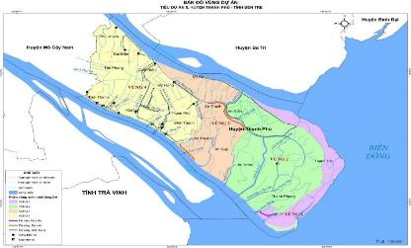

Table 1 - 3: Estimated coordinates and construction locations of the subproject works
Coordinates VN2000, UTM zone 3⁰, meridian axis: 105⁰45’
No. | Work-item | Coordinate VN2000 |  | Commune
 |  | X (m) | Y (m)
I | Co Chien river
 | Co Chien river Embankments
1 | Starting point: Ben Giong canal (K0+00) | 584911.680671 | 1093493.48668 | Binh Thanh, An Thuan
2 | Ending point: DR.27, K2+948) | 583210.798316 | 1095734.82909
 | Bridges on the embankment
1 | Dat Do canal bridge (K0+750) | 584247.44 | 1094340.00 | Binh Thanh
2 | Cong Da canal bridge (K1+300) | 583953.35 | 1094734.86 | An Thuan
3 | Ben Giang canal bridge (K1+800) | 583559.59 | 1095128.77 | An Thuan
 | Bang Cung river
 | Bang Cung river embankments
1 | Starting point: An Thanh CPC (K0) | 588663.95988 | 1099837.50472 | An Thanh, An Quy
2 | Ending point: DR.29 (Cable-stayed bridge) (K7) | 586560.454621 | 1101477.87699
 | Bridges on the embankment
4 | Nha Tho canal bridge | 583569.84 | 1093377.51 | An Thanh
5 | Phu Nu canal bridge | 588415.38 | 1100335.83 | An Thanh
6 | Nha canal bridge | 588502.89 | 1100116.63 | An Thanh
7 | Chum Giuot canal bridge | 588353.57 | 1101427.20 | An Thanh
8 | Ong Hung canal bridge | 587809.57 | 1101562.12 | An Thanh
9 | Ro canal bridge | 587297.71 | 1101520.35 | An Thanh
10 | Ba Pho canal bridge | 587130.29 | 1101496.32 | An Thanh
11 | Ong Phuong canal bridge | 587560.66 | 1101583.69 | An Thanh
12 | Rach Net canal bridge | 586680.87 | 1101467.80 | An Quy
13 | Ong Nom canal bridge | 588922.32 | 1099416.65 | An Quy
14 | Lai Cui canal bridge | 589171.80 | 1099184.08 | An Quy
15 | Ben Gia canal bridge | 589533.36 | 1098981.26 | An Quy
16 | Ba Can canal bridge | 589881.90 | 1098772.46 | An Quy
17 | An Quy canal bridge | 590601.51 | 1098302.99 | An Quy
18 | Large Giao Phay canal bridge | 590776.22 | 1097916.04 | An Quy
19 | Small Giao Phay canal bridge | 588866.76 | 1098282.74 | An Quy
20 | Ben Gia canal bridge | 593343.03 | 1085714.20 | An Quy
II | Consolidation of sea-dike surface
1 | Starting point: Khau Bang canal, K0+00 | 592651.185842 | 1086150.09544 | Thanh Phong
2 | Ending point: DR.DK53, K7+000 | 594657.919474 | 1085928.55236
The non-structural items will be implemented in Thanh Phu town and all 17 communes of Thanh Phu district (An Dien, An Nhon, An Quy, An Thanh, An Thuan, Binh Thanh, Dai Dien, Giao Thanh, Hoa Loi, My An, My Hung, Phu Khanh, Quoi Dien, Tan Phong, Thanh Hai, Thanh Phong, Thoi Thanh). The location map of the non-structural items is shown in the figure below.
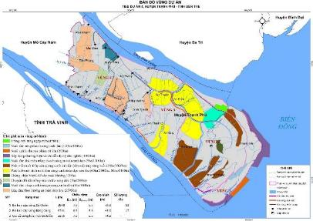
Figure 1 - 2: Location map of non-structural items
The areas benefited from the subproject is 426,548 ha with 127,700 direct beneficiaries.
  - DESCRIPTION OF INVESTMENT WORKS
The subproject consists of 3 river embankments, 20 bridges and 01 sea dike. The details are presented in Table 1-4.

Table 1 - 4: Summary of investment scale of subproject work-items
Work-items | Construction features | Investment scale | Photos
I. Infrastructure
1. Work-item 1: Embankment of Co Chien river (Rehabilitation and new construction of 03 bridges on the embankment with a total length of 2,948 m)  Location: An Thuan and Binh Thanh communes | - Earth road: 4 - 6 m wide;  - Elevation of embankment surface: +2.3 - +2.6 m;  - Dat Do canal (Km0+750), Cong Da canal (Km1+300), Ben Gang canal (Km1+800) are small tributaries of Co Chien river; no bridges crossing these canals; | - Embankment: Upgrading dike, L = 2,948m, combined as Plain Road Class-V, AC pavement, road surface: 5.5 m wide; roadside: 2x1m wide; roadbed: 7.5 m wide; dike elevation: +3.00m, dike riverside slope coefficient m=2.0, dike field-side slope coefficient m=2.0.  - Bridges: Pre-stressed RC, HL.93, simple spans, RC pile foundation 40x40 cm. The details are as follows:  Work-items Locations Basic Design  Stations Communes Bridge decks (m) Elevations Span width (m) Total  Dat Do canal bridge K0+750 Binh Thanh Bridge width = 9.0 Carriage width = 8.0 +3.00 24.54 25.24  Cong Da canal bridge K1+300 An Thuan +3.00 24.54 25.24  Ben Giang canal bridge K1+800 An Thuan +3.50 24.54-24.54-24.54 74.42  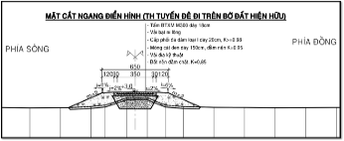 | 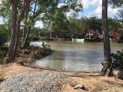  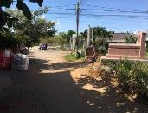  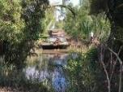  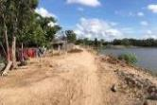
2. Work-item 2: Bang Cung river embankment (Rehabilitation of 11 bridges, construction of new 06 bridges, total length of the route is 7,000 m), in which 01 section of embankment from Lai Cui bridge (K4+535) to K6+000 is completely new;  Location: An Thanh and An Qui communes | - Nearly 2km of concrete road of 1 - 2m wide in An Thanh commune has been deteriorated; along Bang Cung river in An Quy commune is dirt road and shrimp pond banks.  - Elevation of embankment surface: +2.2 - +2.4 m;  - There are 18 small canals that are tributaries of Bang Cung river; There are currently 11 concrete bridges across these canals. | Embankment: Upgrading dike, L = 7,000m, including 01 newly-built section from Lai Cui bridge (K4+535) to K6+000, combined as Rural Road Class-A, Concrete M300, 18cm thick; road surface: 3.5 m wide; road shoulder: 2x1.5 m wide, roadbed: 6.5 m; dike elevation: +3.00m, dike riverside slope coefficient m=2.0, dike field-side slope coefficient m=2.0.  Bridges: Pre-stressed RC, 0.65HL.93, RC pile foundation 35x35cm; the bridge length is from 18.7 to 45.8m. The details are as follows:  No. Bridges Locations Basic design  Stations Communes Bridge decks (m) Elevations Spans (m) Total  1 Nha Tho canal K0+120 An Thanh Bridge width = 4.1 -= Carriage width = 3.5 +2.50 18 18.7  2 Phu Nu canal K0+570 +3.00 9-9-9 27.8  3 Nha canal K0+730 +3.00 9-9-9 27.8  4 Chum Giuot canal K1+010 +2.50 18 18.7  5 Ong Hung canal K1+265 +3.00 9-9-9 27.8  6 Ro canal K1+8 0 +3.00 9-9-9 27.8  7 Ba Pho canal K3+130 +3.00 9-9-9 27.8  8 Ong Phuong canal K3+370 +3.00 9-9-9 27.8  9 Rach Ret canal K3+ 00 An Quy +3.00 15-15-15 45.8  10 Ong Nom canal K4+200 +3.00 18 18.7  11 Lai Cui canal K4+535 +3.00 9-9-9 27.8  12 Ben Gia canal K4+950 +3.50 12-15-12 39.8  13 Ba Can canal K5+375 +3.50 15-15-15 45.8  14 An Quy canal K5+800 +3.00 9-9-9 27.8  15 Big Giao Phay canal K6+300 +3.00 15-15-15 45.8  16 Small Giao Phay canal K6+700 +3.00 15-1 -15 45.8  17 Ben Gia canal DR.28 Bridge width =6.1 Carriage width = 5.5 +3.50 12-15- 39.8  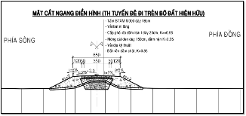 | 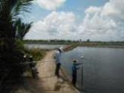  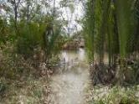  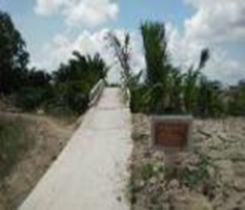  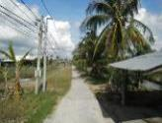
3. Work-item 3: Consolidation of the sea dike surface with a total length of 2,265 m;  Location: Thanh Phong commune | - Currently, the sea dike is made of soil, 7.5 m wide, surrounded by shrimp farming ponds and agricultural land - growing mango;  - Elevation of dike surface: +4.0 - +4.2 m; | - Upgrading dike, L = 2,265 m;  - Plain Road Class-V, RC M300, 18 cm thick;  Road surface: 5.5m wide; Road shoulder: 2x1.0 m wide; roadbed: 7.5 m wide.  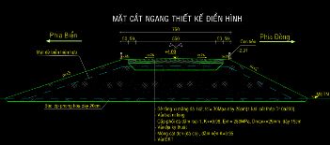  - Dike design elevation +4.00 m. | 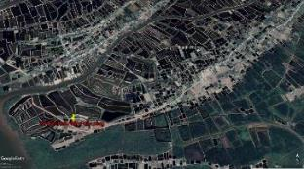  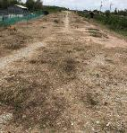  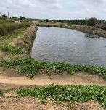
Small-scale infrastructure for livelihood development | - Thanh Phu district currently has 05 water supply plants, including 01 private plant and 04 plants managed by the state Center for Rural Water Supply and Environmental Sanitation. The total capacity of the water plants is 570m³/h, supplying water to 15,241 households, accounting for 38.6%. | - Additional construction of a clean water pipeline network. Number of households benefiting from the subproject is expected to be about 6,611 HHs.  - Volume: about 163,683m of PVC pipe (D60-D315mm); the pipeline expansion covers 13 communes and 1 town: Thanh Hai, Giao Thanh, An Dien, Binh Thanh, My An, My Hung, Quoi Dien, An Nhon, An Thuan, An Thanh, An Qui, Hoa Loi, Thoi Thanh communes and Thanh Phu town. | 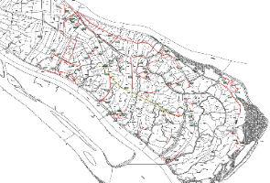  Additional pipeline network
II. Non-structural items
1. Work-item 4: Zone 1: Mangrove ecoregion, covering an area of about 4,000 ha.  Location: Thanh Hai, Thanh Phong and An Dien communes | - Deterioration of mangrove forests, coastal erosion;  - Regional production is still fragmented and farmers are unable to connect with markets;  - Cultivation and production practices are mainly based on experience; the quality and product values of the current production mode are low. | - Newly planting 150ha of mangrove (An Dien);  - Developing a model of 100ha ecological forest shrimp farming and scaling up about 200ha (Thanh Phong, Thanh Hai);  - Developing a model of large-scale commercial clam farming on 80ha and scaling up about 500ha (Thanh Phong, Thanh Hai);  - Developing brand and geographical indications for clam products (Thanh Phong, Thanh Hai);  The designed afforestation items  No. Afforestation items Area (ha) Average height of shrimp farming banks (Htb_m) Average depth of water surface (m) Area used for surrounding canals, 10m wide, 2m deep Afforestation area (ha)  I Zone 1 – Extensive shrimp farming 216.23 1.50 1.50 6.93 151.60  2 Banks of extensive shrimp farm 76.55 1.5 0.75 1000  3 Area of surface water 130.96 1.5 5.54  4 Inner embankment 7.37 0.59  5 Sonneratia caseolaris, Nypa fruticans, Avicennia marina regenerated 1.35 0.05  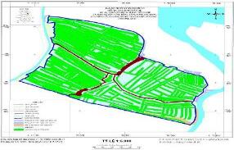  The designed map of afforestation in An Dien commune | Location for afforestation in An Dien  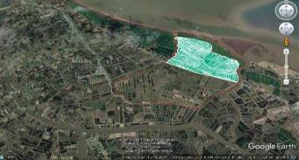  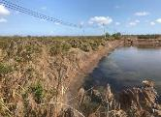  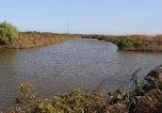  Industrial (left side), extensive (right side) shrimp farms
2. Work-item 5: Zone 2: The saline ecoregion with an area of about 14,000 ha.  Location: An Nhon, An Dien, Giao Thanh, Thanh Phong and Thanh Hai communes | - Water pollution, epidemics, unimproved farming technology; intercropping models are difficult for management. | - Developing a model of 5ha white leg shrimp farming toward biosafe direction, scaling up about 700 ha (Giao Thanh, Thanh Phong);  - Building a model of advanced extensive aquaculture (giant tiger prawn) in 50 ha, then scaling up 5,000 ha (Thanh Phong, Thanh Hai);  - Building a demonstration model of all-male giant freshwater prawn farming combined paddy growing in 60 ha and expected expansion of about 2,000 ha (An Dien);  - Viet GAP certification for about 120 hectares of mangoes (Thanh Phong and Thanh Hai);  - Controlling aquatic epidemics and periodic environmental monitoring.
3. Work-item 6: Zone 3: Brackish ecoregion with an area of about 8,000 ha.  Location: An Quy, An Thuan, An Thanh, An Dien, An Nhon and My An communes | - The area is affected by both East Sea tides and upstream flows, with variable annual saline intrusion, especially in dry seasons.  - Salinity tends to increase.  - Most of the main canal systems in the area are sedimented, reducing the capacity of water supply and drainage, causing water pollution and seriously affecting the quality and output of aquaculture. | - Building a model of 80ha all-male giant freshwater prawn farming combined paddy growing and scaling up about 2,100 ha (An Qui, An Thuan, My An);  - Controlling aquatic epidemics and periodic environmental monitoring (An Quy, An Thuan, An Thanh, An Dien);
4. Work-item 7: Zone 4: The freshwater ecoregion with an area of about 12,000 ha.  Location: Binh Thanh, My Hung, Hoa Loi, Quoi Dien, Dai Dien, Tan Phong, Thoi Thanh, Phu Khanh communes and Thanh Phu town. | - The local sugarcane cultivation area brings low economic efficiency.  - People’s awareness about climate change limits; the management of water quality and cultivation techniques of fresh ecological models is ineffective. | - Converting from sugarcane and rice cultivation into coconut trees with demonstration model of about 3ha and scaling up about 200 ha (Binh Thanh, My Hung and Quoi Dien);  - Developing a demonstration model of raising giant freshwater prawn in a 1-hectare coconut garden and scaling up 300 hectares (Thoi Thanh).

  - CONSTRUCTION METHODS

1.5.1 River embankment
      - Co Chien River Embankment Construction Method
- Step 1: Clearing the ground, peeling the 20cm thick organic layer by excavators and manual.
- Step 2: Using long-reach excavators with arm length of 21-25m, buckets with a capacity of 1.25m³. Soil being excavated up should not be threw too far to avoid breaking the structure of Layer 1a. The excavation order is as follows: Using 2 excavators to dig soil and pour it into the construction and storage areas, do not form a too-high soil pile, avoid breaking the structure of Layer 1a, let the soil drain quickly, spread out the layers from inner to outer and then pour again. Keep doing so until reaching the designed depth of the excavation compartment. Note: Excavated soil is at least 3m away from canal edge to avoid landslide. Appropriate construction schedule is from July – August in lunar calendar.
- Step 3: Transferring soil to the embankment body: When the soil is dry, using a KOBELCO excavator with a capacity of 0.8m³ to dig soil on the roadbed to pour into the embankment shoulders; hoe soil at the embankment foot into the embankment body and level soil. Leveling both sides of the embankment in layers of 30 ÷ 40cm thick, K = 0.85. Digging and filling the roadbed to form slope m = 0.5.
- Step 4: After filling the embankment body and shoulders, starting leveling, rolling, compacting and then lining geotextile fabric as designed, then pumping sand into the roadbed, the compacted sand layer is K = 0.95 until reaching the design elevation of + 2.67m, folding the edge of geotextile. Note: Geotextile fabric arranged sufficiently to be folded is 0.5m.
- Step 5: Using Kobe excavators to level the embankment shoulders till reaching the design elevation of b = 1.2m, horizontal slope of 4%, K =0.85. Then, placing crushed aggregate base course in 15cm thick, pavement slope of 3%, watering and compacting to reach the density of K = 0.98 and design elevation of +2.82m.
- Step 6: Surcharging, rolling and compacting till reaching the elevation of +2.82m, then covering with nylon canvas 3.5m wide.
- Step 7: Installing formwork, expansion joints and doing concreting M300, 18cm thick.
- Step 8: Manually fixing and finishing the road shoulders b = 1.2m and the embankment slope (river side m = 2, field side m = 2). The complete road surface reaches the elevation of + 3.00m.
      - Bang Cung River Embankment Construction Method
- Step 1: Clearing the ground, peeling the organic soil layer by excavators and manual.
- Step 2: Using melaleuca in combination with geotextile fabric to reinforce the embankment foundation by manual;
- Step 3: Using both long-reach and Kobe excavators to dig soil in and surrounding the embankment foundation, drying the soil to reach the designed humidity.
- Step 4: Using excavators to shovel dry soils and fill the embankment layer-by-layer in 50cm thick until reaching the elevation of +2.0m, then stopping and waiting for the ground consolidation within 12 months;
- Step 5: Using excavators to dig dry soils for filling the embankment layer-by-layer in 50cm thick from the elevation of +2.0m to subsidence waiting elevation of +2.75m;
- Step 6: Using excavators to dig the road mold in 5.5m wide, then leveling, rolling and compacting the roadbed to the elevation of +1,665m. Excavated soil is filled on both sides of the embankment to the elevation of +2.85m. Then, placing the geotextile fabric, covering with sand. The first sand layer is 0.4m thick, K ≥ 0.95, Eyc = 40MPa, the second sand layer is 0.5m thick, K ≥ 0.98 till the design elevation of +2,565m.
- Step 7: Applying the crushed aggregate subbase course in 25cm thick, watering and compacting, K ≥ 0.98, Etk = 250MPa. Followed by the crushed aggregate base course in 15cm thick, K ≥ 0.98, Etk = 300MPa to elevation of +2,965m.
- Step 8: Applying the bituminous lining layer of 1kg/cm2, after that, applying the triple bituminous surface treatment (TST) 4.5kg/m2, 3.5cm thick to the crest elevation of +3.0m.
- Step 9: Fixing and finishing the road shoulders b = 1.2m and the embankment slope (river side m = 2, field side m = 2).
- Step 10: Building banks to separate living and production areas of local people with the field-side excavation area to store fresh water for production and daily life.
      - Consolidation of sea dike
- Step 1: Continue to surcharging, compacting, leveling the road surface to the elevation of + 4.00m, then covering with nylon canvas in 3.5m wide.
- Step 2: Installing steel formwork, expansion joints and doing concreting M300, 18cm thick.
- Step 3: Manually fixing and finishing the road shoulders b = 1.2m and the embankment slope (river side m = 2, field side m = 2). The complete road surface reaches the elevation of + 4.00m.
    - Bridges
      - Bridge construction
- Gathering materials, equipment and machinery, mobilizing manpower, building camps and warehouses;
- Clearing the ground, locating the centerline of the bridge;
- Filling soil to form pile-casting yards, and building camps, huts;
- Centrifugal concrete piles are purchased at the plants and transported to the construction sites.
- Locating the centerline of abutments and piers; trial pile driving for bridge abutments and piers; processing reinforced bars and pile concreting;
- Driving reinforced pile heads; processing reinforcement for abutments and piers; concreting abutments and piers;
- Launching the beams into their positions by the horizontal launching method (or using crane);
- Fabrication of steel reinforcement and concreting of cross beams, bridge decks and bridge edges;
- Assembling handrails and guardrails.
      - Bridge-approach roads
(1) Construction method of bridge-approach roads
The construction of roadbed is complied with the national technical regulation TCVN 4447:2012 – Earthworks – Construction, check and acceptance, the construction of foundation layer is in accordance with TCVN 8859:2011, the construction of the base courses with stone 4x6 and macadam complies with TCVN 9504: 2012, the construction and acceptance of asphalt pavement is in accordance with TCVN 8863: 2011.
(2) Construction method of the crushed aggregate subbase course: Complying with TCVN 8859:2011 – Graded aggregate bases and subbases pavement -specification for construction and acceptance.
(3) Construction method of crushed aggregate base course: Construction of the base-course with stone 4x6 and macadam shall comply with TCVN 9504:2012 - Specification for construction and acceptance of water bound macadam layer.
(4) Construction method of asphalt roads: Using hot bitumen, before applying the asphalt treated course, the road surface must be cleaned.
(5) Construction method of cement concrete roads.
  - List of machinery and equipment
    - List of construction machinery and equipment for an embankment section
During the construction process, the equipment is gathered at a certain position of each embankment section. The contractors shall mobilize machinery and equipment to ensure the construction progress. It is possible to divide into construction groups and construction items to restrict the resonant effects of equipment (noise, vibration) in the construction phase.
Table 1 - 5: List of main machinery and equipment needed for the construction of one embankment section
No. | Equipment and Machinery | Features
I | Earth works
1 | Bulldozer | 110 CV
2 | Excavator | 0.6 m³
3 | Roller | 9T
4 | Small compactors | -
5 | Bucket excavator | (0.7÷1.1) m³
II | Formwork
1 | Bar bending machine | 5 KW
2 | Iron cutter | -
3 | Crane | 5T
4 | Electric welding machine | 50 KW
5 | Welding transformer | 50 KW
III | Foundation work
1 | Pile driving machine | -
2 | Barges | 200T tugboat 180CV
IV | Concrete work
1 | Concrete mixing machine | 750L
2 | Fixed concrete mixing plant | 30m³/h
3 | Material conveyor | -
4 | Cooling plant | -
5 | Bulldozer | 110 CV
6 | Concrete pumping machine | -
7 | Crawler crane | -
8 | Needle vibrator | 1.5kW
9 | Plate vibrator | 1.5kW
10 | Concrete hammer | -
11 | Concrete breaker | f 32 mm
V | Others
1 | Compressive strength tester | -
2 | Concrete thermometer | -
3 | Car wash pump | -
4 | Generator | 200 KVA
5 | Electric hoist | 5T
6 | Fire extinguisher | -
    - List of machinery and equipment for the construction of one bridge
Main machinery and equipment selected to be used in the construction of 01 bridge as follows:
Table 1 - 6: Machinery and equipment needed for on-bridge construction
No. | Equipment | Features | State
1 | Barge + crane | 250T + 25T | 90%
2 | Soil pump |  | 90%
3 | Long reach excavator |  | 90%
4 | Backhoe | 0.8 m³ | 90%
5 | Pile driving hammer | 1.8÷2.5T | 90%
6 | Bulldozer | 108CV | 90%
7 | Compactor | 9T | 90%
8 | Small compactor |  | 90%
9 | Dump truck | 8T | 90%
10 | Bitumen sprayer |  | 90%
11 | Concrete mixing machine | 500 liters | 90%
12 | Needle vibrator |  | 90%
13 | Plate vibrator |  | 90%
14 | Concrete pump |  | 90%
15 | Pump | 30 m³/h | 90%
16 | Welding machine |  | 90%
17 | Staging system |  | 90%
18 | Theodolite |  | 90%
19 | Hydrostatic tester |  | 90%
The construction machines will be gathered at each construction sites.
In order to perform the construction, about 20 workers shall be mobilized for each work-item.

  - Volume of earthworks
Table 1 - 7: Volume of excavation and backfill of work-items
No. | Work-item | Excavated soil  (m³) | Reused for backfilling (m³) | Disposal  (m³) | Total backfilled soil volume (m³) | Additional backfilled soil (m³)
1 | Work-item 1 | 16965 | 15268 | 1697 | 21327 | 6059
2 | Work-item 2 | 16228 | 14605 | 1623 | 53460 | 38855
3 | Work-item 3 | 5463 | 4917 | 546 | 7746 | 2829
4 | Clean water supply | 32909 | 29618 | 3291 | 25443 | -
 | Total | 71565 | 64408 | 7157 | 107976 | 43568

  - Demand on materials and fuels
Main materials for construction of the subproject’s items are filling soil, sand, stone, cement, brick and steel, precast and ready-made materials such as precast concrete culverts, asphalt concrete, concrete piles. The volume of materials for construction of the items is displayed in the following Table:
Table 1 - 8: Volume of materials for construction
Work-item | Volume
 | Cement (tons) | Yellow sand | Stone | Riprap | Stone for embankment foot
 |  | (m³) | (m³) | (m³) | (m³)
Work-item 1 | 8,286,047 | 56,361 | 14,461 | 32 | 19,908
Work-item 2 | 1,260,639 | 2,792 | 2,240 | 2,011 | 57
Work-item 3 | 452,664 | 1,300 | 972 | 48 | 66
Total | 9,999,350 | 60,453 | 17,673 | 2,091 | 20,031

Filling soil, cement, sand, stone, steel, etc., are available in Ben Tre province and the vicinities. They are purchased from suppliers, licensed quarries and sand mines, specifically:
- Stone is purchased in Dong Nai province; yellow sand is bought in Long Xuyen city and An Giang province; the transport distance to the construction sites is about 120km.
- Cement and river sand are purchased from primary dealers in Ben Tre with a transport distance of about 20 km by waterway.
- Geotextile and gabions are purchased in Tien Giang and Long An, about 60km from the construction sites. Sheeting piles are purchased directly at the granaries in Ben Tre, Long An or Tien Giang with a transport distance of 60km.
- Fuel (gasoline, oil, etc.,) is purchased from dealers in Ben Tre province.
- Steel is purchased at factories in Ben Tre, Ho Chi Minh City.
- Soils for embankment/dike construction are mainly in-place exploited according to construction methods (digging soil from the core to the sides to ensure the width of the roadbed and the road slope, then pumping sand into the road core to reach the required density). The missing soil will be taken from the two sides of the embankments (not exploited at one point) and compensated with sand. These soils are mainly taken from Bang Cung river embankment in which the shrimp farms are located. Currently, these households completely support the excavation because they do not have enough money to hire labor for digging. The average depth and width of excavation is 1.0-1.2m and 20-25m, respectively, depending on the need for soil in each section. The details on the locations and volume of excavation are in Table 1-14 and Figure 1-20.
The list of borrow pits for the work-items is shown in the Table below.
Table 1 - 9: List of borrow pits to be used for the subproject’s items
Sources | Exploitation permits by Ben Tre PPC | Description
 |  | Area (ha) | Area (ha)
I. Quarries
Thien Tan 10 quarry in Thien Tan commune, Vinh Cuu district and Ho Nai 3 commune, Trang Bom district, Dong Nai province. | Decision No.1849/UBND-CNN dated 27/2/2018 | 75.438 | 0.9
Sok Lu 1 - Gia Kiem, Thong Nhat district, Dong Nai province | Decision No.184/2015/NQ-HDND dated 11/12/2015 | 30.5 | 1.25
II. Sand mines
Sand mine on Hau River of My Hoa Hung commune, Long Xuyen city and An Thanh Trung commune, Hoa Binh commune, Cho Moi district, An Giang province. | License No.603/GP-UBND dated 30/9/2019 | 27.264 | 0.65
Ben Tre Construction Materials JSC – Ben Tre city  Dai Loi Building Materials – Ben Tre city  Lien Phuoc Thanh precast concrete and building materials manufacturing One Member Company Limited – Ben Tre city | Before signing contracts, the material providers need to present their licenses as prescribed.
  - Transportation routes
- Materials transportation
- Construction materials are mainly transported by waterways on Co Chien and Bang Cung rivers and through the canals that cross the embankment/dike system of the subproject.
- For the embankment along Co Chien river: construction materials and equipment are entirely transported to the construction sites by waterways through tributaries of Co Chien river. These tributaries are not more than 200m far from the river, the cross-section is 15m wide which facilitates the smooth movement of 400-ton barges.
- For the embankment along Bang Cung river: the transportation of materials and equipment by waterways is quite convenient thanks to Bang Cung river’s tributaries which are more than 10m wide and less than 200m from the river, facilitating the smooth movement of 200-ton barges or more.
Building materials are mainly purchased from borrow pits and dealers in Ben Tre province, Ho Chi Minh city and neighboring provinces. It is convenient to transport to the construction sites by waterways. Barges carrying materials to the material stockpiles are anchored in the construction area of bridges (for Co Chien river and Bang Cung river embankments) and sea dikes. Small, non-bulky materials can be transported to the site by motorcycles and small trucks. The roads for transportation are expected to be predominantly inter-village and inter-commune asphalt concrete roads. Thus, during the consultation with local government and people, only 2–5-ton trucks are allowed to travel on these routes to avoid damaging local transport infrastructures.
The transport locations and distances are presented in Table 1-10 and Table 1-11.
Table 1 - 10: Expected routes for material transportation to construction sites
Work-items | Materials | Main transportation route | Distance (km)
1 | Geotextile fabric, sheeting piles, gabions | Suppliers (Tien Giang, Long An, Ben Tre) Co Chien river construction sites | 60 km
 | Stone | Quarries (Dong Nai) Dong Nai river Xoai Rap river Tien Giang river by sea Co Chien river Construction site | 120 km
 | Yellow sand | Sand mines (Moi market, An Giang province) Mekong river Co Chien river Construction site | 120 km
 | River sand, cement | Dealers (Ben Tre) Co Chien river Construction site | 20 km
 | Steel | Plant (Ben Tre) Co Chien river Construction site | 20 km
2 | Geotextile fabric, sheeting piles, gabions | Suppliers (Tien Giang, Long An, Ben Tre) Bang Cung river construction sites | 60 km
 | Stone | Quarries (Dong Nai) Dong Nai river Xoai Rap river Tien Giang river by sea Co Chien river Construction site | 120 km
 | Yellow sand | Sand mine (Moi market, An Giang province) Mekong river Ham Luong river Bang Cung river Construction site | 120 km
 | River sand, cement | Dealers (Ben Tre) Ham Luong river Bang Cung river Construction site | 20 km
 | Steel | Plant (Ho Chi Minh city) Ham Luong river Bang Cung river Construction site | 70
3 | Geotextile fabric, sheeting piles, gabions | Suppliers (Tien Giang, Long An, Ben Tre) Co Chien river construction sites | 60 km
 | Stone | Quarries (Dong Nai) Dong Nai river Xoai Rap river Tien Giang river by sea Co Chien river Construction site | 120 m
 | Yellow sand | Sand mine (My Hoa Hung, Long Xuyen) Hau Giang river by sea Co Chien river Construction site | 120 m
 | River sand, cement | Dealers (Ben Tre) Co Chien river Construction site | 20 km
Table 1 - 11: Expected roads for material transportation to the construction sites
Work-items | Main transportation roads | Distance (km)
1 | NH57 DR25/27 inter-village and inter-communal roads the site | 2 -16 km
2 | DR25/27 inter-village and inter-communal roads the site | 0,7 -12 km
1, 2 | NH1A DR25/27 inter-village and inter-communal roads the site | 10 - 13 km
3 | NH57 DR25/27 inter-village and inter-communal roads the site | - - 10 km

The material transportation routes are shown in Figure 1-3.
  - Disposal sites and transportation routes
Excess soil after being used for embankment filling, ground leveling and other purposes, but about 7,157 m³ of non-reusable weathered soil will be transported to the disposal sites which agreed by the local government of Binh Thanh, An Thuan, An Quy, An Thanh and Thanh Phong.
The disposal sites are listed below:
Table 1 - 12: Information about disposal sites and expected routes for transportation

Work-items | Disposal sites of weathered soil | Transportation routes | Distance | Description
Work-item 1: Embankment in Binh Thanh commune | Reused for filling the road from Thanh An village to Thanh Phu town. | Construction site inter-village concrete roads disposal site | 3 - 5 km | Location: Binh Thanh commune;  Area: 0.5 ha;  Reserve: 5,000 – 7,000 m³;  Transport land managed by CPC
Work-item 1: Embankment in An Thuan commune | Reused for ground leveling of An Khuong community center, An Thuan commune. | Construction site District road (DR) 27 Disposal site | 2 km | Location: An Thuan commune;  Area: 0.15 ha;  Reserve: 3,000 – 4,600 m³;  Unused land managed by CPC
Work-item 2: Embankment in An Qui commune | Reused for ground leveling of An Qui CPC’s new headquarter in An Phu village. | Construction site DR 28/29 inter-village concrete road Disposal site | 5 - 7 km | Location: An Phu village, An Quy commune;  Area: 3,000 m²;  Reserve: 15,000 m³;  Vacant land managed by CPC
Work-item 2: Embankment in An Thanh commune | Reused for ground leveling in An Thanh village, opposite An Thanh Temple | Construction site inter-commune concrete road DX04 disposal site | 500 m from the construction sites | Location: An Thanh village;  Area: 1500 m²;  Reserve: 3,000 m³;  Vacant land managed by CPC
Work-item 3 | Reused for ground leveling of Thanh Loc village | Construction site inter-village concrete roads disposal site | 1 km from the construction sites | Location: Thanh Loc village  Area: 5,000 m²;  Reserve: 15,000 m³;  Vacant land managed by CPC

The routes for transporting wastes are presented below.

Figure 1 - 3: Transportation and disposal routes
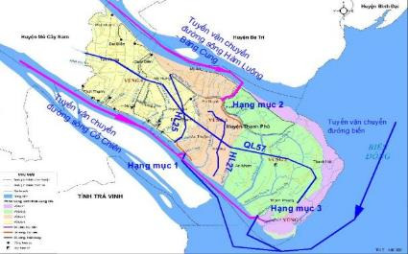

  - Power and water supply
The subproject areas are supplied by the power from the national grid for construction and daily activities. Water from local supply sources, drilled wells or rivers and canals will be used for construction and domestic activities of workers.
  - Management – operation technology
For the bridges, sea dikes, and embankments along Ham Luong and Co Chien rivers, the operating process of sluices is mainly to monitor, check and ensure the good working condition of the work-items. For the culverts crossing the dike/embankment, operating status is checked according to the working schedule.
  - Implementation duration
The subproject implementation will last 24 months for both structural and non-structural items.
Thanh Phu DPC shall act as the management and maintenance unit.

ENVIRONMENTAL AND SOCIO-ECONOMIC CONDITIONS
  - NATURAL CONDITIONS
    - Geological and topographical conditions
      - Topographical conditions
The subproject terrain is relatively flat. Sand dune aquifer dominates which is running parallel with the coast. The natural ground elevation is 0.8 - 1.2 m. Thanh Phu district has 4 main types of terrain as follows:
- Brackish delta: From Mo Cay Nam district to My Hung - Binh Thanh commune. The terrain is relatively flat with many local low-lying areas in Thoi Thanh, Quoi Dien, Dai Dien, Hoa Loi and Thanh Phu town. The soil varies from low-to-medium saline alluvial with heavy mechanical properties.
- Saline river delta: From My Hung - Binh Thanh to Thanh Phong - Thanh Hai. The terrain is relatively flat but there is the difference between the coastal area and the low-lying basin, far from the river due to uneven sedimentation, great separation, and interlaced river systems. The end of the plain is a saline marsh covered with mangroves.
- Sand dune aquifer: Includes ancient differentiated sand dunes in Dai Dien – Phu Khanh and undifferentiated sand dunes in the high tidal flats along the coast. The elevation and density of sand dunes aquifer gradually increases towards the sea. Many sand dune aquifers have an elevation of > 5m.
- High tidal flats: Thanh Phu coast is strongly deposited, forming large high-tidal flats in the southeast coast area with several sand dunes (Cao, Dai, Ong Muoi, Dam, Loi, Ngam, Lon, Bung, Binh Tu, Dia, Mut, Tra sand dunes).
The structural work-items are mainly located in the brackish delta and saline river delta. The non-structural work-items are conducted in all 18 communes and towns of Thanh Phu district. Thus, the terrain there characterizes the above four main types.
      - Geological conditions
The geological characteristics of Ben Tre province include the following layers:
- Layer D: Filling soil, blue-gray, gray-brown clay with sands, gravels and plant roots. State: soft plastic – solid plastic.
- Layer 1b: Riverbed mud clay, referring black-brown colored. State: Liquid.
- Layer 1: Grained marsh estuary sediments, clay components: heavy clay loam and sandy clay, black-gray - dark brown, mixed with fine sand lenticular, tiny little broken shells and vegetable humus. State: Plastic liquid.
- Layer 1a: Like Layer 1 but the particle density of sands in clay rising locally so that the ingredients contain heavy clay loam - sandy clay. State: Plastic, sometimes very soft or soft plastic liquid. Layer exists within Layer 1 in the form of lenticular without distinction line, making the fine particle concentration, humidity and ductility reduced locally.
- Layer 1c: Main components are grained sub-sand mixed with seam clamp clay – sub-clay forming light sub-sand – clay loam, grey – yellow, grey – light brown colored. Untight structure is considered as marking layer with significantly increased shells. Besides, there are lenticular layers existing in Layer 1 and Layer 1a.
- Layer 1d: Is Layer 1 with mixed grained sand lenticular density, making an increase in the ingredients of heavy-medium sub-clay and in the viscosity. Layer 1d exists within Layer 1 under the form of lenticular when concentrating a significant density of individual grained sand lenticular owning water particles that increase particles density and local viscosity.
- Layer 2: Late Quaternary sea sediments with components of heavy clay loam – sandy clay, yellow – light brown to rippling light white-green. State: solid-semisolid.
- Within Layer 1c there are Layer 1d and Layer 1a found sometimes formed by the thin mud holes and the lenticular.
- Physical and mechanical properties of Bang Cung river embankment
According to the FS report and the physio-mechanical properties of the foundation soil in the studied areas, the geological conditions of the subproject area include the following layers:
Layer 1a: Gray-brown, black-brown clay, soft to hard plastic state. This soil layer appears at a depth of 0.0m -1.4m, elevation from +1.7 to -0.1; the thickness of the soil layer is from 1.2m to 1.4m.
Layer 1: Brown-gray, dark gray clay mud, sandy clay mud. This soil layer appears at a depth of 1.2m to 5.0m, elevation from +0.5 to -3.9; the thickness of the soil layer is from 3.6m to 3.8m; the layer bottom has not been detected when drilling to the end of the depth of 5.0m.
- Physical and mechanical properties of Co Chien river embankment
Layer 1a: Topsoil, appears at a depth of 0.0m - 0.3m, elevation of +1.9 - +1.6, 0.3m thick, only exists in borehole CC1.
Layer 1b: Yellow-brown clay loam, soft to hard plastic state. This soil layer appears at a depth of 0.0m - 1.8m, elevation of +2.1 to -0.02, thickness of 1.4m - 1.7m.
Layer 1: Brown-gray, dark gray clay mud, sandy clay mud. This soil layer appears at a depth of 1.4m - 5.0m, elevation of +0.5 to -3.5, 3.2m - 3.6m thick; the layer bottom has not been detected when drilling to the end of the depth of 5.0m.
- Physical and mechanical properties of Khau Bang sea dike
Layer 1a: Topsoil, appears at a depth of 0.0m - 0.5m, elevation of +4.6 - +4.1, 0.5m thick, only exists in borehole KT2.
Layer 1b: Yellow-brown clay loam, soft to hard plastic state. This soil layer appears at a depth of 0.0m – 2.3m, elevation of +4.1 to +0.3, thickness of 1.4m - 1.7m.
Layer 1c: Less tight blackish gray clay sand, appears at a depth of 1.7m - 5.0m, elevation of +2.3 to -3.0, the thickness of 1.8m - 3.3m, only appears in boreholes KT1, KT2; the layer bottom has not been detected when drilling to the end of the depth of 5.0m of borehole KT1.
Layer 1: Brown-gray, dark gray clay mud, appears at a depth of 1.3m - 5.0m, elevation of +1.0 to -2.7, the thickness of 3.2m - 3.6m, only appears in boreholes KT2, KT3. The layer bottom has not been detected when drilling to the end of the depth of 5.0m.
Soil characteristics:
There are three (03) main soil groups in Thanh Phu district, including salic fluvisols, acid sulfate soils and sandy soils.
Salic Fluvisols: an area of 29,000 ha, making up 85.8%; this is the main soil group in the district which consists of the following types:
- Molli Salic Fluvisols (weak saline soil): with an area of 7,501 ha, accounting for 22.2%; this kind of soil has the best fertility in the area, suitable for agricultural production. It is rich in humus, nitrogen, potassium, and medium-to-poor phosphorus, relatively high absorption capacity, heavy mechanical composition. If the temporary dams are built to prevent salinity, the surface water will be freshwater, and water is salty seasonally. Weak saline soil is distributed in the central area from the boundary of Mo Cay Nam district to An Thuan commune and suitable for high-yield rice cultivation and rice-crop rotation.
- Molli Salic Fluvisols (Medium saline soil): covering an area of 6,518 ha, accounting for 18.3%. This kind of soil has the same characteristics as weak saline soil but has higher salinity and longer saline time. If the temporary dams are built to prevent salinity, time for improvement will be longer. Medium saline soil is distributed in the riverside area from Mo Cay Nam district to An Quy commune and suitable for high-yield rice cultivation, rice-crop rotation. In case of appropriate salinity, it is possible to organize the model of shrimp-rice farming.
- Hyper Salic Fluvisols: being occupied in an area of 8,249 ha, accounting for 24.4%, this kind of soil is distributed from An Thanh - An Quy to the mangrove boundary of Thanh Phong - Thanh Hai with the salinity time of over 8 months/year. It is rich in humus, nitrogen, potassium, poor in phosphorus, high absorption capacity but imbalance, heavy mechanical composition; thus, it is difficult to improve for effective agricultural production and crop increase. Under favorable conditions, hyper salic fluvisols can be used for rice-shrimp rotation or specialized shrimp farming. Semi-intensive and intensive shrimp farming can be developed in areas where have poor organic deep profile and stable salinity.
- Permanent salic fluvisols in mangroves: with an area of 7,048 ha, accounting for 20.8%; this kind of soil is located on the boundary of Thanh Phong - Thanh Hai mangrove forest, the salinity takes place all year round, influenced by instant tides. It is rich in humus, nitrogen, potassium, and poor in phosphorus, imbalance absorption capacity, heavy mechanical composition. Permanent salic fluvisols is suitable for rehabilitation of mangroves or extensive shrimp farming, shrimp-forest farming, etc. Because of the rich organic profile, shrimp farming is only developed at semi-intensive model.
Acid sulfate soils: there is only one kind of soil namely acidic-salt affected soil that alum containing layer is located at a depth of more than 50cm (SpM). Acidic-salt affected soil is mainly distributed in My An and An Dien communes with an area of 1,094 ha, making up 3.2%. Soil is salty for more than 8 months every year. The surface layer is rich in humus, nitrogen, potassium and poor in phosphorus, average absorption capacity but imbalance, heavy mechanical composition.
This kind of soil is suitable for one-cropping rice – shrimp rotation or specialized shrimp farming in appropriate conditions. Because of rich organic profile, immature soil and high alum capacity when digging square-shape ponds, shrimp farming is only developed at semi-intensive model.
Arenosols: There is only one kind of soil namely profile-differentiated arenosols (Cz) which covers an area of 3,723ha, accounting for 11.0%. It is infertile but suitable for upland crops cultivation. In addition, it is poor in humus, nitrogen, phosphorus, potassium, has low absorption capacity and light mechanical composition.
This kind of soil is distributed throughout the area in bow-shaped dunes parallel to the coastline; It can be said that Thanh Phu occupies the highest proportion of arenosols in Ben Tre province. Besides, about 1,500 ha of arenosols which have not been differentiated, are forming into sand dunes on the high intertidal area.
    - Climate conditions
Ben Tre subproject is located in tropical monsoon area, with the monthly average temperature of about 28.5⁰C. Climatic conditions differentiate into two distinct seasons: the rainy season usually starts from May and ends in November, the dry season is from December to April next year. However, the impact of climate change in the region in recent times has caused significant changes and difficulties for production. The figures below are taken from Ba Tri and Giong Trom stations in the subproject area.
- Temperature and hours of sunshine
The monthly average temperature is quite high (26.8 - 27.3ºC) and relatively stable during the year. The lowest temperature in the year is in January and February (25.2-25.5ºC). The details are shown in Table 2-1 below.
Table 2 - 1: Air temperature
Station | Month
 | 1 | 2 | 3 | 4 | 5 | 6 | 7 | 8 | 9 | 10 | 11 | 12 | Whole year
Ba Tri | 25.2 | 25.9 | 27.1 | 28.6 | 28.5 | 27.6 | 27.2 | 27 | 26.9 | 26.8 | 26.4 | 25.5 | 26.8
Source: Statistical Year Book of Thanh Phu district, 2019
The number of hours of sunshine varies from 6.2 to 9.3 hours/day, and 7.18 hours/day on average for the whole year (dry season months: 231 - 278 hours/month).
Table 2 - 2: Number of hours of sunshine (hour/day)
Station | Month |  |  |  |  |  |  |  |  |  |  |  | Whole year
 | 1 | 2 | 3 | 4 | 5 | 6 | 7 | 8 | 9 | 10 | 11 | 12
Ba Tri | 8.52 | 9.29 | 9.29 | 8.4 | 6.81 | 6.2 | 6.19 | 6.19 | 5.3 | 6.0 | 7.0 | 7.71 | 7.18
Source: Statistical Year Book of Thanh Phu district, 2019
- Humidity
The air humidity is closely related to the rain regime.
- The rainy season (May – October) is the wet season with an average humidity of 83-86%.
- The dry season (December – April): the average humidity is 76-80%, the lowest is from February to April with the average humidity is 77%.
Table 2 - 3: Monthly humidity
Station | Month |  |  |  |  |  |  |  |  |  |  |  | Whole year
 | 1 | 2 | 3 | 4 | 5 | 6 | 7 | 8 | 9 | 10 | 11 | 12
Ba Tri | 81 | 81 | 80 | 80 | 83 | 85 | 86 | 86 | 88 | 88 | 86 | 82 | 84
Source: Statistical Year Book of Thanh Phu district, 2019
- Evaporation
The total evaporation volume in the whole year ranges from 959mm to 1126mm. The average evaporation per month in the rainy season is 55 - 90mm while the evaporation in dry seasons months is more than 100mm. The average daily evaporation is 2.9mm. The daily evaporation of the largest month is 4.2mm on average.
- The evaporation in February reaches the maximum level while the evaporation in October is the least.
Table 2 - 4: Average monthly evaporation (mm/7 days)
Station | Month |  |  |  |  |  |  |  |  |  |  |  | Whole year
 | 1 | 2 | 3 | 4 | 5 | 6 | 7 | 8 | 9 | 10 | 11 | 12
Ba Tri | 3.7 | 4.2 | 4.0 | 4.1 | 3.0 | 3.0 | 2.7 | 2.5 | 2.3 | 2.2 | 2.6 | 3.1 | 2.9
Source: Statistical Year Book of Thanh Phu district, 2019
- Precipitation
The annual average rainfall in the subproject area is 1404mm/year which is considered as low in the Mekong Delta.
Seasonal rainfall distribution is a characteristic of the Southern region in general and the subproject area in particular. The rainy season is from May to October with a total number of rainy days of 156 - 164 days; the rainfall accounts for 75 - 82% of the total annual rainfall.
Table 2 - 5: Monthly average rainfall (mm)
Station | Month |  |  |  |  |  |  |  |  |  |  |  | Whole year
 | 1 | 2 | 3 | 4 | 5 | 6 | 7 | 8 | 9 | 10 | 11 | 12
Ba Tri | 0.4 | 0.7 | 4.4 | 38.5 | 157 | 207 | 174 | 174 | 286 | 278 | 93 | 9.9 | 1404
Ben Tre | 3.0 | 0.0 | 5.0 | 25 | 169 | 190 | 180 | 198 | 206 | 299 | 90 | 26 | 1389
Table 2 - 6: Number of rainy days in a month (day)
Station | Month |  |  |  |  |  |  |  |  |  |  |  | Whole year
 | 1 | 2 | 3 | 4 | 5 | 6 | 7 | 8 | 9 | 10 | 11 | 12
Ba Tri | 2 | 1 | 1 | 4 | 15 | 20 | 20 | 20 | 20 | 19 | 11 | 4 | 132
Source: Statistical Year Book of Thanh Phu district, 2019
Droughts which sometimes occur in the rainy season, known as “Ba Chang drought”, last from 5 to 10 days in May, June, and July.
    - Hydrological and oceanographical conditions
The subproject area is located between 02 main rivers:
- Ham Luong river: located in the north of the subproject area with a total length of about 71km. Ham Luong is a big river in Ben Tre province, the riverbed is broad and deep, discharge in the rainy season is 3,360 m³/s and sharply plunged in dry seasons at 828 m³/s.
- Co Chien river: located in the South of the subproject area with a total length of about 82km. Co Chien river is a natural boundary between Ben Tre and Tra Vinh, Vinh Long provinces. Discharge in the rainy season and dry season is about 6,000m³/s and 1,480m³/s, respectively.
The subproject area is strongly affected by the East sea tides through these two rivers, which is forming a network of dense rivers and canals across the subproject area in the North - South direction such as Mo Cay - Vam Nuoc Trong, Muong Dieu, Cau Sap, Tan Huong rivers, Tong Cang, Cai Ca, Cai Ban, Giong Luong, Ca Rang Dong, Tang Du, Xeo Vuon, and Nha Tho canals, etc.
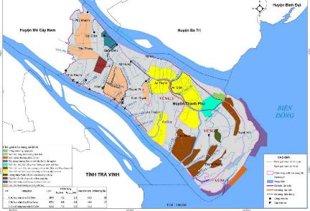
Figure 2 - 1: River system and subproject location
Being located in a downstream part of Ham Luong and Co Chien rivers, connected to the East Sea, Thanh Phu district is influenced by an irregular semi-diurnal tide regime, which is convenient for the gravity water supply and drainage.
According to the actual statistical data at the neighboring hydrological stations, the highest water level is 1.68m and the lowest is 0.6m. The highest tide level is 0.50m, the lowest is -2.32m. The details are as follows.
Table 2 - 7: Monthly average water levels measured at a number of local hydrological stations
No. | Station | Features | Month
 |  |  | I | II | III | IV | V | VI | VII | VIII | IX | X | XI | XII
1 | Ben  Trai | Max | 1.83 | 1.72 | 1.59 | 1.42 | 1.39 | 1.26 | 1.34 | 1.46 | 1.68 | 1.88 | 1.90 | 1.83
 |  | Min | -2.29 | -2.22 | -2.08 | -2.15 | -2.40 | -2.51 | -2.58 | -2.50 | -2.35 | -2.11 | -2.30 | -2.18
2 | An  Thuan | Max | 1.50 | 1.42 | 1.35 | 1.26 | 1.12 | 1.02 | 1.05 | 1.14 | 1.35 | 1.52 | 1.53 | 1.49
 |  | Min | -1.84 | -1.82 | -1.67 | -1.82 | -2.04 | -2.15 | -2.16 | -2.14 | -1.97 | -1.66 | -1.78 | -1.85
(Source: Southern Hydrometeorology Station)
    - Saline intrusion
Salt water from East Sea penetrates the inland through Ham Luong and Co Chien rivers. The saline intrusion depends on the season, tidal regime, flow discharge of Ham Luong and Co Chien rivers. Time of saline intrusion lasts from 6 to 10 months depending on the distance to the sea. When the amount of river water in dry seasons decreases, the salt water will penetrate further into the inner fields. The areas located farthest from the sea such as Phu Khanh, Thoi Thanh have 2-4 months/year of saline intrusion (depending on each year). In general, the entire district is surrounded by salt water in dry seasons. In recent years, due to upstream exploitation, unusual weather, and increased tides, the change of saline intrusion is more and more severe and strongly affects crops and livelihoods of the subproject area.
The subproject area is located between two (02) large rivers namely Ham Luong and Co Chien, the saline intrusion into the inland is about 5 to 6 months per year. The saline concentration of the riverside and field side is 10‰ - 25‰ and 1‰ - 6‰, respectively. Saline intrusion has seriously affected the growth of crops, especially fruit trees in Mo Cay. As reported by the Department of Agriculture and Rural Development of Thanh Phu district, the entire agricultural production area in the subproject area (27,000 ha) has turned salty (of which 10,000 ha has the saline concentration of 2 - 4‰). Typically, the 2016 drought and saltwater intrusion period in Thanh Phu district caused the damage to 1,404.96 ha of paddy field of communes such as Dai Dien, Thoi Thanh, Hoa Loi, Quoi Dien, My Hung, Binh Thanh and Thanh Phu town; of which 656.76ha completely damaged, 404.83ha damaged at 50 - 70%, 251.3ha damaged at 30-50%, 92.07ha damaged at 30%.
    - Extreme weather phenomena

a. Rains and storms
According to statistics of Ben Tre Steering Committee for Flood and Storm Prevention and Control, Search and Rescue, there were 39 storms and 14 tropical cyclones operating in the East Sea in the period of 2011 - 2014, of which 05 storms and 01 tropical depression landed and directly affected our country. In particular, storm No.1 (PAKHAR) directly affected the coastal provinces from Binh Thuan to Ba Ria - Vung Tau in March 2012 and tropical depression No.6 happening from 12 to 15 November 2012 directly affected the coastal area of Ben Tre province.
Table 2 - 8: Number of storms and tropical cyclones in the period of 2011 - 2014
 | 2011 | 2012 | 2013 | 2014
Number of storms | 08 | 10 | 15 | 06
Tropical cyclones | 06 | 02 | 04 | 02
(Source: Final report on Flood and storm prevention and control; search and rescue in 2011, 2012, 2013, 2014)

b. Flood and water level rise
Floods in Ben Tre province are mainly the upstream floods and the rising water which is the combination of high tide with the upstream floods or with storms and tropical low pressures, causing slow drainage and inundation. Ben Tre province is characterized by many rivers and canals, so the influence of floods and rising water on the upstream communes of Cho Lach and Chau Thanh districts, especially the dunes in river is relatively significant. Floods and rising water cause local flooding, landslide, loss of agricultural production (especially fruit gardens) and many other works. In the past few years, although storms and tropical cyclones did not directly affect Ben Tre province, it indirectly caused heavy rains, high tide, and upstream floods.
Table 2 - 9: Summary of damages caused by high-tide in the period of 2011 - 2014
Years | Damages by storms, typhoons
2011 | - Area of crops affected: 351.39 ha  - Area of fruit garden damaged: 14,495 ha  - Area of paddy field damaged: 539.6 ha  - Number of poultry and livestock died: 6,320  - Damages estimated: VND 84,492,370,000
2012 | - 3,573 m of dike/embankment damaged  - 92,045 m of rural roads flooded  - 4,470 ha of agricultural land flooded  - 70 ha of fruit gardens, crops damaged  - Damages estimated: VND 1,153.87
2013 | - 6,616 m of embankment damaged.  - 2,400 m of rural roads flooded  - 02 dams and 01 culvert damaged.  - Damages estimated: VND15.6 billion
2014 | - 66,177 m of rural roads flooded  - 4.5 ha of coastal land eroded.  - 1,120 m of embankment/dike damaged.  - Damages estimated: VND17.9 billion.
(Source: Final report on Flood and storm prevention and control; search and rescue in 2011, 2012, 2013, 2014)
c. Landslide
Erosion and landslide in the riversides and canals are quite complicated and difficult to be controlled. It continues to occur at the locations happened from the previous time, and appear more in other areas along the major tributaries. The main reason is the influence of boat operation and illegal sand exploitation. Illegal and exceeding exploitation has affected soil structure, reduced soil stability, and caused landslides in riverside areas. According to the survey in 2012-2014, the landslide has occurred increasingly in many districts compared to previous years, directly affecting local people and causing significant economic losses.
In 2012, the landslide affected 5 HHs in the province with an area of landslide of about 1,303m2. In 2013, serious landslides occurred in the districts of Binh Dai, Chau Thanh, Cho Lach and Giong Trom, causing a damage of approximate VND 20.3 billion. In 2014, due to the fluctuations of the flow combined with high tides and waves, about 3,405m of embankment were collapsed, causing the impact on 63 houses and productive land of the people. The total of damage was estimated at VND 2.4 billion.
d. Lightning and Tornado
In recent years, heavy rains accompanied by tornadoes and lightning in Ben Tre province have damaged houses and many works such as:
Table 2 - 10: Summary of damages caused by lightning and tornado in the
period of 2011 - 2014
Year | Damages
2011 | - Number of deaths: 3 persons  - 01 processing facility is unroofed with an area of about 100 m²
2012 | - Number of deaths: 1 person  - Number of injured persons: 43  - Number of completely collapsed houses: 82  - Number of damaged houses: 783  - Estimated damage: VND 31,173 million
2013 | - Number of deaths: 1 person  - Number of injured persons: 1  - Number of completely collapsed houses: 3  - Number of damaged houses: 10
2014 | - Number of completely collapsed houses: 02  - Number of damaged houses: 15  - Eroded dike: 1,120 m  - Estimated damage: VND 419 million
(Source: Final report on Flood and storm prevention and control; search and rescue in 2011, 2012, 2013, 2014)
  - ENVIRONMENTAL QUALITY AND BIOLOGICAL RESOURCES
The samples of ambient air, water and soil in the subproject area have been taken by Ben Tre PPMU incorporation with Institute of Coastal and Offshore Engineering – Vietnam Academy for Water Resources to assess the status of baseline environmental quality. The sampling locations are shown in the figure below.
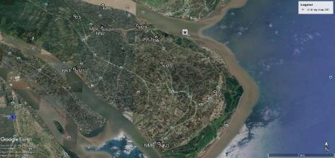
Figure 2 - 2: Sampling locations
    - Air quality
The air quality at 04 monitoring locations in the subproject area is within the limits allowed by the national technical regulation QCVN 05: 2013/BTNMT. The dust content at all monitoring locations is quite low, ranging from 105 - 162µg/m³ compared to QCVN 05:2013/BTNMT (300µg/m3). It can be seen that the air environment in the subproject areas at the time of sampling is not polluted by suspended dust. The non-detection of PM10 and PM2.5 dust proves that the subproject areas have not had any harmful amount of dust. It may be because the subproject areas are covered by a large mangrove vegetation and low traffic density. The detailed analysis results are presented in the table below:
Table 2 - 11: Air sampling locations
No. | Code | Location | Coordinates VN2000
 |  |  | X (m) | Y(m)
1 | KK1 | Unnamed road in Binh Thanh commune | 583050.278 | 1095818.74
2 | KK2 | Unnamed road in My An commune | 585806.992 | 1101723.23
3 | KK3 | Unnamed road in An Dien commune | 592355.2126 | 1100348.74
4 | KK4 | Unnamed road in Thanh Phong commune | 592815.7276 | 1086343.25
Table 2 - 12: Air monitoring results
No. | Code | Microclimate |  |  | Suspended dust | Dust PM10 | Dust PM2.5 | Toxic gas
 |  | Temperature | Humidity | Wind speed |  |  |  | CO | SO₂ | NO₂
 |  | ⁰C | % | m/s | µg/m³
1 | K1 | 32.5 | 68 | 1.6 | 126 | KPH | KPH | <5000 | KPH | KPH
2 | K2 | 33 | 65 | 1.5 | 105 | KPH | KPH | <5000 | KPH | KPH
3 | K3 | 32 | 65 | 2.3 | 132 | KPH | KPH | <5000 | KPH | KPH
4 | K4 | 33 | 67 | 2.0 | 141 | KPH | KPH | <5000 | KPH | KPH
QCVN 05:2013/ BTNMT |  | - | - | - | 300 | - | - | 30,000 | 350 | 200
(Source: Institute of Coastal and Offshore Engineering – Vietnam Academy for Water Resources, 2020)
    - Surface water quality
Surface water samples are taken on the canals and ditches in the construction area, adjacent to local residents, shrimp and fish ponds and crops. These locations both reflect the current state of the surface water quality in the subproject areas and serve as the basis for identifying areas that are potentially vulnerable to the construction activities.
The analysis results show that surface water at some sampling locations is currently degraded by organic pollution. Details of sampling locations are shown in Table 2-13. The analysis results are presented in Table 2-14 and 2-15.
Table 2 - 13: Sampling sites
No. | Code | Location | Coordinates VN2000
 |  |  | X (m) | Y(m)
1 | NM1 | Ben Giong canals near Do Ngang ferry berth | 583008.2787 | 1095801.138
2 | NM2 | An Duc – My An ferry, Ham Luong river | 585700.0067 | 1105225.532
3 | NM3 | Old An Dien ferry on Bang Cung river | 590018.8018 | 1102109.214
4 | NM4 | Bang Cung river T-junction in hamlet 1 of My An commune | 585815.825 | 1101851.989
5 | NM5 | Intersection between Bang Cung and Eo Loi rivers in An Quy commune, near Phu Buu pagoda | 593065.0303 | 1096625.817
6 | NM6 | Khau Bang canal in Thanh Phong commune | 592813.839 | 1086246.464

Table 2 - 14: Analysis results of surface water quality
Indicators | Unit | NM1 | NM2 | NM3 | NM4 | NM5 | NM6 | QCVN 08:MT-2015/BTNMT
 |  |  |  |  |  |  |  | A1 | A2 | B1 | B2
Salinity | ‰ | 14.8 | 18.5 | 17.2 | 20.4 | 21.9 | 26.1 | - | - | - | -
Temperature | ºC | 28.6 | 28.6 | 20.5 | 30.1 | 29.5 | 28.3 | - | - | - | -
pH | - | 7.26 | 7.12 | 7.2 | 7.14 | 6.85 | 7.65 | 6-8.5 | 6-8.5 | 5.5-9 | 5.5-9
TSS | mg/l | 56.0 | 46.8 | 62.4 | 65.4 | 90.4 | 40.3 | 20 | 30 | 50 | 100
EC | µS/cm | 23420 | 29070 | 26580 | 34150 | 34245 | 41184 | - | - | - | -
TDS | mg/l | 16394 | 20349 | 18606 | 23905 | 23972 | 28829 | - | - | - | -
DO | mgO₂/l | 5.12 | 5.15 | 4.05 | 4.65 | 2.80 | 4.06 | ≥6 | ≥5 | ≥4 | ≥2
BOD₅ |  | 7.6 | 7.9 | 10.2 | 14.3 | 11.8 | 7.1 | 4 | 6 | 15 | 25
COD |  | 15.02 | 15.60 | 20.12 | 28.12 | 25.64 | 15.32 | 10 | 15 | 30 | 50
Total N | mg/l | 1.10 | 1.35 | 2.20 | 2.15 | 2.06 | 1.15 | - | - | - | -
Total P |  | 0.16 | 0.14 | 0.18 | 0.20 | 0.18 | 0.15 | - | - | - | -
NO₂ |  | 0.04 | 0.48 | 0.13 | 0.07 | 0.09 | 0.11 | 0.05 | 0.05 | 0.05 | 0.05
NO₃ |  | 0.42 | 0.41 | 0.58 | 0.43 | 0.92 | 0.49 | 2 | 5 | 10 | 15
Pb |  | 0.006 | 0.007 | 0.007 | 0.008 | 0.007 | 0.008 | 0.02 | 0.02 | 0.05 | 0.05
Asen |  | 0.02 | 0.01 | 0.01 | 0.02 | 0.01 | 0.01 | 0.01 | 0.02 | 0.05 | 0.1
Zn |  | 0.025 | 0.03 | 0.025 | 0.036 | 0.02 | 0.02 | 0.5 | 1 | 1.5 | 2
Fe |  | 0.65 | 0.49 | 0.94 | 0.75 | 0.80 | 0.58 | 0.5 | 1 | 1.5 | 2
Cl- |  | 8621 | 11054 | 11654 | 12145 | 11987 | 15620 | - | - | - | -
Oil and grease |  | 0.16 | 0.21 | 0.18 | 0.16 | <0.02 | <0.02 | - | - | - | -
Total Coliform | MPN/100mL | 4600 | 8400 | 7000 | 9500 | 4300 | 4800 | 2500 | 5000 | 7500 | 10000
(Source: Institute of Coastal and Offshore Engineering – Vietnam Academy for Water Resources, 2020)

Table 2 - 15: Analysis results of pesticide residues in surface water samples
Residue of organic chlorine group pesticides | Unit | NM1 | NM2 | NM3 | NM4 | NM5 | NM6 | QCVN08:MT-2015  /BTNMT
Anpha Hexachlorocyclohexane (HCH) | µg/l | ND | ND | ND | ND | ND | ND | -
Beta HCH |  | ND | ND | ND | ND | ND | ND | -
Gama HCH |  | ND | ND | ND | ND | ND | ND | -
Delta HCH |  | ND | ND | ND | ND | ND | ND | -
Heptachlor |  | ND | ND | ND | ND | ND | ND | 1
Heptachor epoxide |  | ND | ND | ND | ND | ND | ND | 1
Aldrin |  | ND | ND | ND | ND | ND | ND | 0.1
Endrin |  | ND | ND | ND | ND | ND | ND | -
Endrin aldehyde |  | ND | ND | ND | ND | ND | ND | -
4,4' DDT |  | ND | ND | ND | ND | ND | ND | -
4,4' DDE |  | ND | ND | ND | ND | ND | ND | -
4,4' DDD |  | ND | ND | ND | ND | ND | ND | -
Methoxychlor |  | ND | ND | ND | ND | ND | ND | -
Anpha endosulfan |  | ND | ND | ND | ND | ND | ND | -
Beta endosulfan |  | ND | ND | ND | ND | ND | ND | -
Endosulfan sulfate |  | ND | ND | ND | ND | ND | ND | -
(Source: Institute of Coastal and Offshore Engineering – Vietnam Academy for Water Resources, 2020)
Note:
- ND: Not Detected
For source of domestic water supply, the Center for Rural Water Supply and Environmental Sanitation of Ben Tre province shall regularly carry out the sample tests to ensure that the sources of water supply meet Class A as stipulated in QCVN 01:2009/BYT - National technical regulation on drinking water quality. The latest analysis results dated 5 October 2020 are below.
The detailed results are shown in the appendix.
Table 2 - 16: Analysis results of domestic water quality
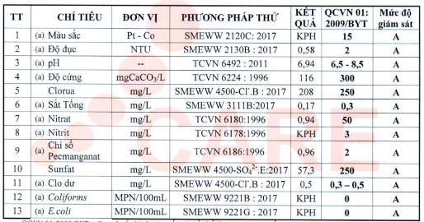
    - Groundwater quality
Currently, the use of tap water in the subproject area has not been popular. Local people often dig wells to take water. The survey shows that groundwater at the depth of 10m can be used for domestic activities.
In order to assess the quality of groundwater, water at three (03) wells that are using by local people have been taken. Sampling sites and analysis results are presented in Table 2-17, 2-18 and 2-19.
Table 2 - 17: Locations of groundwater samples
No. | Code | Location | Coordinates VN2000
 |  |  | X (m) | Y(m)
1 | NN1 | Well water in Binh Thanh | 583065.1506 | 1095842.745
2 | NN2 | Well water in An Thanh | 585817.3622 | 1101717.421
3 | NN3 | Well water in Thanh Phong | 592833.1222 | 1086333.155
Table 2 - 18: Analysis results of groundwater quality
No. | Parameters | Unit | NN1 | NN2 | NN3 | QCVN 09-MT:2015
1 | pH | - | 6.95 | 6.84 | 6.92 | 5.5-8.5
2 | Hardness by CaCO₃ | mgCaCO₃/l | 36.6 | 42.3 | 30.8 | 500
3 | TSS | mg/l | <4 | <4 | <4 | -
4 | Ammonium |  | 0.006 | 0.005 | 0.005 | 1
5 | Chloride |  | 30.5 | 36.4 | 48.2 | 250
6 | Nitrite (NO₂⁻) |  | 0.0064 | 0.0048 | 0.0059 | 1
7 | Nitrate (NO₃⁻) |  | 0.015 | 0.011 | 0.012 | 15
8 | Sunfate |  | 25.4 | 20.6 | 25.9 | 400
9 | Total Nitrogen |  | <0.2 | <0.2 | <0.2 | -
10 | Total P |  | <0.2 | <0.2 | <0.2 | -
11 | Arsenic (As) |  | 0.02 | <0.005 | 0.01 | 0.05
12 | Cadmium (Cd) |  | <0.001 | <0.001 | <0.001 | 0.005
13 | Lead |  | <0.005 | <0.005 | <0.005 | 0.01
14 | Cu |  | <0.006 | <0.006 | <0.006 | 1
15 | Zinc |  | <0.007 | <0.007 | <0.007 | 3
16 | Manganese |  | <0.008 | <0.008 | <0.008 | 0.5
17 | Chromium (VI) |  | <0.009 | <0.009 | <0.009 | 0.05
18 | Fe |  | 0.45 | 0.39 | 0.48 | 5
19 | Cyanide (CN-) |  | <0.005 | <0.005 | <0.005 | 0.01
20 | Coliform | MPN/100mL | 73 | 91 | 18 | 3
Table 2 - 19: Analysis results of pesticide residues in groundwater samples
Residue of organic chlorine group pesticides | Unit | NN1 | NN2 | NN3
Anpha Hexachlorocyclohexane (HCH) | µg/l | ND | ND | ND
Beta HCH |  | ND | ND | ND
Gama HCH |  | ND | ND | ND
Delta HCH |  | ND | ND | ND
Heptachlor |  | ND | ND | ND
Heptachor epoxide |  | ND | ND | ND
Aldrin |  | ND | ND | ND
Endrin |  | ND | ND | ND
Endrin aldehyde |  | ND | ND | ND
4,4' DDT |  | ND | ND | ND
4,4' DDE |  | ND | ND | ND
4,4' DDD |  | ND | ND | ND
Methoxychlor |  | ND | ND | ND
Anpha endosulfan |  | ND | ND | ND
Beta endosulfan |  | ND | ND | ND
Endosulfan sulfate |  | ND | ND | ND
(Source: Institute of Coastal and Offshore Engineering – Vietnam Academy for Water Resources, 2020)
Note:
- ND: Not Detected
Comment: All parameters at the monitoring locations are within the limits allowed by the national technical regulation QCVN 09-MT:2015/BTNM on Groundwater quality.
    - Soil quality
Three (03) soil samples are taken from inside and outside the subproject site. The metal concentration in the soil samples is within the allowable limits of QCVN 03: MT-2015/BTNMT (agricultural land) and QCVN 15:2008/BTNMT on pesticide residues in soil. The pH value ranges from 5 - 6, salinity of 2.14 - 2.45‰, showing that the soil in the subproject area is slightly acidic; not much contaminated with alum or salty (according to the usual calculation, saline soils contain dissolved salt concentration of about 2.56 ‰). In addition, according to the results of the field survey and public consultation, wells in the subproject area with a depth of 15-20m are not salinized, and still used for daily activities.
Sampling sites and analysis results are presented in the tables below:
Table 2 - 20: Locations of soil monitoring
No. | Location | Coordinates VN2000
 |  | X (m) | Y (m)
1 | Paddy fields of An Dien commune | 592533.5628 | 1099809.366
2 | Paddy fields of Thanh Hai commune | 599045.2194 | 1092754.275
3 | Paddy fields of My Huong commune | 582370.5713 | 1103631.507
Table 2 - 21: Analysis results of soil quality
No. | Parameters | Unit | Point 1 | Point 2 | Point 3 | QCVN  03:2008/BTNMT
1 | pH _{(H2O)} | - | 5.62 | 5.14 | 5.03 | -
2 | Salinity | ‰ | 2.24 | 2.45 | 2.14 | -
3 | Pb | mg/kg | 5.26 | 6.32 | 4.05 | 70
4 | Cd | mg/kg | 0.06 | 0.06 | 0.08 | 2
5 | As | mg/kg | 1.52 | 1.86 | 1.94 | 12
6 | Cu | mg/kg | 30.2 | 20.5 | 24.2 | 50
7 | Zn | mg/kg | 115.6 | 118.2 | 112.4 | 200
8 | Cr | mg/kg | 0.03 | 0.05 | 0.06 | -
(Source: Institute of Coastal and Offshore Engineering – Vietnam Academy for Water Resources, 2020)
Table 2 - 22: Analysis results of pesticide residues in soil samples
Residue of organic chlorine group pesticides | Unit | Point1 | Point 2 | Point 3 | QCVN 15:2008  /BTNMT
Anpha Hexachlorocyclohexane (HCH) | µg/l | ND | ND | ND | -
Beta HCH |  | ND | ND | ND | -
Gama HCH |  | ND | ND | ND | -
Delta HCH |  | ND | ND | ND | -
Heptachlor |  | ND | ND | ND | 0.01
Heptachor epoxide |  | ND | ND | ND | -
Aldrin |  | ND | ND | ND | 0.01
Endrin |  | ND | ND | ND | 0.01
Endrin aldehyde |  | ND | 18.90 | ND | -
4,4' DDT |  | ND | ND | ND | 0.01
4,4' DDE |  | ND | ND | ND | -
4,4' DDD |  | ND | ND | ND | -
Methoxychlor |  | 22.1 | 30.5 | 36.9 | -
Anpha endosulfan |  | 20.6 | ND | ND | -
Beta endosulfan |  | ND | ND | ND | -
Endosulfan sulfate |  | ND | ND | ND | -
(Source: Institute of Coastal and Offshore Engineering – Vietnam Academy for Water Resources, 2020)
Note:
- ND: Not Detected
Soil/Sediment quality: is monitored through the analysis parameters including pH, salinity, As, Cd, Cu, Pb, Zn, total chromium, Hg, pesticides. The method of collecting, preserving and analyzing samples is done in accordance with Circular No.33/2011/TT-BTNMT dated 1 August 2011 on technical procedures for soil monitoring. All parameters measured are lower than allowable limits of National Technical Regulations (QCVN 03-MT:2015/BTNMT and QCVN 15:2008/BTNMT, see the attached Appendices for more details). Soil in the subproject areas is eligible to be used for local leveling and embankment construction;
The subproject areas are mainly located in the countryside without industrial activities; therefore, the environmental baselines (surface water, soil and ambient air) are currently not contaminated.
    - Natural/Biological resources
Ben Tre has a coastline of 65km long with 4 estuaries namely: Dai, Ham Luong, Co Chien, and Ba Lai estuaries, spreading over 3 districts of Ba Tri, Binh Dai, and Thanh Phu. Most of them are mudflats with the distinctive characteristics of the mangrove ecosystem (about 800-2000m from the construction sites). Ben Tre is also one of the provinces in the Mekong Delta that co-exist in three ecoregions of fresh, brackish, and saline. Ben Tre is a rich and fertile region with a temperate tropical climate. Over 90% of its total natural area are wetlands that form diverse natural ecosystems and high biological productivity. Biodiversity Resources in Ben Tre province are developed in three typical ecosystems:
- Marine ecosystem.
- Ecosystem of Mangrove - estuary - mudflats.
- Seasonally flooded and inundated freshwater ecosystem.
Although each ecosystem has its values and functions, it all has high reserves and biological productivity, diverse species. It is a place to store abundant genetic resources, and the habitat of many animals – plants that have values in ecology, food, and medicinal herbs, etc.
Therefore, the basic feature of Ben Tre’s economy is the cultivation, exploitation, use, and processing of agro-forestry and fishery products that are exploited from the biodiversity resources of the wetlands and marine.
In Thanh Phu district, there are 185 species of Phytoplankton, in which the Bacillariophyta is the predominant, the remaining groups are Cyanophyta (16 species, 9%), Chlorophyta (14 species, 8%), Pyrrophyta (12 species, 6%) and Eugenophyta (5 species, 3%). The density of Phytoplankton increases in dry seasons and decreases in the rainy season. There are about 93 species of zooplankton, including 57 species of Arthropoda group, 17 species of Protozoa group, 13 species of Nemathelminthes group, 2 species of Mollusca group, 2 species of Annelinda group, 1 species of Echinodermata group, 1 species of Chaetognata group. The density of zooplankton ranges from 49,508-132,875 individuals/m3 in dry seasons and about 40,702-146,108 individuals/m3 in the rainy season. There are 90 species of benthic, including 41 species of Arthropoda group, 23 species of Annelinda group, 23 species of Mollusca group, 2 species of Echinodermata group, 1 species of Sipunculida group.
In the intertidal areas, clam seeds concentrate on the high intertidal area with a common density of 10-20 individuals/m2; Particularly in Cao, Ong Muoi islets, there are about 100-300ha of clam seed with a high density (75-945 individuals/m²). In addition, there are dispersed cockles (Arca granosa) in the mangroves.
Terrestrial ecosystem
Trees and Crops: mainly are Cocos nucifera with several types such as tall coconuts, green xiem coconuts, xiem dwarf coconuts, hybrid coconuts (green and yellow colored), Tam Quan coconuts, etc. There are also a number of fruit specialties such as green-skin grapefruits, “Soan” sweet orange, King oranges, Seedless sweet orange, longan, rambutan, durian, strawberry, cocoa intercropped with coconut. Thanh Phu district also grows paddy fields and sugar cane. In the sand dune area, vegetables and crops are grown. Livestock: mainly chickens, ducks, cows and pigs.
Aquatic ecosystem
To assess the current status of the aquatic ecosystem in the subproject area, 10 samples in Co Chien and Ham Luong rivers were taken, in which, 6 samples (N5 - N10) in Co Chien river and 04 samples (N1 - N4) in Ham Luong river.
Table 2 - 23: Locations of aquatic organisms monitoring
No. | Code | Location | Coordinates VN2000
 |  |  | X (m) | Y(m)
1 | N1 | Area in Ham Luong river | 1115922.363 | 572145.072
2 | N2 | Area in Ham Luong river | 1115536.338 | 572684.141
3 | N3 | Area in Ham Luong river | 1102510.680 | 584626.705
4 | N4 | Area in Ham Luong river | 1102362.479 | 584579.232
5 | N5 | Area in Co Chien river | 1100497.614 | 578181.918
6 | N6 | Area in Co Chien river | 1100878.917 | 578334.914
7 | N7 | Area in Co Chien river | 1101426.789 | 574284.593
8 | N8 | Area in Co Chien river | 1101563.398 | 574380.256
9 | N9 | Area in Co Chien river | 1101781.259 | 573493.483
10 | N10 | Area in Co Chien river | 1101845.174 | 573498.531
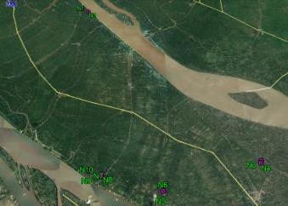
Figure 2 - 3: Locations of monitoring and sampling aquatic organisms
The detailed results are shown in Appendix 3. The analysis results of 10 sampling sites in March 2020 are summarized as follows:
The aquatic organisms in the subproject area are poor with the presence of 91 species. In which, Phytoplankton is predominant with 58 species, followed by Zooplankton with 18 species and finally Zoobenthos with 15 species. The aquatic ecosystem here is characterized by freshwater species mixed with saltwater species that migrate deeply inland and widely distributed. The density of phytoplankton at sampling sites is higher than that of the zooplankton and zoobenthos. It can be seen that the water environment in the subproject area is suitable for the growth and distribution of algae.
The relatively high density of the zoo-phytoplankton species at each sampling site shows that the natural food sources for aquaculture are rich and abundant. The density of zoobenthos is much smaller, concentrating mainly on the Polychaeta group.
The predominant species at the sampling sites are Cyanobacteria (Phytoplankton), Copepoda nauplius larvae (Zooplankton) and Polychaeta (zoobenthos) and there was an imbalanced development in all three groups of organisms.
Thus, the subproject area is just normal natural habitat, not sensitive one.
  - SOCIO-ECONOMIC CONDITIONS
    - Economic profiles
a. Agriculture
The agricultural sector plays a key role in the subproject areas. In the area planned for construction of structural items (embankments and bridges), it can be seen that land is mainly used for agricultural production (paddy growth) and ​​fruit trees (coconut), a small part is occupied for fish ponds and shrimp farms (extensive farming). To adapt to the climate change situation, people in the subproject area currently change to raising tilapia, giant freshwater shrimp in paddy fields or in garden ditches. The total area for raising giant tiger shrimp and white shrimp is about 16,415 hectares, the area for raising giant freshwater shrimp is about 1,550 hectares (of which 439 hectares of specialized farming). The pathogen-contaminated water environment is quite high. The model of crabs intercropping with tiger shrimp farm is quite effective with the yield of 1,550 tons/year; The area for ​​raising fish is 373 ha with an output of about 7,200 tons/year (of which the outputs of specialized farming are 1,500 tons/year). The area for clam farming is 603 ha, reaching 1,838 tons/year.
b. Trade – Services
Currently, the subproject communes have small and medium-sized markets, of which the town markets are quite large. The total number of trading and service establishments in the district is 8,536. The purchase of goods, agricultural products, food, etc., is increasingly developed, ensuring the supply of production and daily needs for local people in a timely manner. The total annual retail of goods, agricultural products, food, etc., is over VND 1,600 billion.
In the first 6 months of 2020, due to the complicated development of Coronavirus (Covid-19) the production and business activities of enterprises face many difficulties. In addition, the domestic and international market demand fell sharply, affecting the consumption of local products.
c. Industry and handicraft
Industry - Construction sector: Freshwater salinization has affected the operations of enterprises in the industrial parks and clusters, particularly: freshwater for workers, water for cleaning plants, water required in the manufacturing stage, especially for some plants with high demands for water use such as beer, food, boilers, fabric dyeing, etc. Due to the impacts of Covid-19 pandemic on the export market, the production and processing of food from coconut and seafood grows slowly; the garment factories (textiles, footwear, and handbags) face many difficulties due to lack of raw materials and decreased export demand. As a result, many businesses have to narrow production scale, reduce the number of workers, even wind up their business or suspend operations.
d. Tourism
Adjacent to the subproject area to the northwest is the most famous orchard village named Cai Mon; the tomb and memorial of Truong Vinh Ky (Cho Lach district), Tuyen Linh pagoda, Dong Khoi (Mo Cay Nam), the ancient house in Dai Dien commune - Thanh Phu, etc. About 20km from the Southeast of the subproject area is Con Bung beach and Thanh Phong - Thanh Hai Ecotourism Area (Thanh Phu district).
In spite of inadequate infrastructure and services, the annual revenue from tourism in the two districts reaches nearly VND 50 billion with approximately 250,000 tourists.
e. Transportation
- Roadways
Connecting with NH60 in Mo Cay town, NH57 toward Northwest - Southeast is the central axis which runs through the subproject area to Thanh Phu district with a total length of 60km. From the central axis of NH57 to Ham Luong river and Co Chien river embankments are the district roads (DR20, DR22, DR23, DR24, DR25) with a total length of 50km, distributed quite evenly from the North to the South. There are about 30km of inter-commune roads and nearly 100km of roads entering the centers of communes.
According to the masterplan on the provincial transportation to 2020, with the vision to 2030, Co Chien river embankment is expected to be the provincial road, thus, the scale and structure of the bridge on the culvert body and the entrance reach HL93. The Ham Luong river embankment is expected to be an inter-commune road, so the scale and structure of the bridge on the culvert body and the entrance shall reach 0.65HL93. Bridges such as Cai Ca, Nha Tho, Ben Luong should have the capacity of 0.5HL93, the scale and structures of bridge-approach roads reach Grade A (road surface 3.5m, roadbed 6.5m).
In general, the road network in the subproject area meets the traffic requirements inside and outside the province. All key roads are made of asphalt concrete, with solid bridges across rivers and canals, especially Co Chien bridge which has opened traffic at the end of 2016 connecting the subproject area with Tra Vinh province.
- Waterways
Waterways in the subproject area managed by the Central Government are Ham Luong river, Co Chien river; Thom - Vam Nuoc Trong river; inland waterways managed by the local government include Cai Quao, Tan Huong, Bang Cung rivers (connecting to Ham Luong river), big Cai Chat, small Cai Chat, Thom rivers (flowing into Co Chien river). These are large rivers and canals that play a very important role in navigation in the subproject area.
    - Social conditions
- Population and distribution
The total population of Thanh Phu district is 127,736 people who will be directly benefited from both structural and non-structural items of the subproject. The population in the subproject area where the structural items are conducted (Binh Thanh, An Thuan, An Quy, An Thanh and Thanh Phong communes) consists of 37,743 people. The population in the subproject area is unevenly distributed in the communes, concentrated in urban areas, along the major roads and canals. The average population density is relatively low, ranging from 131 people/km² (An Dien commune) to 484 people/km² (An Thanh commune).
b. Employment - Income
Nearly 70% of the people in the subproject area live in rural areas. Most of them are engaged in agriculture, animal husbandry, and aquaculture to increase their income. Average income: 30 million VND/person/year; the rate of poor households in rural areas is quite high (14.9%) due to lack of land and capital for production. The rate of trained labor in rural areas is still low, not commensurate with the potentials for the development toward industrialization and modernization.
c. Education
Since 1990, communes in Thanh Phu district have basically completed the anti-illiteracy campaigns. In which, achieved universal primary enrollment, the universal secondary and high school education is on-progress in the whole area with a widely-developed school network. There are at least 1 preschool, 1 junior high school in each commune, and at present, there are 05 high schools in the subproject area.
d. Healthcare
The healthcare system in Thanh Phu district consists of one (1) general hospital; one (1) regional polyclinic; 1 medical office; 1 medical center; 17 healthcare stations in communes and towns; 52 pharmacies, drugstores and dealers. In addition, there are 29 private clinics, 6 traditional medicine treatment clinics in the district, contributing to improving the care and protection of public health. The whole healthcare system has 160 hospital cots, 245 medical staff, including 52 doctors, 1 pharmacist (university degree), 53 doctor assistants, medical technicians, 24 nurses, midwives, 32 pharmacists, pharmacy assistants and 83 practitioners (76 nurses).
Currently, there is 01 medical station with one doctor at each commune, one hospital in each district. Adjacent to the Northwest of the subproject area is Cu Lao Minh Hospital. The index of hospital cots per 10,000 people is 18.5; the number of doctors per 10,000 people is 4.54; basically, meeting the demand for medical examination and treatment for local people.
The most common diseases in the district include arthritis, gastritis, hypertension, degenerative spine, cardiovascular, diabetes, etc. According to statistics of Thach Phu DPC in 2020, Thanh Phu district has the lowest number of HIV/AIDS infected patients (114 infected people - accounting for 4.6%).
e. Social culture
There are community centers, stadiums, libraries and radio stations in the central area of the town; and all communes have radio stations, teams of cheerleading and performance. Up to now, 100% of communes and towns in the 2 districts have been recognized as cultural communes and 90% of households have reached the criteria of a well-functioning family (typical family). In general, the cultural and spiritual life of local people has made many progresses compared to previous years.
For many years, the districts have made efforts to focus on: poverty reduction 3%/year, effective remuneration implementation for the policy households. Striving to 2020, about 50% of communes to be recognized as new rural communes. Many roads, bridges, irrigation canals, schools, healthcare stations, clean water plants have been built all over the communes. Illiteracy eradication programs, vocational loans and job creation have made a significant contribution to reducing poverty; promoting production restructuring for sustainable agricultural development, improving the standard of living for local people.
f. Historical - cultural relics
Historical - cultural relics in the subproject area are structures and places associated with typical historical events in the process of building and defending the homeland such as Ong Nam Hai Mausoleum Relic in Thanh Hai commune of Thanh Phu district (about 5km from Work-item 3). There are also architectural works of typical value of one or more historical periods such as: Huynh Phu ancient house (Huong Liem) and the tomb in Dai Dien commune, Thanh Phu district (about 4km from Work-item 2). However, these relics are about 4-5km away from the construction sites, they will not be affected by the subproject implementation.
g. Use of water
The sources of water within the subproject’s benefit area in general and the construction areas (embankments and bridges) in particular are used for production (agriculture) and daily activities.
- Water for domestic use: most people use water from water supply stations which are brought from towns and centralized water supply stations, some households still use ground water (drilled wells).
- Water for agricultural production is taken from primary, secondary and inland canals (herringbone canal). Water of primary and secondary canals are taken from Ham Luong and Co Chien rivers.
- Freshwater from Mo Cay district (taking at the source), leading through main canals to the subproject area to serve water supply and irrigation.
- The source of surface water in the region is generally quite abundant, meeting the requirements for production if the sluices to prevent salinity and storage freshwater are built.
- Currently, at some ends of the canal, which are planned to be built bridges and embankments, temporary dams have been constructed to prevent saline water and store freshwater for agricultural production. However, dam filling has caused the increase of water pollution, due to the stagnation, accumulation of wastes from production and domestic activities.
- In summary, to meet the needs of exploiting and using water sources for domestic activities, protecting environmental resources, minimizing pollution, improving the quality of life, Sluices to prevent saline water and store freshwater are required.
h. Water drainage
In recent years, the impact of climate change – water rise and decreased upstream water sources has led to an increase in saline intrusion. Particularly, within the period of 2015 - 2016 and 2019 –2020, Ben Tre province and its coastal areas are significantly affected by saline intrusion and so do the subproject areas.
Therefore, dams at a number of canal ends connecting to Ham Luong and Co Chien rivers have been built to prevent saline water, tides and to store freshwater for agricultural production.
Although the construction of temporary dams brings efficiency in preventing saline water, storing fresh water, the negative issue occurring is that the in-field water sources, wastewater from production and living activities cannot be drained or slowly drained, not meeting the requirements.
The locations where the sluices are to be built, are strongly polluted, especially the canals near the temporary dams because the water source cannot be drained. Water in these locations is polluted by production and domestic wastes of the local people.
    - Current state of land use and management
The water flow has been cleared and the embankment has been filled temporarily in Bang Cung river section passing An Thanh commune. The embankment will run through a number of shrimp farms of local people in An Quy commune. Co Chien river embankment was built in 2007 and structured with sand and soil in 4-6m wide, the embankment elevation is +2.30 ÷ 2.60 (m). The embankment is located along Co Chien river and 100 ÷ 200 m from the edge of the river banks with the previous clearance range of 9m wide. Khau Bang sea dike was built by filling soil. The actual construction sites of Bang Cung, Co Chien and Khau Bang rivers are shown in the Figure 2-4, 2-5 and 2-6 below:
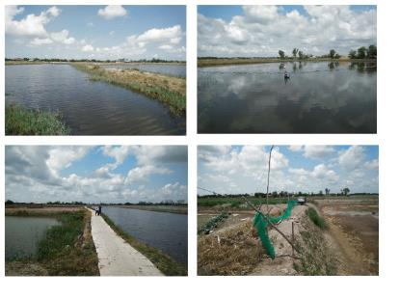
Figure 2 - 4: Current station of Bang Cung river embankment 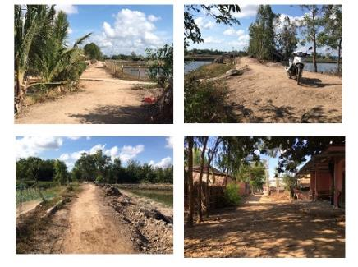
Figure 2 - 5: Current state of Co Chien river embankment
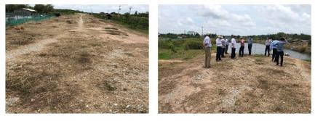
Figure 2 - 6: Site photos
Land use for non-structural items
Afforestation is planned to be implemented in An Dien commune of Thanh Phu district, Ben Tre province. It borders Bang Cung river to the East, C3 bridge canal to the West, Ham Luong river to the North and Ca Cat canal to the South.
- Location boundary is shown in the figure below:
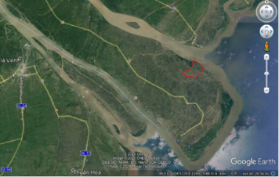
Figure 2 - 7: Land for afforestation in An Dien commune of Thanh Phu district
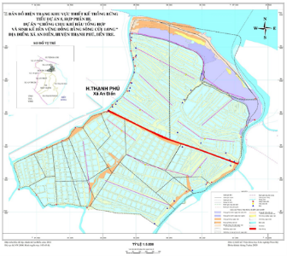
Figure 2 - 8: Location for Rhizophora apiculate planting
Table 2 - 24: Current land use
No. | Current survey | Area (ha) | Designable area for afforestation (ha)
I | Extensive shrimp farm | 287.09 | 281.10
1 | Banks of extensive shrimp farm | 104.79 | 104.79
2 | Embankment of extensive shrimp farm | 16.99 | 16.99
3 | Area of surface water in extensive shrimp farm | 159.31 | 159.31
4 | Primary forest on saline wetland | 2.80
5 | Poor secondary forest on saline wetland | 3.20
II | Industrial shrimp farms | 276.47 | 239.93
1 | Banks of the industrial shrimp farming | 82.37 | 82.37
3 | Area of surface water in the industrial shrimp farms | 157.57 | 157.57
4 | Canals in the industrial shrimp farms | 19.43
5 | Primary forest on saline wetland | 17.10
III | Protective forest | 46.84
 | TOTAL | 610.40 | 521.03
The land use for afforestation is mainly unused shrimp farms, of which afforestation will be conducted with an area of 521.03 ha. It is proposed to use an area of 216.33ha from the road to the estuary as follows:
Table 2 - 25: Summary of land for afforestation
No. | Work-items | Area | Percentage | Note
 | Zone 1 – Extensive shrimp farm | HA | %
1 | Banks of extensive shrimp farm | 76.55 | 35.40 | Designed for afforestation
2 | Area of surface water | 130.96 | 60.57 | Designed for afforestation
3 | Inner embankment | 7.37 | 3.41 | Not for afforestation
4 | Sonneratia caseolaris, Nypa fruticans, Avicennia marina regenerated | 1.35 | 0.62 | Not for afforestation
 | TỔNG | 216.23 | 100.00

    - Status of soil supply areas for Bang Cung river embankment
Embankment soil will be taken from soil strips along the route, 120 - 390m from the route centerline. The average excavation depth is from 1 - 1.2m and the average excavation width is 20-25m. The total volume of excavation is 25,000m3. The current status of the soil supply areas is shown in the Table below.
Table 2 - 26: Current state of the soil supply areas
No. | Station |  | Photos | Description
1 | K3+250 – K3+450 | 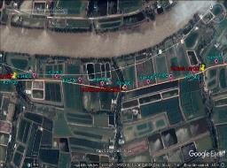 | 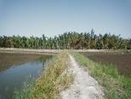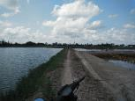 | Current status: Land for aquaculture, mainly shrimp farming, no structures on the route; weeds and nypa fruticans are predominant.
2 | K3+600-K4+340
3 | K4+550-K4+900 | 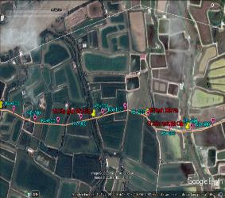 | 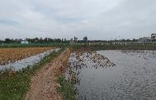  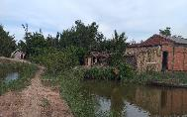 | Current status: paddy field intercropped with shrimp farming, no structures on the route. There are a few households living along the left side along the alignment.
4 | K5+260-K5+900
5 | K6+165-K6+450 | 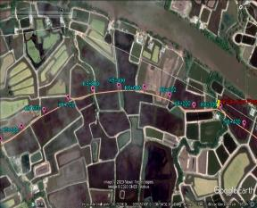 | 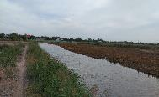 | Current status: paddy field intercropped with shrimp farming, no structures on the route. There are a few households living along the left side along the alignment.
9 | K6+580-K6+700 |  | 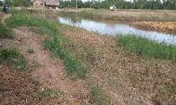 | Current status: land for aquaculture, mainly shrimp farming, no major structures on the route, there are some huts of shrimp farmers.

    - Status of expected disposal sites
The expected disposal sites in the subproject areas are shown in the Table below:
Table 2 - 27: Location of expected disposal sites
Work-items | Location
(i) Co Chien river embankment
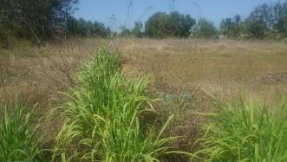  Landfill 1: the playground planned for the kindergarten – An Thuan commune  Status: uncultivated land, dominated by weeds, shrubs, no timber trees; located next to the DR.27, about 300m from the nearest residents’ houses, surrounded by infertile agricultural land. | 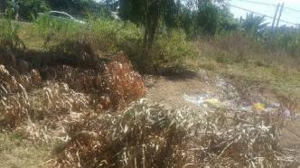  Landfill 2: Land planned for An Khuong community center  Status: uncultivated land, located next to the DR27, planned for the construction of An Khuong Community Center; surrounded by unused agricultural land.
(ii) Bang Cung river embankment
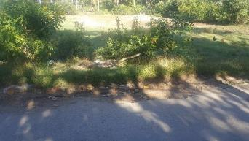  Landfill 3: Land planned for headquarter of An Qui CPC  Status: uncultivated land plot, located behind Ai Qui CPC, mainly shrubs. This land plot is planned for the construction of CPC’s headquarter. | 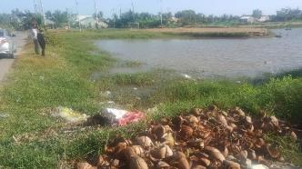  Landfill 4: Land in An Binh hamlet of An Qui commune  Status: Lowllying land along the inter-commune road, inundated in the rainy season, surrounded by agricultural land.
(iii) Consolidation of Khau Bang sea dike
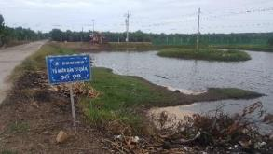 | 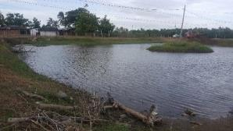
Land planned for the construction of Thanh Loc hamlet’s community center, Thanh Phong commune
Current status: Lowllying land along the inter-village road, inundated in the rainy season, surrounded by inter-village roads and agricultural land.

    - Description of sensitive receptors
Table 2 - 28: Sensitive receptors in the subproject area
No. | Sensitive receptor | Characteristics
I. Work-items
- Co Chien river Embankment
1 | Khung An Ninh Primary School of An Thuan commune  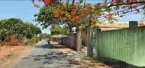 | - Location: Located on the road to the landfill, An Ninh hamlet, An Thuan commune  - Distance to the subproject area: about 1000 m, near the transportation route about 3 - 5 m;  - Number of classes/students: 10 classrooms, 200 pupils;  - Working time: 5 days/ week; 7h - 11h and 13h30 - 17h.
2 | An Ninh A market (An Thuan commune)  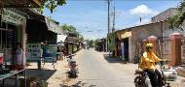 | - Location: on the road to the disposal site (300m from the starting point of river embankment);  - Distance to the subproject area: About 1.5 - 3m;  - Working time: 7 days/week. 5h - 11h and 15h - 18h.
3 | Shrimp farms of people in Thach Tan hamlet, Binh Thanh communes  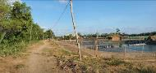 | - Location: near the on-progress embankment (400m from the starting point of the embankment);  - Distance to subproject area: about 3 - 5 m;
- Bang Cung River Embankment
1 | Ben Vinh market  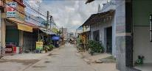 | - Location: near the starting point of Bang Cung River embankment about 30m;  - Distance to subproject area: about 20 - 30m  - Working time: 7 days/week; 5h - 11h and 15h - 18h.
2 | An Thanh Ferry Boat  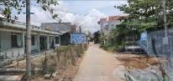 | - Location: on the Bang Cung river embankments;  - Distance to subproject area: About 1.5 - 3 m;  - Function: Serve for more than 1,000 people of An Thanh commune and surrounding areas;  - Working time: 7 days/week; 7h - 11h and 13h30 - 17h.
3 | An Thanh CPC  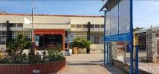 | - Location: on the transportation route to the disposal site;  - Distance to subproject area: About 5 - 10m;  - Working time: 5 days/week; 7h - 11h and 13h - 17h.
 | 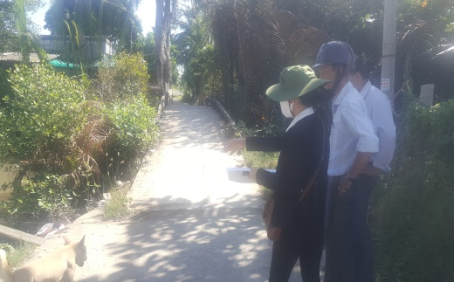  Bridges on Bang Cung river embankment | - Location: the upgraded bridges are located on the Bang Cung river embankment
 | An Thanh communal house  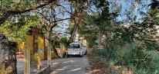 | - Location: located opposite the disposal site of An Thanh hamlet, An Thanh commune;  - Distance to the construction sites: about 5-15m;  - Function: for Buddhism beliefs in An Thanh commune;  - Operating time: An Thanh Communal House’s festival is usually held twice per year (mid-year and year end in the lunar calendar).
(iii) Consolidation of sea dike route
1 | Shrimp farms of people in Thanh Loc hamlet, Thanh Phong commune  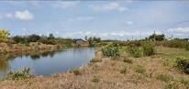 | - Location: near the on-progress dike route (about 400m far from the beginning of the embankment);  - Distance to subproject area: About 10 - 20m;  - Function: Production activities that generate main income for people in Thanh Loc hamlet;  - Working time: 7 days/week.

  - AQUACULTURE PRACTICES
In agriculture and aquaculture, a range of environmental issues has been arisen due to the use of chemicals. The biggest issue is the indiscriminate use of antibiotics to control or prevent disease, especially the use of antibiotics that affect human health, such as chloramphenicol.
In recent years, a number of bacterial and viral diseases have hindered the shrimp farming. A great number of antibiotics and other drugs have been used to reduce shrimp mortality. Some of them are discharged into the environment and absorbed by other organisms. It has been estimated that about 70-80% of the end-use antibiotics will release the same environment as leftovers and feces (Greenpeace 1995, extracted from Clay 1996). Three main environmental problems in relation to the antibiotic use are as follows:
The increase in antibiotic resistance (more danger) of pathogens as a result of improper or continuous use of antibiotics, and it may persist in sediments.
Infiltration of the antibiotic into fish and other natural organisms in the vicinity of the farms.
Antibiotics destroy the bacteria naturally present in sediments, and affect the composition and structure of the microbial ecology of benthic environments.
Chemical and drug abuse often occurs because the costs of damage caused by the disease are very high compared to the costs of treatment. Furthermore, when instructing to use a certain dose, manufacturers sometimes assume that doubling the dose will double the effect of the drug, so they recommend overdosing. Hence a lack of training and knowledge can lead to poor production rates, or even disaster.
The effects of most chemicals used in shrimp farming depend on quantity used, duration of illumination, and dilution. Even if a non-toxic compound with moderate amounts in an environment with good dilution properties, it can have a serious impact if large quantities are released in coastal environments with poor water exchange capacity.
Formalin (40% of formaldehyde) is widely used to kill fungi, viruses, bacteria and ectoparasites in shrimp culture. Formaldehyde has a half-life of 36 hours. Together with sodium hydroxide (NaOH), formalin exists in nature and has no significant impact on the environment (Tobiesen & Braaten 1995). The effects of chemicals on humans should also be taken into account (GESAMP 1997).
For example, organophosphates and malachite green are respiratory enzyme toxins. Rotenone can cause respiratory paralysis. Ingestion of chloramphenicol can cause aplastic anemia. Formalin can cause cancer and severe allergic reactions in humans through long-term exposure. Although some of the chemicals most frequently used in shrimp farming are only moderately toxic, they can have a serious impact on the environment and people working on shrimp farms, depending on the using value, dilution, repeated and preventive measures.
Many of the chemicals used in shrimp culture (e.g., formalin, furazolidone, dichlorvos) are non-persistent in the environment, with a half-life of 36 to 200 hours. On the other hand, Oxytetracycline, oxalinic acid and flumequine persist relatively long and can be found in pond sediments six months or more after treatment.
Organisms in the environment can be highly sensitive to some of the chemicals used in aquaculture, especially chemicals combating ectoparasites. In fact, the use of chemicals in shrimp farming is less common than that in fish farming. Other organisms can directly absorb substances in the environment. Mollusks, for example, may absorb chemotherapeutants, especially in case of polyculture, then it may pose a danger to those who eat them, although there is little evidence about it.
Consumers have widespread concerns related to chemical residues in aquaculture products. Most shrimp destined for export are currently tested for antibiotics and other substances. However, aquacultural products sold on the domestic market are not subject to such testing, so strict regulations need to be set.

ASSESSMENT ON ENVIRONMENTAL AND SOCIAL IMPACTS

The main work-items of the subproject include (i) additional construction and solidification of sea dike from Khau Bang canal connecting cross road of Con Dai bridge with the length of 2266m, (ii) construction of 9699m embankment and rural transport road, (iii) newly planting and supplementation of 150 ha of mangroves, and (iv) investment in a network of clean water supply to 7400 households in 13 communes and 1 town. When implementing the subproject, there will be positive and negative impacts and social environment risks which will be assessed below.

POSITIVE IMPACTS
The works put into operation will create positive impacts on the environment, including prevention of flood and muddiness, easier traffic to travel throughout the subproject area;
+ The dikes will contribute to the development of the rural transport infrastructure system, positively affecting the subproject area’s economic exchange with other regions inside and outside of the province;
This chapter will focus on assessing and forecasting the impacts of each work-item of the subproject including ring dikes, sea dikes and bridges in the construction preparation, construction and operation phases of the subproject. This chapter will also outline the impacts of the non-structural work-item.

CLASSIFICATION OF NEGATIVE IMPACTS AND RISKS
There will be potential negative impacts and risks in the pre-construction, construction and operation phases of the subproject. By analyzing baseline data, surveying sites, and consulting with the stakeholders, we identify and classify the subproject's potential negative environmental and social impacts as follows:
Large impact (L)
- Significant changes over a large area will affect the nature and features of landscape which could last for more than 2 years.
- Impacts that exceed specified standards or long-term widespread impacts.
- Change of ecosystem or operations over a large area, causing moderate losses (lasting for over 2 years), however, it can be recovered within 10 years;
- Impacts on human-being health.
- Potential financial damage to users or the community;
- Significant risk of environmental and social impacts which can only be controlled and minimized where mitigation measures are applied if appropriate.
Medium impact (M)
- Remarkable change which does not last over 2 years or significant change from 6 months to 2 years, on a large scale to important components or nature and landscape composition.
- Change to the ecosystem or activities on a local scale and in a short time, with good resiliency. The magnitude of the impact is similar to present changes but can generate cumulative effects.
- (Uncertain) impacts to human-being health which may interfere with some users;
- Moderate, local and temporary impacts which mitigation measures should be applied.
Minor impact (N)
- Significant change of less than 2 years or a significant change of less than 6 months.
- The changes occurred within current variation range, permitted standards and its impact can be completely controlled.
- May interfere with operations but no impacts on users or the community;
- Small, local and temporary impacts which can be ignored.
No impact (K)
- Any change which is insignificant, negligible or no change that cannot be predicted
- Unrecognizable or measurable change due to basic activities;
- No mutual effect causing no change.

        - CATEGORY OF CONSTRUCTION WORKS
  - ASSESSMENT OF COMFORMITY OF THE SUBPROJECT'S LOCATION WITH ITS NATURAL AND SOCIO-ECONOMIC CONDITIONS
When the subproject "Infrastructure to Improve Livelihoods in Northern Thanh Phu Area to Adapt to Climate Change" will contribute to upgrading the transport network in the region, promoting economic development and improving living standards of the local people. On the other hand, the upgraded dike system will help to mitigate the impacts of climate change, sea level rise, natural disasters, to recover and improve the efficiency of agricultural production in the current context of the province.
The construction and locations of 20 bridges, 2 river dikes (Bang Cung and Co Chien rivers) and 1 reinforced sea dike are selected to ensure a certain distance from the riverbank to avoid annual landslides; and the flow through the construction sites is arranged to mitigate and minimize the erosion and site clearance, relocation, disturbance of local people’s life and economy as well as to increase investment costs. At the same time, the construction of works is also in line with the local traffic planning.
Review and comments:
The construction location of the subproject: "Infrastructure to Improve Livelihoods in Northern Thanh Phu Area to Adapt to Climate Change" is in line with the natural conditions and the current state of the irrigation and drainage system in the region. After completing, the subproject's items will bring positive effects, basically respond and overcome problems of natural disasters, ensuring stability and socio-economic development in the subproject area.
  - ASSESSMENT OF THE IMPACTS IN PRE-CONSTRUCTION PHASE

3.2.1 Land acquisition
The construction of the subproject works also temporarily affects public land in 05 communes. The total area of ​​temporarily affected land is estimated at 3,000m². The temporarily affected land area is currently managed by the CPCs in the subproject area and there are no crops or structures on this land.
The total permanently acquired land area for the subproject implementation is 56,372 m². In which, the area of ​​affected paddy land is 51,812 m² and the area of affected aquaculture land is 4,560 m².
The implementation of the work-items will affect 170 households. In which, (i) 53 AHs are affected with paddy land, (ii) 06 AHs are affected with aquaculture land, (iii) 170 AHs are affected with crops; no household is affected with structures and no household must be relocated and resettled. There is no commune which is permanently affected on public land. 100% of the affected households are all slightly affected. The number of affected households in each work-item is presented in the following tables:
Table 3 - 1: Total impact level of permanent land acquisition of the subproject
No. | Work-items | Locations (communes/wards) | Unit | Paddy Land | Aquaculture land | Total
1 | Work-item 1 | An Thuan | m² | 0 | 0 | 0
 |  | Binh Thanh | m² | 0 | 0 | 0
2 | Work-item 2 | An Qui | m² | 45,214 | 0 | 45.214
 |  | An Thanh | m² | 0 | 0 | 0
3 | Work-item 3 | Thanh Phong | m² | 6,598 | 4,560 | 11,158
4 | Work-item 4 | 15 communes | m² | 0 | 0 | 0
Total |  |  | m² | 51.812 | 4,560 | 56,372
Table 3 - 2: Number of households affected by the subproject
No. | Work-items | Locations (communes/wards) | Total number of affected households | Number of households with affected paddy land | Number of households with affected land for aquaculture | Number of households with affected crops
1 | Work-item 1 | An Thuan | 38 | 0 | 0 | 38
 |  | Binh Thanh | 56 | 0 | 0 | 56
2 | Work-item 2 | An Qui | 48 | 48 | 0 | 48
 |  | An Thanh | 15 | 0 | 0 | 15
3 | Work-item 3 | Thanh Phong | 13 | 5 | 6 | 13
4 | Work-item 4 | 15 communes | 0 | 0 | 0 | 0
Total |  |  | 170 | 53 | 6 | 170
Source: RAP, August 2020
Note: Certain households may experience multiple types of land impacts.
Although this impact will last long and take place in the area of ​​05/18 subproject communes/town, it is assessed as "MEDIUM" for the following reasons:
- The number of affected households accounts for only 0.13% of the total number of households in 18 communes/town (170 affected households compared with nearly 127,736 households in 18 communes/town).
- Households with affected agricultural land will also be influenced in terms of livelihoods and agricultural production disruption. However, this impact level is assessed as negligible because most households with affected agricultural land still have enough land to grow rice and crops (vegetables, beans, maize, potatoes, cassava, etc.) and fruit trees. Moreover, in recent years, the income from agriculture in the household income structure tends to decrease.
- The number of households with affected aquaculture land is 6 households, accounting for 3.5% of the total number of affected households. The impacts for these households are assessed to be low because their aquaculture land is insignificantly partly affected.
Techniques, construction methods, local factors, consultation with local authorities and communities have been reviewed in details for the next stages to reduce the number of households who will be affected by the work-items. At the same time, affected households will be compensated for land, trees, structures... and other subsidies (such as resettlement allowance, livelihood restoration allowance, job change, etc.) according to the subproject resettlement action plan.

3.2.2 Risks of mines and explosives (UXO)
Bombs, mines, explosive materials from the wars are still found in many areas of Vietnam. The impacts from unexploded ordnance are significantly negative, becoming high risk to health, life, and infrastructure if mitigation measures are not taken. The items of solidification of the sea dike surface and the clean water supply network are constructed on the existing roadbed so there is no need to clear bombs, mines, explosives again because it had been done before the road was constructed. Meanwhile, 02 other items of the embankment and 20 bridges will need to be cleared of bombs, mines and explosives. The Subproject Owner will contract with a functional agency to conduct the UXO clearance and to issue a mine security certification prior to the construction.
  - ASSESSMENT AND FORECAST OF IMPACTS IN CONSTRUCTION

3.3.1 Waste-related impact assessment
- Impact on air quality
Dust
Dust generated during construction activities includes (i) earthwork construction, leveling, (ii) material transportation and disposal. The generation of dust will affect the air environment, workers on site and people around the subproject areas in a short time.
- Dust from material transportation and disposal
During the transportation of raw materials and dumping, dust will be generated by construction materials and means of transport, loading and unloading of materials and waste. Dust is mainly generated from road vehicles (cars and trucks) and transporting materials. However, the amount of dust generated by the transportation of materials and wastes is limited because: (i) construction materials (sand, stone, cement, ...) are purchased locally and in neighboring provinces; (ii) transporting materials mainly by waterways; (iii) the amount of waste from the excavation process is not big due to being reused for backfill; and (iv) the transporting material and waste is intermittent. Therefore this impact is assessed as minor and controllable.
- Dust from earthwork
The amount of dust generated from excavation and embankment for the construction of dikes, embankments, foundation pits, piers, abutments, water pipes ... depends on the composition of excavated soil, humidity and weather conditions. According to the calculation, the total volume of excavation for the work-items is about 71,565m³, of which the amount of land reused for filling is 64,408m³. With the total demand for embankment is 107,976m³, the amount of unfillled soil is 43,568m³. The land resource will be exploited according to construction method or additional sand filling. Any excess soil that cannot be used to build the dike will be disposed.
The time for excavation and backfilling during the leveling process is expected to be 90 days x 8 hours/day; Affected area around the leveling area is assumed for 3 times of the subproject area, thus the affected area is 9 times of the subproject area and the dispersion height is 10m. The space of the area affected by dust is 9 x 19,064.5 m² x 10m. Dust emission factor according to WHO Rapid Assessment Document is as follows:
Table 3 - 3: Dust emission factor from construction
No. | Source of pollution | Emission factor
1 | Dust from the excavation, embankment is swept up by the wind (dust and sand) | 1 ÷ 100g/m³
2 | Dust from the process of loading and unloading construction materials (soil, stone, sand, etc.) | 0.1 ÷ 1g/m³
3 | Dust generated from fallen sand and soil during transportation | 0.1 ÷ 1g/m³
Source: WHO Quick Review, 1993
The max dust load generated from the leveling process is as follows:
Cmax (excavation, backfill) = (Volume of excavation + volume of embankment) m³ x 100g/m³/(9 x 19,064.5 x 10m x 90 days x 8 hours).
Thereby, it is possible to temporarily calculate the emissions for each item as follows:
Table 3 - 4: The amount of dust emissions scattered by excavation and backfilling for each work-item
No. | Work-items | Dust emission | QCVN05:2013/BTNMT
 |  | mg/m³
I | Dikes
1 | Cover bank of Co Chien river | 0.009622 | 0.3
2 | Cover bank of Bang Cung river | 0.017308 | 0.3
3 | Reinforcement of sea dike surface | 0.005225 | 0.3
II | Bridges
1 | Ben Giang canal bridge | 0.032666 | 0.3
2 | Kenh Dat canal bridge | 0.100727 | 0.3
3 | Cong Da canal bridge | 0.100216 | 0.3
4 | Women canal bridge | 0.041834 | 0.3
5 | Chach Giuot canal bridge | 0.142208 | 0.3
6 | Church canal bridge | 0.082019 | 0.3
7 | Ong Hung canal bridge | 0.054653 | 0.3
8 | Ro canal bridge | 0.079317 | 0.3
9 | Ong Phuong Bridge | 0.072946 | 0.3
10 | Ba Pho canal bridge | 0.0363 | 0.3
11 | Lai Cui canal bridge | 0.053895 | 0.3
12 | An Quy canal bridge | 0.053874 | 0.3
13 | Rach Nha Bridge | 0.039023 | 0.3
14 | Ong Nhom canal bridge | 0.263755 | 0.3
15 | Rach Ret canal bridge | 0.030844 | 0.3
16 | Ba Can canal bridge | 0.062143 | 0.3
17 | Big Giao Phay bridge | 0.054065 | 0.3
18 | Small Giao Phay bridge | 0.081999 | 0.3
19 | Ben Gia DH 28 canal bridge | 0.016855 | 0.3
20 | Ben Gia canal bridge | 0.044166 | 0.3
III | Water pipelines
 | Water pipeline system | 0.00154 | 0.3
According to calculation results, the amount of dust emission of each construction item in the construction period is relatively low, much lower than the Regulation on dust emission. At the construction sites, the population density is low, mainly along the dike that does not affect the people in the area. The construction sites have a relatively small population density as these areas are located close to the dike. The main construction sites are agricultural production land, fruit trees (coconut) and aquaculture land.
Thus, (i) dust concentration generated from earthwork is much lower than QCVN 05:2013/BTNMT. The concentration of dust generated from leveling activities is the lowest in the construction of the water supply network, only 1/195 of the permitted content according to QCVN 05:2013/BTNMT and the highest is at the construction sites of Ong Nom canal bridge, equal to 0.9 allowed concentration. In general, the dust impacts generated from these activities on the subproject areas are very small, locally, directly affecting machine operators at the construction sites (7-10 people in each area). The impact time is not long lasting (about 3 months per each work-item, the calculated amount of dust emissions is small and can be mitigated by appropriate measures.
(ii) Concentration of dust generated from the transportation of materials and wastes is negligible due to intermittent events during the construction period (for 12 - 18 months and at most construction sites, the nearest residential area from the sites 30m, while construction materials are mainly transported by waterways. The people in An Ninh hamlet market, An Thuan commune and the boat route across An Thanh, the health center of An Thanh commune on the transportation road to Co Chien embankment dump are those mostly affected by dust from the transportation. The scale of the subproject is small and scattered, the construction area is clear, so the impact level is low and can be mitigated.
- Emissions
Emissions from the operation of transport trucks and machines on the sites:
Operation of vehicles and machines during the leveling and construction of the work-items (dikes, bridges, water supply network) will release into the environment an amount of exhaust fumes containing pollutants such as dust air, CO, SOx, NOx that affect the environmental quality. Due to the similar nature, scale and work-items, it requires to calculate emissions generated from the testing equipment that will represent the construction items of the dike and Kenh Dat Do bridge; the remaining items will also generate similar emissions.
Depending on the capacity, the air pollutant load can be calculated based on the following pollution load factors of the World Health Organization (WHO).
Table 3 - 5: Air pollution emission coefficient of diesel engine
Pollutant | Dust | SO2 | NO2 | CO | VOC
Factor (kg/ton) | 0.71 | 20 x S | 9.62 | 2.19 | 0.791
Source: World Health Organization WHO, 1993
Note: S is the sulfur content in DO oil, S = 0.05%.
According to the fuel-consumption norm of construction vehicles (Decision No.1134/QD-BXD dated October 8, 2015 of the Ministry of Construction on the announcement of the norm of waste for determining the price of constructional machine shift and construction equipment) and estimation of vehicles, machinery and equipment in the construction phase of the subproject, the generated emission loads are calculated and presented in Table 3-6 as follows:

Table 3 - 6: The loads of pollutants from construction vehicles
No. | Vehicles | Qty | Quota  (liter DO/shift) | Pollutant loads (kg/shift)
 |  |  |  | Dust | SO2 | NO2 | CO | VOCs
I | Leveling
1 | 108CV bulldozer | 02 | 46.2 | 0.06 | 0.08 | 0.77 | 0.18 | 0.06
2 | 9T compactor | 02 | 19.2 | 0.02 | 0.04 | 0.32 | 0.08 | 0.02
3 | 8T truck | 04 | 37.8 | 0.05 | 0.07 | 0.63 | 0.14 | 0.05
 | Sum I | 08 | 103.2 | 0.17 | 0.25 | 2.36 | 0.55 | 0.18
II | Construction of each dike item
1 | Rope bucket digger1.2m³ | 01 | 70.2 | 0.04 | 0.06 | 0.59 | 0.13 | 0.05
2 | 250T barges + 25T cranes | 02 | 81.0 | 0.10 | 0.14 | 1.35 | 0.31 | 0.11
3 | Reverse bucket excavator with long lever | 01 | 56.7 | 0.04 | 0.05 | 0.47 | 0.12 | 0.04
4 | 0.8m³ reverse bucket excavator | 01 | 64.8 | 0.04 | 0.06 | 0.54 | 0.12 | 0.04
5 | Vibrating plate compactors | 02 | 19.2 | 0.02 | 0.03 | 0.32 | 0.07 | 0.03
6 | Electric vibrator | 02 | 25.9 | 0.03 | 0.05 | 0.43 | 0.10 | 0.04
7 | 8T truck | 02 | 37.8 | 0.05 | 0.07 | 0.63 | 0.14 | 0.05
 | Sum II | 15 | 355.6 | 0.32 | 0.46 | 4.33 | 0.99 | 0.36
III | Construction of each bridge item
1 | 250T barges + 25T cranes | 02 | 81.0 | 0.10 | 0.14 | 1.35 | 0.31 | 0.11
2 | Reverse bucket excavator with long lever | 01 | 56.7 | 0.04 | 0.05 | 0.47 | 0.12 | 0.04
3 | 0.8m³ reverse bucket excavator | 01 | 64.8 | 0.04 | 0.06 | 0.54 | 0.12 | 0.04
4 | Pile driving hammer 1.8 - 2.5T | 01 | 46.7 | 0.03 | 0.04 | 0.39 | 0.09 | 0.03
5 | 9T compactor | 01 | 38.6 | 0.02 | 0.03 | 0.31 | 0.07 | 0.03
6 | Vibrating plate compactors | 02 | 19.2 | 0.02 | 0.03 | 0.32 | 0.07 | 0.03
7 | Electric vibrator | 02 | 25.9 | 0.03 | 0.05 | 0.43 | 0.10 | 0.04
8 | Water pump with capacity of 30m³/h | 01 | 5.1 | 0.004 | 0.004 | 0.04 | 0.01 | 0.003
9 | 8T truck | 02 | 37.8 | 0.05 | 0.07 | 0.63 | 0.14 | 0.05
 | Sum III | 13 | 375.8 | 0.334 | 0.474 | 4.48 | 1.03 | 0.373
IV | Construction of each section of water supply system
1 | Kobe excavator | 01 | 56.7 | 0.04 | 0.05 | 0.47 | 0.12 | 0.04
 | Sum IV | 01 | 56.7 | 0.04 | 0.05 | 0.47 | 0.12 | 0.04
Tables 3-8 shows the pollutant loads for each activity. For example: the leveling generates a dust pollution load of 0.13 kg/shift and respectively consuming 103.2 kg DO/shift emitting 2,332.3 m³ of exhaust gas/shift. So, the discharged pollutant concentration is: (0.13 * 106)/2,332.3= 55.74 mg/m³. Other pollutants will be similarly calculated.
The emission concentration of construction machinery and equipment is shown in Table 3-7:

Table 3 - 7: The emission concentration of means of construction and machinery
No. | Pollutants | Concentration calculated under actual conditions (mg/m3) | Concentration calculated under standard conditions (mg/Nm3) | QCVN 19:2009/BTNMT  – column B (mg/Nm³)
I | Leveling
1 | Dust | 55.74 | 57.63 | 240
2 | SO2 | 81.46 | 84.23 | 600
3 | NOx | 737.47 | 762.54 | 1,020
4 | CO | 171.50 | 177.34 | 1.200
5 | VOCs | 55.74 | 57.63 | -
II | Construction of each dike route
1 | Dust | 39.82 | 41.17 | 240
2 | SO2 | 57.24 | 59.18 | 600
3 | NOx | 538.79 | 557.10 | 1,020
4 | CO | 123.19 | 127.37 | 1,200
5 | VOCs | 44.79 | 46.32 | -
III | Construction of each bridge
1 | Dust | 39.32 | 40.66 | 240
2 | SO2 | 55.81 | 57.71 | 600
3 | NOx | 527.49 | 545.42 | 1,020
4 | CO | 121.27 | 125.40 | 1,200
5 | VOCs | 43.92 | 45.41 | -
IV | Construction of each section of water supply system
1 | Dust | 6.33 | 7.02 | 240
2 | SO2 | 9.1 | 9.41 | 600
3 | NOx | 85.67 | 88.58 | 1,020
4 | CO | 19.59 | 20.25 | 1,200
5 | VOCs | 7.12 | 7.36 | -
The calculations in the table above show that the concentrations of dust, CO, SO2 and NOx present in the exhaust emissions of construction vehicles, machinery and equipment (from the leveling process, the construction process of each grade of embankment and of each bridge item, sections of the water supply system) are all lower than the limits of the permissible standard (QCVN 19: 2009/BTNMT - Column B). In addition, construction facilities, machinery and equipment can be used neither at the same time nor the same location, so the exhaust emissions generated from the construction process is easy to reduced. However, the Subproject Owner will apply solutions to control construction vehicles, machinery and equipment to mitigate the impact of exhaust emissions on the ambient air quality.
Exhaust fumes during welding:
The construction of the bridge items will involve welding. The chemicals in welding rods will generate smoke containing harmful substances, polluting the environment and affecting the health of workers. Electric welding will generate extremely strong light and cause serious injury to workers' eyes. In addition, toxic fumes from welding may cause serious chronic diseases, even with high concentrations in case of long-term exposure and victims can be acute poison.
Table 3 - 8: Loads of pollutants during welding
Pollutants | Diameter of welding rod (mm)
 | 2.5 | 3.25 | 4 | 5 | 6
Welding fumes (containing other contaminants) (mg/rod) | 285 | 508 | 706 | 1,100 | 1,578
CO (mg/rod) | 10 | 15 | 25 | 35 | 50
NOx (mg/rod) | 12 | 20 | 30 | 45 | 70
Source: Pham Ngoc Dang, 2004
The amount of welding rods used is estimated at 25kg. With the assumption of using welding rods with the average diameter of 4 mm and 25 rods/kg, the load of toxic gases generated from the welding stage during construction is as follows:
Welding fumes: 0.441 kg
CO: 0.016 kg
NOx: 0.019 kg
The pollutant loads from this activity during the bridge construction phase last about 180 days and the pollution concentration is dispersed. Furthermore, the impacts take place intermittently and locally at the construction sites. The residential areas are located away from the construction sites (about 30m) and the effects caused by welding will only affect some workers directly involved in welding. Therefore, the welding effects are assessed as LOW and can be mitigated through adequate labor protection for workers.
- Impact on water quality
- Domestic wastewater
The source of wastewater generated during the construction of work-items is mainly domestic wastewater from construction workers on site. Manpower involved in the construction for a dike route is 20 persons (with 02 specialized engineers) and for the bridge is 20 persons (with 02 specialized engineers).
According to TCXDVN 33–2006 of the Ministry of Construction on Water Supply - Pipeline networks and works - Design standards, the amount of water supplied to construction workers is 45 liters/person/shift (construction is done in 1 shift/day) with the air conditioning coefficient of 2.5. The total amount of domestic wastewater used and discharged in the construction phase for each work-item is as follows:
Table 3 - 9: Amount of domestic wastewater generated in the construction phase
Work-items | Manpower | Quota  (liter) | The amount of wastewater (m³)
 |  |  | Every day | Every month
For 01 dike route | 20 | 45 x 2.5 | 2.25 | 58.5
For 1 bridge | 20 | 45 x 2.5 | 2.25 | 58.5
Components of domestic wastewater include suspended substances, oils, high concentrations of organic matter, residues, dissolved organic substances (through indicators BOD5, COD), nutritional compounds (Nitrogen, Phosphorus) and microorganisms. Based on the pollution coefficient set by the World Health Organization (WHO) and the number of project personnel, the quantity and concentration of pollutants in domestic wastewater of each work-item can be calculated as follows:
Table 3 - 10: The pollutants in domestic wastewater (untreated)
No. | Pollutants | WHO pollution coefficient (g/person/day) | Loads (kg/day)
 |  |  | Dikes | Bridges
1 | BOD₅ | 45 - 54 | 0.9 - 1.08 | 0.9 - 1.08
2 | COD | 72 - 102 | 1.44 - 2.04 | 1.44 - 2.04
3 | Floating solids (TSS) | 70 - 145 | 1.4 - 2.9 | 1.4 - 2.9
4 | Non-mineral oil and grease | 10 - 30 | 0.2 - 0.6 | 0.2 - 0.6
5 | Nitrogen (N-NO₃⁻) | 6 - 12 | 0.12 - 0.24 | 0.12 - 0.24
6 | Ammonium (N-NH₄⁺) | 2.4 - 4.8 | 0.05 - 0.1 | 0.05 - 0.1
7 | Phosphorus (P-PO₄³⁻) | 0.8 - 4.0 | 0.02 - 0.08 | 0.02 - 0.08
8 | Coliform (MNP/100ml) | 10⁶ - 10⁹ | 2x10⁴ - 2x10⁷ | 2x10⁴ - 2x10⁷
Source: World Health Organization (WHO), assessment of sources of environmental pollution on soil, water, and air, volume 1, Generva
Table 3 - 11: Concentration of pollutants in domestic wastewater (untreated)
No. | Parameters | Unit | Contaminant concentration |  | QCVN 14:2008/BTNMT  (column A)
 |  |  | Dike route | Bridge
1 | pH | - | - | - | 5-9
2 | BOD₅(20ºC) | mg/l | 400-480 | 400-480 | 36
3 | TSS | mg/l | 622.2-1288.9 | 622.2-1288.9 | 60
4 | Ammonium  (N-NH₄⁺) | mg/l | 22.2-44.4 | 22.2-44.4 | 6
5 | Vegetable and animal fats and oils | mg/l | 88.9-266.7 | 88.9-266.7 | 12
6 | Nitrate (N-NO₃⁻) | mg/l | 53.3-106.7 | 53.3-106.7 | 36
7 | Phosphate  (P-PO₄³⁻) | mg/l | 8.9-35.6 | 8.9-35.6 | 7.2
8 | Total Coliforms | MPN/  100ml | 9x10⁶ - 9x10⁹ | 9x10⁶ - 9x10⁹ | 3000
Note:
Value (-): Unknown;
QCVN 14:2008/BTNMT: National Technical Regulation on Domestic Wastewater. The coefficient K value, which takes into account the size and type of service and public facilities and apartments, is chosen to be 1.2.
General assessment:
+ Comparing the concentration of pollutants in domestic wastewater discharged by workers in construction sites with the National Technical Regulation on Domestic Wastewater (QCVN 14: 2008/BTNMT, Column A) shows that most all the parameters exceed the permitted standards. Therefore, if this domestic wastewater is not treated before being discharged directly to the environment, it may degrade surface water quality and spread diseases to local people around the subproject construction area.
+ To mitigate pollution, wastewater will be collected and treated by septic tanks before being discharged into the environment.
Impacts by arising wastewater from construction
Construction wastewater means the amount of water pumped out from the construction process of the foundation pits in the construction areas. This amount of water will be pumped into the canals and ditches adjacent to the construction sites.
General assessment: Arising amount of wastewater from construction is relatively small, with the area of ​​the foundation pits of the bridge piers about 5-10m², the amount of wastewater is expected to be only about 3-5m³/foundation pit.
Impacted by rainwater runoff
Rainwater runoff through the construction sites will carry surface impurities. Mud within the site can also follow the storm-water runoff and drain into canals and ditches. This is the source that affects the quality of the surface water environment and the regional ecology. The amount of stormwater runoff over the surface of the construction sites is calculated by the method of limited rainfall intensity (TCXDVN 51/2008 - Drainage - Outside Network and Works):
Q = q x C’ x F x 10⁻³
Of which:
Q: calculation flow (m³/s)
F: the subproject construction sites's surface area;
Table 3 - 12: The construction sites of the work-items
No. | Construction sites | Area (m²) | Area (ha)
I | Dike
1 | Embankment covering Co Chien river | 19064.5 | 190645
2 | Embankment covering Bang Cung river | 40911 | 40911
3 | Reinforcement of sea dike surface | 16995 | 16995
II | Bridge
1 | Ben Giang canal bridge | 669.78 | 0.066978
2 | Dat Do canal bridge | 227.16 | 0.022716
3 | Cong Da canal bridge | 227.16 | 0.022716
4 | Phu Nu canal bridge | 113.98 | 0.011398
5 | Chum Giot canal bridge | 76.67 | 0.007667
6 | Nha Tho canal bridge | 76.67 | 0.007667
7 | Ong Hung canal bridge | 113.98 | 0.011398
8 | Ro canal bridge | 113.98 | 0.011398
9 | Ong Phuong canal bridge | 113.98 | 0.011398
10 | Ba Pho canal bridge | 113.98 | 0.011398
11 | Lai Cui canal bridge | 113.98 | 0.011398
12 | An Quy canal bridge | 113.98 | 0.011398
13 | Nha canal bridge | 113.98 | 0.011398
14 | Ong Nom canal bridge | 76.67 | 0.007667
15 | Rach Ret canal bridge | 187.78 | 0.018778
16 | Ba Can canal bridge | 187.78 | 0.018778
17 | Big Giao Phay canal bridge | 187.78 | 0.018778
18 | Small Giao Phay canal bridge | 187.78 | 0.018778
19 | DH.28 Ben Gia canal bridge | 163.18 | 0.016318
20 | Ben Gia canal bridge | 242.78 | 0.024278
C’: flow coefficient C '= 0.32 where P = 1 and 2, C' = 0.34 with P = 5, C '= 0.37 with P = 10, C' = 0.4 with P = 25 (surface with small slope from 1 ÷ 2% relatively)
q: calculated rain intensity (l/s.ha). Rain intensity is calculated according to the formula:
, of which:
t: the time of rain flow (in case of stormwater runoff on the surface without rainwater drainage system, t in the range of 8 ÷ 12 minutes), on average t = 10 (minutes);
P: the calculated rain repeating cycle (year);
A, b, C, k: are parameters determined according to the rainy conditions of Ben Tre province (determined according to Table PL 2 - 1, Appendix II, TCXDVN 51: 2008): A = 9150; C = 0.53; b = 28; k = 0.97.
Thus, the rain intensity will be calculated as follows:
Table 3 - 13: Rain intensity calculated in the subproject area
Calculated rain repeating cycle, P (year) | 1 | 2 | 5 | 10 | 25
Rain intensity, q (l/s.ha) | 268.55 | 311.40 | 368.04 | 410.89 | 467.53
The result of calculating the rainwater runoff at the construction sites is:
Table 3 - 14: Rainwater runoff over the construction sites of the subproject
No. | Construction sites | Unit,  flow Q | Rainfall frequency, P (year)
 |  |  | 1 | 2 | 5 | 10 | 25
I | Dikes
1 | Embankment covering Co Chien river | m³/s | 1,638 | 1,900 | 2,386 | 2,898 | 3,565
2 | Embankment covering Bang Cung river | m³/s | 3,516 | 4,077 | 5,119 | 6,220 | 7,651
3 | Reinforcement of sea dike surface | m³/s | 1,460 | 1,694 | 2,127 | 2,584 | 3,178
II | Bridges
1 | Ben Giang canal bridge | m³/s | 0.058 | 0.067 | 0.084 | 0.102 | 0.125
2 | Dat Do canal bridge | m³/s | 0.020 | 0.023 | 0.028 | 0.035 | 0.042
3 | Cong Da canal bridge | m³/s | 0.020 | 0.023 | 0.028 | 0.035 | 0.042
4 | Phu Nu canal bridge | m³/s | 0.010 | 0.011 | 0.014 | 0.017 | 0.021
5 | Chum Giuot canal bridge | m³/s | 0.007 | 0.008 | 0.010 | 0.012 | 0.014
6 | Nha Tho canal bridge | m³/s | 0.007 | 0.008 | 0.010 | 0.012 | 0.014
7 | Ong Hung canal bridge | m³/s | 0.010 | 0.011 | 0.014 | 0.017 | 0.021
8 | Ro canal bridge | m³/s | 0.010 | 0.011 | 0.014 | 0.017 | 0.021
9 | Ong Phuong canal bridge | m³/s | 0.010 | 0.011 | 0.014 | 0.017 | 0.021
10 | Ba Pho canal bridge | m³/s | 0.010 | 0.011 | 0.014 | 0.017 | 0.021
11 | Lai Cui canal bridge | m³/s | 0.010 | 0.011 | 0.014 | 0.017 | 0.021
12 | An Quy canal bridge | m³/s | 0.010 | 0.011 | 0.014 | 0.017 | 0.021
13 | Nha canal bridge | m³/s | 0.010 | 0.011 | 0.014 | 0.017 | 0.021
14 | Ong Nom canal bridge | m³/s | 0.007 | 0.008 | 0.010 | 0.012 | 0.014
15 | Rach Ret canal bridge | m³/s | 0.016 | 0.019 | 0.023 | 0.029 | 0.035
16 | Ba Can canal bridge | m³/s | 0.016 | 0.019 | 0.023 | 0.029 | 0.035
17 | Big Giao Phay canal bridge | m³/s | 0.016 | 0.019 | 0.023 | 0.029 | 0.035
18 | Small Giao Phay canal bridge | m³/s | 0.016 | 0.019 | 0.023 | 0.029 | 0.035
19 | DH.28 Ben Gia canal bridge | m³/s | 0.014 | 0.016 | 0.020 | 0.025 | 0.031
20 | Ben Gia canal bridge | m³/s | 0.021 | 0.024 | 0.030 | 0.037 | 0.045
General assessment:
When rainwater overflows on the surface of the construction sites, the calculated flow is from 0.01 ÷ 7.651m³/s. However, the large amount of stormwater runoff is due to the construction area stretching on the dike route of more than 6km and even though the amount of rainwater runoff is large, it will be evenly distributed throughout the dike route combined with easy drainage into canals. Therefore, this amount of rainwater runoff is negligible only when the runoff is able to wash away soil, sand, debris, ... in which there may be dirt on lower areas outside the construction sites and flowing into canals, ditches…. Therefore, the surface water sources in the vicinity of the construction sites are at risk of being polluted by grease, organic matter, construction solid waste, domestic waste and soil, and sand. The construction contractors need to apply measures to mitigate the impact of storm-water runoff on surface water environment. However, this impact depends on the intensity of rain and the frequency of the annual rainfall in the region.
Impact rating: Medium.
- Impacts by solid waste
Solid waste generated in the construction phase includes waste from construction activities on the sites and domestic waste of construction workers.
- Excess soil due to excavation activities: Excess soil due to excavation activities will be transported to the disposal sites which has been agreed by the authorities. The specific impacts at the disposal sites will be presented in the specific impact assessment.
- Construction solid waste:
- Waste and spilled construction materials such as iron, scrap steel, brick, stone, cement, ... are estimated at between 30 and 50 kg/day during concentrated construction. This waste is not discharged into the environment but will be reused for leveling (bricks, stones, debris, ...) or reuse, sale of scrap (iron, steel, ...). Therefore, the impact of construction waste generated at the construction sites is negligible.
- Solid waste generated from construction activities such as beams, bearing trees, scum…. This amount of generated waste, if there is no treatment plan, will cause loss of landscape and potentially obstruct the operation of waterways.
- Domestic solid waste: The number of workers for construction of an embankment is 20 persons/day and for of bridge is 20 persons/day. Hence, it calculates an average of 0.5 kg of waste/person/day. Total amount of generated waste in each work-item is about 10kg/day. The main components of household waste include:
- Compounds of organic origin such as vegetables, leftovers ...
- Types of packages, food and beverage packages ...
- Inorganic compounds such as plastics, glass ...
- Metal like canned food, ...
At the construction sites, domestic solid waste will be collected in the trash and gathered in the waste gathering area in the construction area. The Subproject Owner will contract with the local collection team to transport for treatment to ensure no environmental pollution.
- Impacts by hazardous waste
The estimated amounts of hazardous solid waste on the construction sites include:
- Grease-stick rags, gasoline cans, paint cans, solvents, ... arise, but the quantity is not much (about 5 ÷ 6 kg/month depending on use on the site) during the construction process;
- Waste oil and grease from the maintenance and repair of transport vehicles and construction machinery and equipment in the subproject area. The amount of waste oil and grease generated in the subproject area depends on the number of means of transportation, machinery, oil change cycle and machinery maintenance (on average about 3 to 6 months of oil change per time depending on vehicle's operational intensity). The amount of oil discharged per time (average 7 liters/change). This waste oil is not discharged directly into the environment but is collected in the storage area where equipment and vehicles are maintained and repaired.
Table 3 - 15: Hazardous waste to be generated at the construction sites
No | Waste | Hazardous waste code | Volume incurred (kg/month)
1 | Oil rag and tin | 180201 | 5÷6
2 | Waste oil | 170204 | 5÷6
 | Sum |  | 10÷12
All hazardous waste generated will be collected, sorted and stored in covered containers, labeled and placed in a safe location at the construction sites.
Hazardous waste will be stored. Every 3 months and at the end of construction, the Contractor will contract with a licensed hazardous waste transportation and treatment unit) to transport and treat the entire amount of hazardous waste. harm on site. The process of collection, storage, transportation and treatment are in accordance with hazardous waste management regulations, so this impact is assessed as small and controllable.
- Impacts on biological resources
Activities of site clearance and leveling in preparation for the construction phase will change the environmental landscape in the planned area for the subproject construction. The assessment of impact capacity is specifically as follows:
A part of green areas (mainly trees) will be lost, instead of vacant land or temporary works (camps, construction commanders). The loss of greenery areas will form new plant ecosystems: dust trees and inundated trees such as reed grass, bitter vegetables, coriander, slender ditches, jasmine, polygonum Orientale L, Persicaria barbata, Persicaria hydropiper, etc.
When the plant ecosystem changes, there will be changes in the animal ecosystem, species including mainly earthworms, crickets, grasshoppers, etc. whose food sources or environment will be changed or lost. This comes along with the increase of pests, disease spread, that threaten to destroy people's productions such as mice, bugs, cockroaches, etc.
Site clearance takes place mainly in the upper ground. Therefore, impacts on ecosystems are mainly terrestrial ecosystems, aquatic ecosystems are almost negligible. The field survey results of the subproject area in May 2020 and January 2021 show that the construction sites are mostly field land, river banks, empty roads…. The process of site clearance mainly changes the topography, the habitat of terrestrial organisms whose impact on aquatic life is insignificant. The major impacts occur during the construction phase of the subproject.

3.3.2 Assessment of waste-unrelated impacts
- Impacts by noise and vibration
During the construction process of work-items, the main source of vibrations is construction machinery, pile hammers, construction barges and water vehicles, materials transporters. Operation of trucks, boats and barges may create vibrations and affect households living around the subproject area. However, due to the limited number of vehicles in operation (only about 2 vehicles and 1 barge in each work-item), the impact of vibration generated by the vehicles is assessed to be small. The piling hammer is used for a short time, the piling area is the bridge construction sites which is far from the residential area, so the impact of vibration is assessed to be insignificant.
Regarding the impacts due to noise, during the subproject construction, noise is likely due to:
- Construction machinery and equipment (excavators, compactors, concrete mixers, earth suction pumps, water pumps, pile driving hammers, welding machines, etc.);
- Means of transporting materials and equipment, construction vehicles (trucks, barges)
Refer to some technical documents for noise levels generated by construction vehicles and construction machines as follows:
Table 3 - 16: Noise levels from construction vehicles, machinery and equipment
No | Machinery and equipment | Noise level (dBA)
A | Leveling
1 | Bulldozers | 93
2 | Compactors | 74
3 | 8T truck | 94
4 | Piledriver (diesel, 1.8-2.5ton) | 75-85
B | Construction items
1 | Concrete mixer with capacity of 500 liters | 88
2 | Concrete pumps | 83
3 | Rollers | 74
4 | 8T truck | 94
5 | Compactors | 74
6 | Water pumps | 83
7 | Excavators | 84
8 | Asphalt distributor | 88,5
9 | Clamshell | 93
Source: Dinh Xuan Thang, 2012
The noise level from construction machines and equipment in the subproject operation area can be up to 72 ÷ 94 dBA (the noise level from the generated source at a distance of 1.5m). In case the machines and equipment operate at the same time, the generated resonant noise source will be calculated as follows:
- Resonant noise source from leveling: L∑ = 96.56 (dBA);
- Resonant noise source from construction works: L∑ = 98.16 (dBA).
The ability of noise at the construction sites to spread affecting the surrounding areas can be estimated through the following formula:
P₁ – P₂ = 20 x log(D₂/D₁) (*)
Of which:
- P_{i}: Noise level at distance I (dBA);
- D_{i}: Distance from noise source to receiving point (m).
From the formula (*) presented above, it is possible to calculate the noise level of construction vehicles, machinery and equipment on the construction sites to the surrounding environment at a distance of 30m, 50m and 100m as shown in the following Table.
Table 3 - 17: Estimated noise impact level by distance during construction phase
No | Construction equipment | Noise level at the distance 30m | Noise level at the distance 50m | Noise level at the distance 100m
A | Leveling
1 | Bulldozers | 67.0 | 62.5 | 56.5
2 | Compactors | 48.0 | 43.5 | 37.5
3 | 8T truck | 68.0 | 63.5 | 57.5
4 | Resonant noise source | 70.5 | 66.1 | 60.1
B | Construction items
1 | Concrete mixer with capacity of 500 liters | 62.0 | 57.5 | 51.5
2 | Concrete pumps | 57.0 | 52.5 | 46.5
3 | Rollers | 48.0 | 43.5 | 37.5
4 | 8T truck | 68.0 | 63.5 | 57.5
5 | Compactors | 48.0 | 43.5 | 37.5
6 | Water pumps | 57.0 | 52.5 | 46.5
7 | Excavators | 58.0 | 53.5 | 47.5
8 | Asphalt distributor | 62.5 | 58.0 | 52.0
9 | Clamshell | 67.0 | 62.5 | 56.5
10 | Resonant noise source | 72.1 | 67.7 | 61.7
QCVN 26:2010/BTNMT  (From 6 to 21 hours) |  | Maximum allowable limit of noise: 70dBA
General assessment:
- Refer to Table 3.21 and 3.22 for calculation of noise level from construction machinery, it shows that the noise level at the work construction location (1.5m away from the source) is quite high 72 ÷ 94 dBA which is higher allowable standards (QCVN 26:2010/BTNMT - National technical regulation on noise) and QCVN 24: 2016/BYT, the continuous sound level at the workplace must not exceed 85dBA for 8 hours. Therefore, this noise level will have certain impacts on construction workers at the construction sites.
- However, this noise level will decrease gradually with distance. The nearest residential location of 30m from the subproject construction sites will be affected by noise generated from construction activities in the range from 48 ÷ 72.1 dBA (exceeding the permissible limit of the standard). Households living within 50m or more (from the construction sites) will not be affected by construction noise.
- In addition, the construction sites with barriers; the sparse population density, rivers, canals near the construction sites; and intermittent operation of construction equipment and mitigation measures applied by the Subproject Owner, this impact is assessed to be medium, short term, controllable and mitigable.
- Impacts by slide, landslide
During the construction process, at the construction sites needing mechanical equipment, the operation of the mechanical equipment can affect the ground surface, potentially causing impacts to create the risk of subsidence or landslide in the area.
- Impacts on transportation
  - Existing roadway traffic/infrastructure.
At the construction sites of bridges, travel will be interrupted for about 3-4 months. The bridge construction will affect the travel of about 170 households in the communes, and there are more than 17 trips in/out of the day on the dikes.
The improvement of the dike route will make it difficult for the travel of people and students (about 2,000 households will be affected when relocating) of An Thanh, An Thuan, Binh Thanh communes. This will cause difficulties for the community due to changing directions, and increasing traffic/infrastructure pressure in the surrounding areas.
The impacts on traffic are assessed to be MEDIUM because: (i) Auxiliary bridge will be constructed and traffic divergence will be implemented; (ii) the Subproject Owner and the contractor will arrange speed limit signs and warning signs, etc. at the construction sites. These signs are arranged at a suitable distance of about 2 km from the construction sites in both directions; (iii) construction time does not last too long (about 3-4 months); (iv) impacts are only locally natured at construction sites; (v) construction plans are publicly communicated to local communities through direct communication to local authorities and people in the affected area as well as by mass media such as television, broadcasting or newspapers, etc.
  - Waterway traffic
Materials are transported by water such as Larsen piles, gabions, etc. from Tien Giang, Long An with a transport distance of about 60km; cement and sand are bought locally with a distance of about 20km. Therefore, it is estimated that the transportation distance by river is about 80km. According to Table 1.13 chapter 1, the amount of concrete which is used for Co Chien river dike of about 1753.3 is estimated at 4,207.896 tons; amount of iron is 284.69 kg. So, the total volume of materials needed to carry to each work-item is about 4,208.18 tons. With a means of transport by barge of 200 tons, the average distance per trip is 80km, so the number of barges for transporting raw materials to the subproject area is about 21 trips per 2-year construction period from 2020-2022, equivalent to 0.03 trip/day or 01 trip every 05 days.
General assessment:
The process of transporting, gathering materials and equipment by waterway for construction of main work-items can affect the navigation as follows:
- Increase the density of vehicles travelling on channels to the subproject area due to the big amount of construction material supply and transportation and gathering by boats, barges with far distances;
- The risk of collisions between barge transporting equipment, machinery with a huge load and overloaded, oversized equipment, .... with boats operating on the channel;
- The construction of dikes and bridges will have certain obstacles to traffic activities in the area, the transportation of goods and communication between communes will have to move through the temporary channels at the construction sites or move further which causes transportation cost increase, affecting income and economic production activities of households.
However, with the not-too-large construction scale of the subproject, the number of barges of 200T traveling on the river per trip/day at the same time with construction items, the level of operation is not high. On the other hand, with the features of a lot of canals with 20-50m width, while Ham Luong and Co Chien rivers with the range of 500-1000m; the transportation of heavy equipment will strictly comply with the current regulations to ensure the safety of people and existing infrastructure systems. Therefore, this impact is assessed as moderate, controllable and mitigated.
- Social impacts
Social issues
The social impact is mainly related to the mobilization of workers from other localities to the subproject area. Community disturbance due to increased dust and noise levels, increased traffic disruption and safety risks.
Construction of work-items will mobilize 20 workers to work at each site. Mobilization of workers from other localities may cause conflicts between the workers and local people living in the subproject area due to differences in behavior and customs, occupations and income, traditions or if workers engage in gambling, drugs, alcohol consumption and prostitution. If workers engage in evils, they may be at risk of transmitting infectious diseases, social diseases such as HIV/AIDS, syphilis, etc. This impact will occur during construction. With a small number of workers and worker management measures in place, the level of social impact is assessed to be moderate and can be mitigated: (i) interruption due to power cut during the connection for construction of the dike route; (ii) travel effects of people living near dikes around Bang Cung river, Co Chien river and Khau Bang sea dike; (iii) impact of small businesses near the dike surrounding Khau Bang river (end of route), Bang Cung river (the beginning of the route), the household business near Grade III dumping site, and along the material transportation route of the dikes. However, the impact level is assessed to be small because: (i) households live sparsely on the dike route (about 30-50 households), the newly built route passing through the shrimp farm does not affect the people's houses; (ii) construction time is from 12-18 months depending on the work-item; (iii) Local authorities and people will be notified before the subproject commenced.
Impacts on women
The construction of the work-items will lose land, trees and crops of the households in the subproject area. This will affect the lives and livelihoods of households, especially women. The women are likely to lose their jobs and the main source of income, as they are the main roles engaged in agricultural production, farming, and aquaculture activities. When the subproject is implemented, they may have the opportunity to participate in construction activities, doing manual work that does not require expertise, but there is a high risk of overwork and health impacts.
The subproject’s construction activities, if not controlled, can lead to water and air pollution ..., affecting the health of local people, construction workers, especially women, the elderly, children - people with weaker resistance and more vulnerable to environmental problems.
There are about 20 workers at each construction sites, which usually includes a few women doing light jobs such as cleaning, cooking. The concentration of male workers can cause social disturbance, directly affecting women on the construction sites or women living around the subproject area and their families during the construction phase. Women are more likely to be subject to violence, harassment or sexual abuse. However, the impact on women is considered UNIQUE because:
- Experience from construction works in Vietnam in general and in the province in particular shows that violence against women working for contractors hardly occurs.
- The awareness level of female workers is increasing day by day, they have an understanding of gender issues, women's rights and understanding of self-protection methods.
- Local people are sociable and supportive to the construction of works that benefit the community.
- The number of female workers normally accounts for only about 10-20% of the number of workers on site and will mainly participate in simple jobs.
Child labor
In order to reduce construction costs of work-items, some jobs do not require skilled labor, so there is a risk that the Contractor will employ child labor (according to Vietnamese regulations, child labor means children under 15 years old). Due to their limited knowledge, children can experience labor abuse, affecting their psychology, health and ability to learn. However, the impact is assessed at the UNIQUE level because:
- There are no recorded issues related to child labor in the subproject area according to socio-economic survey results;
- The Labor Code stipulates that children under 15 years old are prohibited to work in employers, except for some occupations and jobs regulated by Ministry of Labor, Invalids and Social Affairs. With regard to occupations and jobs where children under 15 years of age are admitted for work or apprenticeship, the admission and use must be consented and monitored by their parents or sponsors.
- Safety and Health Risks
Risks of worker’s safety and health loss
In general, occupational accidents can occur at any construction stage of the subproject, including:
- Construction machinery and equipment do not ensure safety conditions; equipment is not tested for labor safety according to the instructions;
- Vehicles in and out the construction sites may cause accidents;
- Workers on rivers (construction of dikes, bridges across rivers) are at risk of drowning due to carelessness or fatigue or failure to comply with the labor safety regulations during working;
- Workers under intense hot weather (in the summer, the temperature can reach 37.5⁰C in April). According to Chapter 1-15, all 4 construction items will be implemented from March 2021 to 7/2022, so this risk may be high.
- Machinery and equipment used for loading and unloading materials, equipment, dredging, digging, building and transporting materials;
- Construction barge to be sunk, overturned due to failure to comply with technical requirements in the construction process;
- Landslide in the area to be deepened;
- Injuries caused by insect bites, snake/centipede, broken glass fragments when working in bushes during site clearance;
- Extreme weather conditions such as heavy rain, storm, flash flood, lightning or very hot weather;
- Demolition of an existing bridge: accident can occur if people/tourists walk on the bridge in the process of being demolished.
- The subproject construction area is a river area, so there are quite a lot of mosquitoes. Therefore, the risk of malaria and dengue fever is high. In addition, the issue of water usage should be paid attention, otherwise it may lead to gastrointestinal diseases. When the disease arises on a large scale, it will seriously affect the subproject implementation progress, affect social factors and the health of the people living in the vicinity. Therefore, the Subproject Owner needs to prepare management measures; Construction contractors need to control and timely inform the epidemic situation to have solutions for containment right from the start.
The probability of an incident will depend on the contractor's sense of observance of the regulations on safety for machinery and equipment as well as the construction process of the contractor and the workers’ compliance with the labor safety rules and regulations in each specific case. Overall, the risk of occupational accidents on site is SMALL and can be mitigated through appropriate measures such as safety training before and during construction and the provision of adequate protective equipment. Workers' protection as well as close supervision and timely response can minimize damage to people and property.

Community health and safety risks
Digging deep holes for soil filling may cause a drowning risk to communities. In addition, deep pits near the road with new and unstable banks may cause a risk of falling when people walk near the banks of these holes.
Risk of fire, explosion and fuel leakage
Fire and explosion can occur in the case of transport and storage of fuel, or temporary insecure power supply system can endanger life and property damage during construction. The specific causes are identified as follows:
- Temporary storage of raw materials and fuels (gas, DO oil, FO oil, welding gas, ...) is considered the source of fire and explosion. The occurrence of such incidents can cause serious damage to people, society, the economy and the environment.
- Risk of fire and explosion can occur when operating machinery, welding and vehicles using gasoline and diesel without complying with fire regulations.
- Construction with electrical equipment can cause electric shock, fire and explosion.
Welding
Electro-welding produces extremely strong light and can seriously damage workers' eyes. In undesirable circumstances, welding can lead to blindness. Additionally, welding can generate toxic fumes and long exposure can cause serious chronic illness. Workers are primarily affected by the effects of welding. Location of the bridge will be affected. However, this impact is minor which can be mitigated as the residential areas are far away from the construction sites with little traffic volume and the impact from welding is assessed as SMALL, local, and unusual piercing.
- Risks, environmental incidents during construction
- Risk of occupational accident
With the characteristics of the construction work mainly done on the river, the problem of occupational accidents is always present which happen in an easy way, so it needs to be paid attention from the beginning and seriously implemented in during construction and equipment installation. Issues that could potentially cause an occupational accident include:
- Construction machinery and equipment do not ensure safety conditions; equipment is not tested for labor safety according to the instructions;
- Vehicles in and out the construction sites may lead to accidents;
- Failure to comply with regulations on occupational safety when working with cranes, construction equipment, high-piled construction materials, ...
- Labor accidents resulting from access to electrical equipment;
- Sunk, overturned construction barge due to failure to comply with technical requirements in the construction process;
- Construction on high in case of bad weather can cause accidents, risk of falling, drowning;
- In rainy days, the risk of an occupational accident can be increased: slippery ground with spilled construction materials, piled up leading to slipping incidents for workers, high risk incidents of electricity, soft soil and subsidence will cause problems for people and construction machinery ...
The probability of an incident will depend on the contractor's sense of observance of the regulations on safety for machinery and equipment as well as the construction process of the contractor and the contractor's sense of observing the labor safety rules and regulations. workers in each specific case.
When construction is well managed and safety regulations are strictly enforced, workers are equipped with adequate high quality protective equipment, this impact may or may not occur.
The experience of professional construction contractors, along with strict compliance with occupational safety regulations during construction and equipment installation, as well as strict supervision and prompt response can be reduced to the lowest level of damage to people and property.
- Risk of fire
Explosion may occur in case of transporting and storing fuel for construction vehicles, machinery and equipment. Fire incidents can cause a lot of damage to people and property during construction. The specific causes can be identified as follows:
- Temporary fuel storage area for construction, machinery, technical equipment (paint, gasoline, DO oil ...) is a possible source of fire and explosion. When the incident occurs, it can cause serious damage to people, economy and environment;
- The use of heating equipment in construction (metal cutting, welding ...) can cause fire and explosion if the technical requirements are not complied with properly;
- Construction process with electrical equipment can cause electric shock, fire and explosion.
Because these incidents can occur at any time, the construction contractor will have to ensure effective prevention and control measures are applied to mitigate these negative impacts.
- Risk of waterway accidents
Traffic accidents (collision between vehicles, collision with construction works) can occur at any time during the construction phase, causing heavy damage to property and property. network. The reason may be that the transport means are not technically guaranteed or the operator does not pay attention or does not comply with the traffic safety rules. This incident is completely prevented by checking the technical status of the means of transport to ensure traffic safety, propagating to improve the awareness of observing traffic rules for the operators and construction workers.
- Risk of fuel leak
The reason for the leakage of fuel (petrol, DO oil) in the subproject construction phase is due to the technically unsecured tanks or cans or exceeding the permissible capacity, in addition to the collisions, at Accidents in transit can also lead to punctures, rupture or spillage.
When the fuel leaks, there will be effects because of the ability to spread in the water environment with the flow and especially difficult to handle in the rainy season, the risk of pollution of surface water and aquatic systems. In the area where the incident occurred, the concentration of VOCs increased, causing the air environment to change, affecting the health of those working nearby and the possibility of fire.
- Risk of disease outbreaks
The subproject construction area is a river area, so there are quite a few mosquitoes. Therefore, the risk of malaria and dengue fever is very likely to occur. In addition, the issue of water usage should be paid attention, otherwise it may lead to gastrointestinal diseases. When the disease arises on a large scale, it will seriously affect the subproject implementation progress, affect social factors and the health of the people living in the vicinity. Therefore, the Subproject Owner needs to prepare management measures; and contractors need to control and timely inform the epidemic situation for solutions for containment from the commencement.

Electric short-circuit and electric shock
Construction activities can cause a risk of electric short-circuiting affecting the health of workers, residents and property. Temporary power supply system for machinery and equipment during construction can cause problems with electric shock, electric shock, ... causing economic damage and occupational accidents for workers. Impact level is considered to be MEDIUM.

Community Health and Safety Risks
Construction activities can lead to a significant increase in the transportation of heavy vehicles to transport construction materials and equipment increasing the risk of traffic accidents and injuries to local communities. Because there are households living along the traffic road near the construction sites so traffic accidents may occur. Road traffic incidents involving vehicles serving the construction process will be minimized through a combination of education and awareness. However, for the subprojects where only small trucks with a tonnage of 5 tons with low frequency of transportation (from 2 to 17 trips/day) can be allowed, the discharge load of dust, gas, noise, vibrations as mentioned above is mostly lower than the permissible standards. In addition, the risk of drowning accident on the river due to carelessness, incompliance with the use of labor protection equipment may also occur during the construction of the bridge. Therefore, the impacts on public health and safety during the construction phase are assessed to be low to moderate depending on each subproject area, intermittent and can be mitigated by means of legal suit.
  - ENVIRONMENTAL IMPACTS DURING OPERATION
Bridges: due to the rural characteristics of the subproject area, the sparse population density, the transportation of vehicles is mainly rudimentary vehicles, bicycles and motorbikes. So, emissions and dust generated by vehicles are considered small.
Impact by elevation of dikes and embankments
In dike construction, roadbeds and dike embankments will be elevated according to the following elevations:
- The embankment of Bang Cung river has a design elevation of 2.7m compared with that of 2.0m.
- The embankment of Co Chien river has the design elevation of 3.0m compared with that of 2.8m.
- Khau Bang sea dike has the design elevation of 4.2m compared with that of 4.0m.
Thus, the elevation of Bang Cung embankment by an average of 0.7m will affect the travel of about 85 households living along the road as well as affect the drainage process from the right to the side part of the river towards the route. However, because most of the houses are not close to the road (usually 5-10m from the road), the entrance to the house yard can be renovated. In addition, at present, the natural canal system as well as the drainage canals of the gardens have many drainage directions, so the impact of road elevation is considered minor.
        - NON-CONSTRUCTION IMPACT ASSESSMENT

- Building a representation model of 100 ha organic forest shrimp farming and expected replication of about 200 ha. The representation models of organic forest shrimp farming still feed the mature shrimp without using chemicals. The environmental impact is less than that of the current farming process, so the impact will be negligible.
- Building a representation model of white leg shrimp farming in the direction of biosafety with 5ha, replication of the model of about 700ha. This model applies disease-resistant seed and a number of technical measures to increase the quality of the trade without using chemicals, only using bio-preparations. However, this is the model using canvas so the amount of sludge is mainly generated by the excess feed, shrimp manure and the development of the treatment microbiota due to the biological treatment process. This amount of sludge does not contain harmful components but many nutrients so it will adversely affect the environment when being discharged without treatment. However, this amount of sludge can be used for many other purposes if pretreatment measures may be applied. As such, this model also causes a negligible impact.
- Building a representation model of breeding all-male giant freshwater shrimp intercropped with rice on a scale of 60ha and replication of an estimated 2,000ha and building a representation model of giant freshwater prawn farming in a 1 ha coconut garden and replication of 300ha. The rice-shrimp intercropping models have been applied for a long time, but with no suitable techniques (intercropping without feeding shrimp), leading low profit. Building this model will help reduce pesticides when growing rice (due to impact on shrimp) and shrimp manure will be processed by microbiota (similar to wetland). Therefore, this model also has a negligible impact.
- Develop a representation model of improved extensive aquaculture (black tiger shrimp) to increase productivity on a 50-hectare scale, replication of a 5,000-hectare model, and build a representation model of large-scale commercial clam farming on an 80-hectare scale and multiplication Expected width is about 500 ha. The main environmental impact of the model is as follows:
Organic compounds and nutrients: Water in shrimp ponds is rich in organic matter and nutrients, especially at the end of the production season. Nutrients derived mainly from uneaten food and metabolic products, as well as from a small amount of added fertilizers at the beginning of the plankton growth stimulation (Boyd, 1998).
Wastewater from shrimp farms containing high concentrations of nutrients and organic matter is discharged into coastal waters, which can have a negative impact on the ecosystem, depending on the amount of receivable load of the ecosystem. Potential negative impacts include (Clay, 1996; Dierberg & Kiattisimkul 1996; Lin 1995):
- Change in the rate of sediment;
- Eutrophication, increasing the risk of flowering of toxic algae;
- Changes in the nutritional cycle;
- Oxygen depletion;
- Products of organic matter decomposition are sulfide and ammonia compounds that are toxic to the environment; increases the incidence of shrimp diseases, due to poor water quality and affects the aquatic life.
These impacts are detrimental to the farm itself, on neighboring farms, and to the surrounding environment. However, increased concentrations of nutrients and organic matter may be useful for a number of coastal ecosystems. The true function of mangroves is the ability to absorb and utilize debris and nutrients from estuaries and coastal waters. Therefore, the discharge load does not exceed the ability to assimilate nutrients and organics from shrimp ponds can be beneficial.
Although there is an example that the effects of aquaculture on lake eutrophication have been reported in coastal waters, the concentration of nutrients and organic matter in the postharvest wastewater from shrimp farms is relatively low when compared to the post-treatment domestic wastewater.
Table 3 - 21: Characteristics of shrimp farming wastewater compared with domestic wastewater (mg/l)
No | Pollutant | Shrimp farming wastewater | Domestic wastewater
 |  |  | Untreated | Preliminarily treated | Treated
1 | BOD₅ | 4 – 10.2 | 300 | 200 | 30
2 | TN | 0.03-1.24 | 74 | 60 | 40
3 | TP | 0.011-2.02 | 20 | 15 | 12
4 | SS | 30-225 | - | 500 | 15
Sources of Beveridge, Phillips, & Mackintosh 1997.
The important impact of organic matter and nutrients from aquaculture first depends on the management, on the other hand, the assimilation capacity of the receiving environment. Good management practice can completely reduce the discharge of nutrients to the environment, in addition to a good farm dispersion of pollutants or a high ability to assimilate the environment (e.g., the local environment has better efficiency), the possible impacts are minimal.
The most severe impacts occur at harvest time, when organic matter accumulates in pond sediments can be discharged into the environment or pumped into the environment by pressure pipes.
Table 3 - 22: Variation in effluent quality from similar models in the Southern of Thailand
No | Parameters (mg/l) | Periodic disposal | Post-harvest
1 | Total N | 0.5 -3.4 | 1900 -2600
2 | Total P | 0.05 -0.4 | 40 -110
In addition, chemicals are made of plastics from filter media or other structural materials used in shrimp farming. The most commonly used chemicals in shrimp farming are chlorine for disinfecting tanks, ponds, and water supply; lime, saponin, and rotenone for pond bottom treatment disinfection; formalin disinfection of breeding stock and larvae, and some disinfectants and disease treatments; BKC and EDTA for pond water management; Various antibiotics to treat the disease. Small amounts of anesthetic are used during the transport of breeding stock.
Chlorine is used to disinfect ponds between shrimp crops. It is used for water disinfection in hatcheries, and increasingly used to disinfect pond water (used for addition to culture ponds). The most common compounds used are sodium and calcium hypochlorite. Chloramine is sometimes used to disinfect vehicles and equipment. In the presence of organic substances, hypochlorite and chloramine rapidly decrease non-toxic compounds, and chlorine is responsible for inactivation of the virus (Hedge et al. 1996). Both hypochlorite and chloramine are bioaccumulants, and they may have more than just local effects. Research shows the ability to create complex long-chain chlorinated organic compounds, which can have serious environmental effects.
        - COMMENTS ON DETAILS AND RELIABILITY OF ASSESSMENT AND FORECAST RESULTS
    - The level of detail of assessments and forecasts
The ESMP of the subproject “Infrastructure to Improve Livelihoods in Northern Thanh Phu Area to Adapt to Climate Change” was prepared based on the decision to approve the investment policy of Ministry of Agriculture and Rural Development. In this report, applied techniques, technologies, environmental impact assessment are shown as follows:
- When implementing the project from the project design stage, the survey and design were conducted in accordance with current Vietnamese and international standards, and proposing optimal and economical design plans to minimizing the volume of site clearance, volume of earthwork and discharge into the environment; minimizing property damage, affecting people's production. Survey data, statistics on the land and affected areas ensure reliability;
- Collected documents are included:
- Documents on ecological environment, meteorology, hydrology, geology, topography and land have been implemented by specialized experts in the subproject area, combined with many available data sources for synthesis, analysis and evaluation;
- Documents on environmental quality of air, surface water, groundwater, soil and sediment: the Consultant takes samples, measures, samples and analyzes according to current standards and regulations. These data are used to evaluate the quality of the background environment and forecast the change of environmental quality where buildings are constructed;
- The data, calculation results, forecast of impacts in the preparation, construction and operation phases of the subproject are compared with the current Vietnamese standards and regulations.
- The impacts assessed when implementing the subproject during the preparation, construction and operation phases are evaluated the causes of the impact, emission possibility, nature and extent of impacts, respectively quantitative estimates...
However, because the impact assessments are based on FS reports, many contents are still not fully described, such as: the route for transporting construction materials, machinery and equipment; arrangement of auxiliary items on the sites (construction sites management, tents, ...), construction material gathering yards, disposal sites, detailed operation technology processes, division of bidding packages and progress detailed construction level. These contents are only shown in detail in the technical design and construction drawing step of the project. Therefore, many assessed and forecasted contents are only general and based on the experience, forecast of involving designers, so the level of completeness and detail is not really high.
    - The reliability of the assessments
The reliability of the report is assessed based on the data, information, etc. which are provided and calculated. The assessment capability and reliability are shown in the following points:
- Realism and universality: opinions collected from the actual process of interviews, surveys and meetings in the subproject area;
- Accuracy, characteristics, and consistency of the data: data on the current state of the background environment and information on the subproject area;
- Reliability: Comparing the analyzed, calculated and estimated values according to the environmental parameters in the set of environmental standards such as: QCVN 05:2013/BTNMT, QCVN 26:2010/BTNMT, QCVN 08-MT:2015/BTNMT, QCVN 14:2015/BTNMT, QCVN 01-1:2018/BYT, ... and some other current regulations and standards of Vietnam.
- Eligibility: Comply with the regulations on EIA for the project according to Decree No.18/2015/ND-CP dated February 14, 2015 and Decree No.40/2019/ND-CP dated May 13, 2019 and Circular No.25/2019/TT-BTNMT dated December 31, 2019.
The methods used to evaluate the environmental impacts in this Report have basically met the requirements of the ESMP Report, reflecting the current status as well as the main environmental impacts of the subproject.
The method of statistics, listing or research, field survey has quantitatively described the environmental status of the subproject area. Geographic information system shows a picture of the current situation as well as potential impacts in the subproject area. The expert method also shows that potential impacts are not quantified or statistically obtained through the experience of similar projects.
However, in this impact assessment, the calculation results of the discharge load are only predictive, the calculation methods are only generalized, estimated according to statistics, experience and pressure. For each construction sites, only approximate results are available.
During the implementation of the subproject's environmental monitoring at each phase, the negative impacts will be further identified and detailed, and appropriate mitigation measures will be applied.
So it can be assessed that the ESMP Report for the subproject “Infrastructure to Improve Livelihoods in Northern Thanh Phu Area to Adapt to Climate Change” is complete, specific, accurate in terms of data, relevant information and assessment methods. Therefore, the report is highly reliable and legally valid. This is the basis for the Subproject Owner, the local environmental management agency to adjust and manage when implementing the subproject in accordance with the environmental regulations, minimizing negative impacts on the surrounding environment and human.

MEASURES TO ENVIRONMENTAL IMPACTS

This chapter proposes measures to minimize main impacts of the subproject in the pre-construction, construction and operation phases.
- CONSTRUCTION WORKS
  - Mitigation measures in pre-construction phase
    - Measures to minimize land acquisition
During the subproject formulation, the Resettlement Consultant, Technical Consultant and PPMU worked together and reviewed technical requirements and construction methods to reduce implementation of resettlement to (i) minimize impacts from land acquisition for households in the subproject area; and (ii) prioritize the construction options that require the smallest land acquisition area.
The total cost of compensation, support and resettlement for the work-items is VND 21,340,336,776.
Table 4 - 1: Estimated cost for the resettlement action plan of Ben Tre subproject
No. | Work-items | Unit | Quantity | Unit | Amount
I | Land |  |  |  | 7,863,894,000
1 | Paddy land | m2 | 51,812 | 139,500 | 7,227,774,000
2 | Aquaculture land | m2 | 4,560 | 139,500 | 636,120,000
II | Structure |  |  |  | 2,640,000,000
1 | Relocation of electric poles | poles | 132 | 20,000,000 | 2,640,000,000
III | Trees |  |  |  | 312,120,000
1 | Mango | trees | 120 | 600,000 | 72,000,000
2 | Eucalyptus (support for cutting trees) | trees | 1,200 | 60,000 | 72,000,000
3 | Acacia (support for cutting trees) | trees | 200 | 60,000 | 12,000,000
4 | Tamarind | trees | 50 | 400,000 | 20,000,000
5 | Sonneratia caseolari (support for cutting trees) | trees | 102 | 60,000 | 6,120,000
6 | Coconut | trees | 65 | 2,000,000 | 130,000,000
IV | Support |  |  |  | 8,203,894,000
1 | Occupational change due to loss of production land (1.5 times agricultural land price) | m2 | 56,372 | 139,500 | 7,863,894,000
2 | Support for timely hand-over of premise | hhs | 170 | 2,000,000 | 340,000,000
V | Total: I+II+III+IV |  |  |  | 19,019,908,000
VI | Management cost = 2% V |  |  |  | 380,398,160
VII | Total: V+ VI |  |  |  | 19,400,306,160
VIII | Contingency cost (10% of the total amount) |  |  |  | 1,940,030,616
 | Total cost |  |  |  | 21,340,336,776
The cost for site clearance and resettlement is estimated at VND 21.3 billion. This amount includes compensation/support cost for land, structures and assets affected by the subproject, income restoration program, transition support, evaluation monitoring, implementation management and contingencies. The specific mitigation measures for land acquisition are provided in the RAP of the subproject.
Progress of implementation: the compensation and support of the subproject must be completed before the land acquisition for construction.
    - Mitigation of UXO risks
The Subproject Owner (PPMU) will sign a contract with the Military Command of Ben Tre province for unexploded ordinance (UXO) detection and clearance at the construction sites. UXO must be cleared prior to the construction activities. The order of steps to clear mines and explosives must be strictly carried out and in accordance with the regulations. Ensure that the activities taking place at the construction sites will be implemented after the PPMU confirms that the unexploded ordnances have been demolished.
Before carrying out bomb and mine clearance, the Military Command of Ben Tre province will inform the local authorities of the times, locations, and plans of the UXO clearance to inform people. The demining area will be fenced and absolutely prohibited for outsiders to reach. Guarding and checking entrances/exits of the area where UXOs are being explored must be ensured. When detecting mines and unexploded ordnances in fields and ponds is implemented at a depth of less than 0.5m, there must be embankment and drainage so as not to miss out. When detecting UXO on land, warning signboards and safeguards must be sufficient to prevent people, animals and vehicles from trespassing and crossing the construction sites to avoid accidents. The UXO clearance is conducted in accordance with QCVN 01: 2012/BQP - National technical regulation on demining mines of the Minister of Defense.
The detection, classification, transportation and disposal of detected explosive ordnances comply with the safety standards on storage, transportation and use of explosive materials, QCVN02:2008/BCT - National technical regulation on safety in storage, transportation, use and disposal of industrial explosive materials, set by the Military Engineering Command and other applicable regulations.
  - Mitigation measures during construction phase
As part of the Environmental and Social Management Plan (ESMP) for the subproject, these general measures have been translated into bidding and contract documents. These are referred to the Environmental Codes of Practice (ECOPs) and will be applied to mitigate the typical impacts of the subproject’s civil works during the pre-construction and construction phases.
The ECOPs describe typical requirements to be undertaken by the contractors and supervised by the construction supervision consultants during construction. The ECOPs will be incorporated into the bidding and contract documents (BD/CD) appendix. The typical mitigation measures are identified for the following aspects:
- Impact on the air environment
- Impact on water quality
- Impact of solid waste and hazardous waste
- Impact on biological resources
- Impact on physical cultural assets
- Impact on traffic
- Social impact
- Safety and health risks
Specific mitigation measures are identified for each embankment and bridge structures for the following aspects:
- Specific impacts on the water environment in the construction areas of bridges and embankments and sea dikes
- Erosion, subsidence and damaged existing infrastructure
- Impacts on waterway traffic on rivers
- Impacts on agricultural and aquaculture activities
- Disruption of business activities
- Impact on sensitive structures
The ECOPs for minimizing general impacts during the construction phase are listed in the following table.
Table 4 - 2: General mitigation measures
Environmental and social issues |  |  | Mitigation measures | Vietnamese regulations | Responsibility
 |  |  |  |  | Implementation | Monitoring
Impact on the air environment |  | Dust | The contractors are responsible for complying with the requirements corresponding to Vietnamese regulations on ambient air quality.  The contractors must ensure that dust generation is mitigated and will not annoy local people. The contractors must implement a dust management program to maintain a clean working environment and minimize disturbance to the surrounding residential areas.  The contractors will be responsible for dust mitigation measures (i.e.: using spraying trucks to water roads, covering material transportation trucks, etc.).  Construction materials such as cement, sand and gravel must be properly covered during transportation to prevent the scattering of soil, sand, materials, or dust.  Excavated soil and material stockpiles must be protected against wind erosion and the location of stockpiles shall take into consideration the prevailing wind directions and locations of sensitive receptors.  Material should be properly shielded and secured during transport to prevent soil, sand or dust.  All vehicles shall comply with Vietnamese regulations controlling allowable emission limits of exhaust gases. Equip masks for workers to use.  Leveling material must be completed section by section neatly.  Water construction areas near people’s houses | Decision No.35/2005/QD-BGTVT on inspection of quality, technical safety and environmental protection;  QCVN 05:2013/BTNMT: National technical regulation on ambient air quality;  EHS Guidelines. | Contractors | PPMU, CSC  EMC and IEMC
 |  | Emissions | All vehicles must comply with the Vietnamese regulations and the EHS Guidelines on allowable emission limits of exhaust gases.  Vehicles in Vietnam must undergo regular emission check and getting: “Certificate of conformity from inspection of quality, technical safety and environmental protection” following Decision No.35/2005/QD-BGTVT;  It is not allowed to burn waste or construction materials (for example: asphalt, etc.) on sites. | Decision No.35/2005/QD-BGTVT on inspection of quality, technical safety and environmental protection;  QCVN 05:2013/BTNMT: National technical regulation on ambient air quality;  EHS Guidelines. | Contractors | PPMU, CSC  EMC and IEMC
 |  | Noise and vibration | The contractors are responsible for compliance with the relevant Vietnamese regulations on noise and vibration.  All vehicles must have appropriate “Certificates of conformity from inspection of quality, technical safety and environmental protection; to avoid exceeding noise emission from poorly maintained machines.  Periodic maintenance of construction machinery. When the noise is too loud or abnormal, the contractors must take necessary measures such as installing silencers or replacing some necessary parts to reduce the noise to an acceptable level.  Limit simultaneous operation of too many vehicles emitting loud noise where there are sensitive objects to noise and vibration.  Avoid construction at night and avoid generating noisy activities between 22:00 and 06:00.  Turn off the engine when vehicle/equipment is stopped for more than 30 seconds;  Avoid or restrict transportation or choose material locations (concrete mixing) passing through or near residential areas.  Avoid construction at night. If the construction is required at night, at least 3 days' notice is required.  Limit simultaneous operation of equipment types that cause vibration. | QCVN 26:2010/BTNMT: National technical regulation on noise  QCVN 27:2010/BTNMT: National technical regulation on vibration | Contractors | PPMU, CSC  EMC and IEMC
Impacts on water environment |  | Construction wastewater | The contractors are responsible for compliance with the relevant Vietnamese regulations on wastewater discharges into surroundings.  Prior to the construction, the contractors must apply for discharge permission, if required.  Wastewater from washing vehicles and construction equipment should be collected into settling ponds before discharged into the local drainage system.  At completion of construction works, wastewater collection tanks and septic tanks shall be safely disposed of or effectively sealed off.  Oil water separators and grease traps should be installed and maintained as appropriate at refueling facilities, workshops, parking areas, fuel storage and containment areas. | QCVN 40:2011/BTNMT: National technical regulation on industrial wastewater  EHS Guidelines | Contractors | PPMU, CSC  EMC and IEMC
 |  | Domestic wastewater | Hire local workers to limit emissions  Increase the recruitment of local workers to reduce wastewater generated.  Use a barge capable of less than 10 people. Use septic toilets, once a month, supplement with probiotics. When the construction period is completed (as max as 12 months), the tank will be suctioned by the barge owner. | QCVN 14:2008/BTNMT: National technical regulation on domestic wastewater.  QCVN 40:2011/BTNMT: National technical regulation on wastewater.  EHS Guidelines | Contractors | PPMU, CSC  EMC and IEMC
 |  | Rainwater flows over the construction sites | Storm water should be separated from process and sanitary wastewater streams in order to reduce the volume of wastewater to be treated prior to discharging.  Surface runoff from process areas or potential sources of contamination should be prevented.  Where this approach is not practical, runoff from process and storage areas should be segregated from potentially less contaminated runoff.  Minimize runoff from areas without potential sources of contamination should be minimized (e.g., by minimizing the area of impermeable surfaces) and the peak discharge rate should be reduced (e.g., by using vegetated swales and retention ponds);  Where storm-water treatment is deemed necessary to protect the quality of receiving water bodies, priority should be given to managing and treating the first flush of storm-water runoff where the majority of potential contaminants tend to be present;  When water quality criteria allow, storm-water should be managed as a resource, either for groundwater recharge or for meeting water needs.  Sludge from storm-water catchments or collection and treatment systems may contain elevated levels of pollutants and should be disposed of in compliance with local regulatory requirements, in the absence of which disposal has to be consistent with protection of public health and safety, and conservation and long-term sustainability of water and land resources. | QCVN 14:2008/BTNMT: National technical regulation on domestic wastewater;  QCVN 40:2011/BTNMT: National technical regulation on wastewater;  EHS Guidelines | Contractors | PPMU, CSC  EMC and IEMC
8.  Solid waste and hazardous waste |  | Construction solid waste | Before construction, a solid waste management procedure (storage, supply of dust bins, site cleanup plan, dust bin cleanup plan etc.) must be prepared and carefully monitored by the contractors during the construction phase;  Prior to the construction, all necessary permits or certificates for waste disposal must be completed;  Solid waste can be temporarily stored on site in the areas designated by the Construction Supervision Consultant and relevant local authorities before being collected and treated by functional waste collectors;  If there is solid and construction waste not being transported from the site, the contractors will only be dumped at predetermined locations and approved by the CSC. In any case, the contractors may not pour any materials into environmentally sensitive areas such as natural habitats or canals, rivers. The contractors shall put dustbins at all construction sites and release regulations banning indiscriminate littering;  Reuse excavated soil when clearing the site for useful purposes such as leveling or planting trees if the soil quality meets the applicable standards;  Solid waste is only stored in locations approved by the CSC and local authorities, otherwise it must be transported immediately to dumping sites.  Trash bins must have tight lids, withstand rain and shine, prevent rodents and insects.  The soil surface used for concrete mixing must be impervious. Collecting waste and wastewater containing cement is implemented through drainage canals with settling pits at the construction sites before discharging wastewater into surrounding water bodies;  Sorting waste that can be reused or recycled from construction waste before transporting it to landfills must be implemented;  Recyclable materials such as wood formwork, steel, scaffolding, struts, packaging, etc. will be collected and sorted on site for reuse, leveling or selling to scrap collectors.  Waste collection and construction sites cleaning must be done at the end of each day or at the end of each shift, and transport them out of the construction sites as soon as possible. In the case of temporary storage of dredged material, necessary measures to control pollution should be applied such as placing them in closed and covered containers in fenced areas, etc. with warning signs. | Decision No.59/2007/NĐ-CP on solid waste management;  Decree No.38/2015/ND-CP on waste and scrap management;  EHS Guidelines. | Contractors | PPMU, CSC  EMC and IEMC
 |  | Domestic waste | The contractors employ local labor to limit domestic waste generated.  Place dustbins in workers' camps; temporarily collect and classify domestic waste; provide watertight bins with lids for domestic waste to avoid odors and leaking water which attract flies, rats and other pests.  Rent barges for workers to stay.  Domestic waste is collected in dustbins on the barge and contracted with the waste collection unit.  Do not burn, bury or throw waste indiscriminately. | Decree No.38/2015/ND-CP on solid waste management  EHS Guidelines | Contractors | PPMU, CSC  EMC and IEMC
 |  | Hazardous wastes | Disposal of cementitious materials or other hazardous substances should only be carried out by appropriately trained and qualified workers;  Used grease and oil, rags and greasy materials when maintaining vehicles and machinery will be collected into containers to be transported off site by hazardous waste disposal companies;  Immediately notify CSC and PPMU so that they will notify relevant authorities when an accident or chemical incident occurs.  Store chemicals appropriately, label them with all necessary information;  Inform and train workers to recognize and respond to chemical incidents;  Develop and implement action plans for material spills or incidents. If they do occur, the contractors must submit reports explaining causes of chemical spill or accident, consequences/damages and corrective actions. | No.38/2015/ND-CP dated 24/04/2015 on waste and scrap management.  Circular No.36/2015/TT-BTNMT on management of hazardous substance.  EHS Guidelines | Contractors | PPMU, CSC  EMC and IEMC
9. Disturbance of vegetation and biological resources |  |  | The contractors will propose measures to minimize impacts and risks to vegetation and biological resources and strictly implement after being approved by the CSC;  Do not use chemicals to clear plants;  It is strictly forbidden to cut down any trees that are not in the clearance area for construction;  If necessary, install temporary fences to protect trees before starting construction;  The contractors undertake that hunting, trapping and poisoning of animals are forbidden. | Law on Environmental Protection No.55/2014/QH13 | Contractors | PPMU, CSC  EMC and IEMC
10. Physical cultural assets |  |  | If the contractors discover by chance archaeological sites, historical sites, remains and artifacts, including graveyards or graves, during excavation and construction, they are responsible for:  Stopping construction activities in exposed areas;  Zoning off and demarcate locations or discovery areas;  Protecting the scene, prevent damage or loss of removable objects.  If it is a movable artifact or sensitive remains, guardians must be provided at night until local authorities. i.e., the Department of Culture, Sports and Tourism, take over;  Notifying the Project Owner to notify the authorities within 24 hours or earlier);  The authorities will make decisions about the next proceedings. They may have preliminary assessment reports on revealed artifacts based on different criteria of cultural heritage such as aesthetic value, history, science, research, society and economy...;  Decisions on how to handle the sites with exposed artifacts will be made by the authorities. This may include realignment of construction sites, conservation, protection, restoration or excavation for retrieval;  If revealed artifacts or relics are valuable, it is possible to recommend the conservation by experts. The Subproject Owner will then have to realign the design to meet the requirements and preserve this site;  Decisions on relic management will be notified in writing by the competent authorities;  The contractors are allowed resuming the construction only when competent authorities permit... | Law on cultural heritage No.28/2001/QH10;  Amended and supplemented Law on cultural heritage No.32/2009/QH12;  Decree No.98/2010/ND-CP dated 21/09/2010 on guideline to implement Cultural Heritage Law. | Contractors | PPMU, CSC  EMC and IEMC
11.Impact on traffic |  |  | The contractors develop and submit traffic management plans and submit them to the Project Owner for consideration and approval before commencing the construction;  Consult with local authorities, community and work with traffic police before commencement of construction;  Install lights at night in necessary locations to ensure traffic safety at night;  Place traffic signs around the construction sites to minimize traffic disturbance, and ensure safety;  Apply traffic control for roads and waterway on rivers/canals and flag bearers to guide traffic at dangerous locations;  Avoid material transportation for construction during rush hours;  There are separate walkways for pedestrians and carriageways for vehicles inside and outside the construction areas to ensure safety.  Installation of signs is necessary for the control of waterway and road traffic.  Organize propaganda, training to raise awareness about observance of traffic safety regulations for drivers;  Assign traffic control personnel in the construction areas to ensure traffic safety. | Law on Road Transport No.23/2008/QH12  Law on Construction No.50/2014/QH13  - Circular No.22/2010/TT-BXD dated 03/12/2010 of Ministry of Construction providing labor safety in construction. | Contractors | PPMU, CSC  EMC and IEMC
12. Social impact | Social problems |  | The contractors register temporary residence for workers with local authorities.  Communicate and require workers to comply with the Project's Code of Conduct.  Arrange regular guardians and ensure lighting at night on the site.  Temporary storage areas, warehouses of materials are at least 50m away from residential areas.  The Code of Conduct of workers (at the end of this table). | Decree No.167/2013/ND-CP on administrative penalty for violations related to social security, order and safety issues.  EHS Guidelines | Contractors | PPMU, CSC  EMC and IEMC
 | Impacts on women |  | Arrange suitable jobs for women when implementing the works.  Organize training and disseminating information for female workers on social diseases and prevention.  Develop rules, regulations, sanctions and responsibilities for construction workers at each construction sites.  The contractors coordinate with local authorities to manage number of workers on site. | Decree No.167/2013/ND-CP on administrative penalty for violations related to social security, order and safety issues.  EHS Guidelines | Contractors | PPMU, CSC  EMC and IEMC
 | Use children labor |  | The contractors commit not to recruit child labor for the subproject implementation.  The Subproject Owner coordinates with the local authorities and relevant agencies to strictly control the use of labors.  No use of child labor is one of the required conditions in the bidding documents. | Decree No.167/2013/ND-CP on administrative penalty for violations related to social security, order and safety issues.  EHS Guidelines | Contractors | PPMU, CSC  EMC and IEMC
Safety and health risks | Workers’ health and safety risks |  | Train on HIV/AIDS within 2 weeks prior to the commencement of the construction packages that extend at least 6 months.  Train on first-aid skills and first-aid kits to workers and site engineers.  Check workers' health before and regularly during the construction phase to ensure occupational health.  Provide workers with PPE such as masks, gloves, helmets, shoes/boots, goggles, safety belt, etc. and enforce wearing when working especially working at heights and dangerous areas.  Limit working in extreme weather conditions, e.g., too hot, heavy rain, strong wind, and dense fog.  Provision of proper eye goggles such as welder goggles and/or a full-face eye shield for all personnel involved in, or assisting, welding operations. Additional methods may include the use of welding barrier screens around the specific work station (a solid piece of light metal, canvas, or plywood designed to block welding light from others). Devices to extract and remove noxious fumes at the source may also be required.  Special hot work and fire prevention precautions and Standard Operating Procedures (SOPs) must be implemented if welding or hot cutting is undertaken outside established welding work stations, including ‘Hot Work Permits, stand-by fire extinguishers, stand-by fire watch, and maintaining the fire watch for up to one hour after welding or hot cutting has terminated. Special procedures are required for hot work on tanks or vessels that have contained flammable materials.  Safely install power lines at offices and construction sites and do not lay connectors on the ground or water surface. Electric wires must be with plugs. Place outdoor electric panels in protection cabinets.  Erect fences, barriers for dangerous warning/prohibition sites around the construction areas to warn the public of potential danger.  Provide safeguard measures as installation of fences, barriers warning signs, lighting system against traffic accidents as well as other risks to people and sensitive areas.  Install night lights system when carrying out construction activities at night.  Locate noise-generating sources and concrete mixing plants far enough from and downwind of residential areas and camps.  Store fuels and chemicals in the areas with impermeable ground, roofs, surrounding banks, and warning signs at least 50m far from and downwind of residential areas and the camps.  Provide fire-fighting training for workers and fire-extinguishers for the camps.  Prepare emergency plans for chemical/fuel spill incidents before the construction begins.  Provide the camps with sufficient supplies of clean water, power, and sanitary facilities. There must be at least one toilet compartment for every 30 workers, with separate toilets for males and females. Workers’ beds must be provided with mosquito nets so as to prevent dengue fever. Temporary tents will be unacceptable.  Clean camps, kitchens, baths, and toilets and sanitize regularly, and maintain good sanitation. Provide dustbins and collect wastes daily from the camps. Clear drainage ditches around the camps periodically.  Install lightning equipment on site commanding offices and workers' camps. | Directive No.02/2008/CT-BXD on labor safety and sanitation in construction agencies;  Circular No.22/2010/TT-BXD on regulation on labor safety in construction  QCVN 18: 2014/BXD: Technical regulation on safety in construction  EHS Guidelines. | Contractors | PPMU, CSC  EMC and IEMC
 | Fire, explosion and leakage of fuel risks |  | Comply with the national laws and regulations on fire prevention and fight extinguishing and EHS Guidelines.  Prepare emergency preparedness plans for fire hazard control.  Equip the substations with sufficient fire extinguishers.  Frequently check equipment to detect and repair fire hazards.  Train operators on fire prevention and fire control.  All the fuel at the construction sites shall be stored and fenced; the fuel storage area shall not be near any source of water (namely, up to 100m from the source of water).  Dangerous goods should be stored in a designated storing device. Provisional storage regulations should be developed for dangerous goods like fuel, oil and paint.  Such a storage area is for personnel concerned only.  Such storage points should also be protected from vehicle damage and regularly checked.  The above storage area is for authorized personnel only  The maintenance of machines and equipment shall be conducted only in the contractors’ camps. The operating surface (the concrete floor within the enclosed area) must be properly designed to ensure that oil and fuel are collected in the right containers. In case of oil/fuel leakage, the contaminated soil must be moved to the duly approved site for disposal.  To prevent soil and water pollution or erosion by grease, oil, fuel, solvents and chemicals, corresponding preventive measures must always be taken. | Decree 46/2012/ND-CP  Decree 113/2017/GM-CP  EHS Guidelines | Contractors | PPMU, CSC  EMC and IEMC
 | Welding |  | Always keep the work area clean and tidy. Remove any combustible/flammable materials from the work area. Use suitable means, such as covering with flame retardant materials, to protect combustible materials that cannot be removed from close contact with the hot slag or sparks.  For welding operations in open areas, implement effective measures to prevent hot slag or sparks from being carried away by wind and igniting combustible materials in the vicinity.  Personal protective equipment should be used to protect welders’ eyes, faces, skin and bodies. | Law on labor safety No.10/2012/QH13; No.84/2015/QH13;  Circular No.22/2010/TT-BXD on regulation on labor safety in construction  QCVN 18: 2014/BXD: Technical regulation on safety in construction  EHS Guidelines | Contractors | PPMU, CSC  EMC and IEMC
 | Short-circuit and electric shock |  | Select electrical equipment that is suitable for the working environment. i.e.: electric lamps or apparatus for outdoor use should be weatherproof in design.  Ensure that electrical equipment is safe, properly and regularly maintained so that equipment is always in safe working order.  In a poor working environment, like a humid workplace, use pneumatic, hydraulic or hand-operated tools as much as possible. Do not use electric tools in a hazardous workplace unless they are designed for such purpose.  The casing at the end of a flexible power cord must be tightly clamped inside the plug to prevent the cables (especially the earth line) from slipping off the plug when pulled;  For every fixed machine, provide an easily accessible and clearly marked emergency stop switch near to it so that you can cut off the power source during an emergency.  Replace damaged power cables immediately.  Use suitable connecting plugs or electric wire couplings to connect electric wires.  When equipment failure is suspected, stop operating electrical equipment immediately and put up a warning sign to suspend its use. The equipment should then be inspected and repaired by competent persons.  Cut off power supply or pull-out plugs before cleaning or adjusting an electrical apparatus. | Law on labor safety No.10/2012/QH13; No.84/2015/QH13;  Circular No.22/2010/TT-BXD on regulation on labor safety in construction;  EHS Guidelines | Contractors | PPMU, CSC  EMC and IEMC
 | Community health and safety risk. |  | The contractors must comply with all Vietnamese regulations and EHS Guidelines regarding worker safeguards.  Prepare and implement action plan to cope with risk and emergency.  Prepare emergency aid service at construction sites.  Training workers on occupational safety regulations.  If blasting is required, additional mitigation measures and safety precautions must be outlined in the ESMP.  Ensure that ear plugs are provided to and used by workers who must manipulate noisy machines such as piling, explosion, mixing, etc., for noise control and workers protection.  Ensure workers have adequate belts, safety belts and strictly and properly used in the process of overhead construction, especially when constructing bridges to avoid labor accidents and the risk of falling into the river causing drowning.  During the demolition of existing infrastructure, workers and the general public must be protected from falling debris by measures such as chutes, traffic control, and use of restricted access zones.  Install fences, barriers, dangerous warning/prohibition sites around the construction area which shows potential danger to people.  The contractors must provide safety measures as installation of fences, barriers warning signs, lighting systems against traffic accidents as well as other risks to people and sensitive areas. | Decree No.167/2013/ND-CP on administrative penalty for violations related to social security, order and safety issues.  EHS Guidelines  QCVN 18: 2014/BXD: Technical regulation on safety in construction | Contractors | PPMU, CSC  EMC and IEMC

WORKERS’ CODE OF CONDUCT
- Comply with the relevant provisions of the current laws.
- Comply with the health and safety requirements (including the use of personal protective equipment, accident prevention and responsibility for reporting actions at risk of insecurity and or environmental threats).
- Prohibit the use of banned substances.
- No discrimination on family, ethnicity, gender, religion, language, marital status, age, disability or political views.
- Communicate properly with local communities with respect and non-discrimination.
- Prohibit sexual harassment, prohibit the use of languages or behaviors, especially against women and children, which are harassing, abusive, intentionally sex harassing, unsuitable for human dignity or cultural incompatibility.
- Forbid acts of violence or abuse. Use of money, employment, goods or services for sexual exchange, including sexual brokerage or other forms of humiliation, demeaning or exploitation is prohibited.
- Protect children including prohibiting abuse and unacceptable behaviors towards children, limiting contact with children and ensuring safety for children at the construction sites.
- Certify that workers use clean water and hygienic facilities provided by the contractors; prohibit indiscriminate defecation.
- Avoid conflicts of interest. No provision of benefits, contracts, employment, or bias treatment to anyone with financial, family, or personal relationships is permitted.
- Respect for job requirements including environmental and social standards.
- Protect and rationally use of property. Theft, indiscriminate use of resources and discharge polluting the environment are prohibited.
- No retaliation against workers who report a breach.
- To be responsible for reporting any violations of this Code.
- The contractors must assure that every worker (i) receives a copy of the Code of Conduct, (ii) gets a clear and complete explanation of the requirements in the Code of Conduct, (iii) commits to complying with the Code as a term of employment contract, and (iv) understand that violation of the Code will result in serious consequences such as dismission and prosecution.
The "prohibitions" and "must-do"
Must-dos | Prohibitions
- Use the provided sanitation facilities, notify immediately when they are dirty or dirty storage tanks are full.  - Clean domestic solid waste and construction solid waste at the construction areas at the end of each day; use provided trashes with lids.  - When there is an oil or fuel leak/spill, notify the appropriate parties as soon as possible and take steps to prevent it from happening again.  - Only smoke and remove ashtrays in designated places.  - Localize the construction and equipment storage areas in the construction areas.  - Use safety equipment and comply with occupational safeguards.  - Prevent pollution problems, pollution of streams and canals.  - Make sure that fire extinguishers work well in case of emergency such as welding, grinding ...  - Report any accidents involving workers and animals.  - Drive on the right side of the roads.  - Prevent dust and noise. | - Cut trees outside the construction sites, deliberately clear or destroy vegetation.  - Fish, shoot or catch, collect natural plants and animals.  - Illegally fish, injure, trap or do anything harmful to animals like birds, frogs, snakes...  - Buy and sell wild animals for food.  - Lock up wild animals (especially birds).  - Poach and hunt in any form.  - Collection of firewood.  - Arbitrarily burn fire and waste in the construction areas.  - Grow oil spill.  - Doil off outside of the permitted areas.  - Enter restricted areas.  - Unsafe driving in the area.  - Discharge domestic waste, construction solid waste or storage leftovers around,  - Use hazardous materials such as paints containing lead, asbestos.  - Disrupt works of historical or architectural values.  - Use weapon (except security guards).  - Organize gambling  - Workers drink alcohol in working hours.  - Keep maintenance of machinery and equipment outside the construction areas.  - Affect and disturb the life of the community.  - Do not use PPE when working (including helmets and boots).  - Wash clothes, vehicles, machinery and equipment in rivers and streams.

Table 4 - 3: Specific impacts and mitigation measures
Locations and features | Specific impacts | Mitigation measures
Component 1 - Co Chien river embankments
Aquaculture and agricultural production areas along the existing dikes.  Vessels and means of transport on the river near the embankment area.  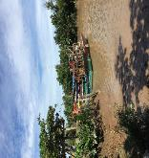  Along the dike, there are a number of households that often use the dike to travel and trade  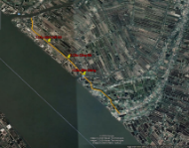 | - Material spillage degrades water quality, affects aquaculture productivity and activities | - Build ditches for stormwater drainage, sedimentation pits and maintain them periodically to ensure that most solids present in surface runoff are retained before discharging into the surrounding water sources.  - Leaching water from sediment of excavation and backfilling must be deposited in sedimentation tanks/traps before being discharged into the river. Contractors are strictly prohibited from discharging waste into the river.  - Collect excess materials on the site every day. In case of a storm forecast, stop all construction activities, clean the area, protect construction materials and machinery.  - Do not gather construction materials as well as machinery and equipment near the river banks. Mobilize each small volume of material in accordance with the construction progress. Material must be shielded with tarpaulin, avoid wind direction and near the river.  - Prevent hazardous waste, waste oil or waste from spilling into water flow.
 | - Increase the density of vehicles in waterway, causing the risk of collisions between equipment operating on rivers, obstructing traffic and transporting goods by water | - Vessels and barges must meet all safety technical requirements and inspection papers from functional agencies before being allowed to work. When operating, the vehicle owners must comply with the traffic laws; when entering the subproject area, they must follow the instructions of the operators on the direction, parking locations, loading, etc.;  - Limit transportation at peak hours with high traffic density;  - Project Owner and contractors must have detailed plans to arrange time and waterway properly in the process of transporting materials and equipment for construction to avoid congestion and accidents in the area;  - At the access to the construction area, there must be signs and lights to sign ships, boats and barges, especially in dangerous sections.
 | - Risk of slipping of the dike roof when newly built, not stable, affecting property and health | - Reinforce embankment before carrying out the earthwork. This construction method should be proposed and submitted to the competent authorities for approval before commencement of work.  - Use construction methods suitable for each work-item.  - Closely monitor vibration levels;  - Construction of slope according to design;  - Arrange construction time reasonably in the rainy season;  - Do not arrange heavy machinery and traffic vehicles near the canals. Inspection and monitoring of the risk of subsidence should be done regularly to prepare appropriate reinforcement plans.
An Thuan Kindergarten (An Khuong School branch)  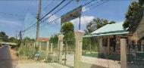  An Ninh Primary School (An Thuan commune) | Noisy due to worker concentration affects the learning of students | - Do not let machines or vehicles run idle for more than 2 minutes  - Avoid disturbing areas during rush hours to school and after school  - Workers must strictly follow the code of conduct when working in the area, do not argue, swear  - Limit construction activities during class time and after school.
 | Noise and dust from waste transportation to dumping sites. | - Take measures to limit noise such as closing glass doors, windows.  - Machines and vehicles will be checked periodically and changed with lubrication to ensure working efficiency…  - Truck drivers must refrain from honking their horns when approaching schools.
 | Workers’ inappropriate languages and behaviors may affect students | - Workers must strictly follow the code of conduct when working in the area, do not argue, swear.
 | Traffic risks when picking students | - Place warning signs, construction signs, speed signs in construction areas with lights at night at construction road sections.  - Limit construction activities during crowded times of students such as opening school, going to school, after school, festival...
 | Traffic risks when picking students | - Place warning signs, construction signs, speed signs in construction areas with lights at night at construction road sections.  - Limit construction activities during crowded times of students such as opening school, going to school, after school, festival...
An Ninh A Hamlet Market (An Thuan Commune) | Noisy due to concentration of workers, there may be conflicts between construction workers and local people due to traffic collision | - Avoid construction at night or consult and notify the communities if it is not possible to avoid construction at night.  - Avoid disturbing the market at shopping times in mornings or afternoons  - Limit construction activities during peak hours  - Manage workers to avoid conflicts with local people and business households.
 | Noise from dike construction activities. | Use construction machines with low noise affecting business activities and other activities of people near the market.  Machines and vehicles will be checked periodically and changed with lubrication to ensure working efficiency…
Shrimp squares of people in Thach Tan hamlet, Binh Thanh commune | Risk of landslide in shrimp farming squares in Thach Tan hamlet next to Co Chien embankment due to newly built dike, not yet compacted. | - Closely monitor vibration levels;  - Construction of slope according to design;  - Give reasonable construction time in the rainy season;  - Do not arrange heavy machinery and traffic vehicles near the canals. Inspection and monitoring of the risk of subsidence should be done regularly to prepare appropriate reinforcement plans.
 | Trees outside the construction areas and some natural creatures may be harmed due to unconscious workers’ behaviors. | - Clear trees by hand within the construction scope; workers are not allowed to cut trees without permission  - Restrict disturbance to the smallest extent  - Supervise workers’ compliance with the Code of Conduct
 | Material spillage degrades water quality, affects aquaculture productivity and activities. | - Dig sedimentation pits, clear stagnancy periodically to ensure that most solids present in the surface runoff are retained in the pit before discharging into the surrounding water sources;  - Prohibit the contractors from discharging waste directly into the river;  - Collect excess materials on the site every day. In case of a storm forecast, stop all construction activities, clean the area, protect construction materials and machinery;  - Do not gather construction materials as well as machinery and equipment near the river banks. Mobilize each small volume of material in accordance with the construction progress. Material must be shielded with tarpaulin, avoid wind direction and near the river.  - Prevent hazardous waste, waste oil or waste from spilling into water flow.
Kenh Dat Do Bridge (currently it is an earth dam) K0+750, Binh Thanh commune  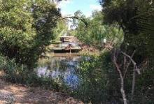 | Dust, noise, vibration during construction, especially piling activities that affect households | - Clean spilled materials around the construction area near residential areas to limit dust spread.  - Install walls and barriers to avoid spreading dust to the surrounding area.  - If the piling is implemented, avoid the breeding season (October-March) of many species.  - Limit the simultaneous operation of many vehicles and equipment emitting loud noise in areas with objects sensitive to noise and vibration.  - The contractors only use vehicles and machines with valid registration certificates.  - Periodic maintenance of construction machinery. When the noise becomes excessively loud or abnormal, the contractors will apply necessary measures, such as installing silencers or replacing some necessary parts to reduce the noise to an acceptable level.
 | Impact on existing infrastructure in the area such as power lines and roadside trees | - Inform local authorities and residents of the execution time.  - Strictly follow the design specifications for the removal and impact of trees and infrastructure.  - Do not use chemicals to clear plants;  - Strictly forbid cutting down any trees that are not located in the site clearance area to serve construction.  - If necessary, install temporary fences to protect trees before starting construction.
 | Impact on waterway activities | - Vessels and barges must meet all safety technical requirements and inspection papers from functional agencies before being allowed to work. When operating, the vehicle owners must comply with the traffic laws; when entering the subproject area, they must follow the instructions of the operators on the direction, parking locations, loading, etc.  - Limit transportation at peak hours with high traffic density;  - Reasonable division of flows and routes in the process of transporting materials and equipment in service of construction to avoid traffic congestion and accidents in the area;  - At the access to the construction area, there must be signs and lights to guide ships, boats and barges, especially in dangerous sections.
 | Risk of erosion during construction, and heavy rains may be the risk of land subsidence and riverbank erosion at the bridge construction sites, affecting property and health. | - Reinforce embankment before carrying out the earthwork. Construction methods should be proposed and submitted to the competent authorities for approval before commencement of works;  - Ensure land acquisition and house relocation at the construction sites before starting construction;  - Use suitable construction methods for bridges  - Closely monitor vibration levels;  - Construction of slope according to design;  - Give reasonable construction time in the rainy season;  - Do not arrange heavy machinery and traffic vehicles near the canals. Inspection and monitoring of the risk of subsidence should be done regularly to prepare appropriate reinforcement plans.
Rach Cong Da Bridge (currently moving by ferry, canal width 17m), K 1+300, An Thuan commune  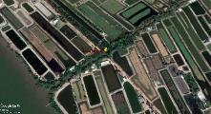 | Dust, noise, vibration during construction, especially piling activities affect households | - Clean spilled materials around the construction area near residential area to limit dust spread  - If the piling is implemented, avoid the breeding season (October-March) of many species  - Limit the simultaneous operation of many vehicles and equipment emitting loud noise in areas with objects sensitive to noise and vibration.  - The contractors only use vehicles and machines with valid registration certificates.  - Periodic maintenance of construction machinery. When the noise becomes excessively loud or abnormal, the contractors will apply necessary measures, such as installing silencers or replacing some necessary parts to reduce the noise to an acceptable level.
 | Impact on existing infrastructure in the area such as power lines and roadside trees | - Assign traffic guides and cranes to avoid breaking trees and public infrastructure such as power lines.  - Inform local authorities and residents of the execution time.  - Do not use chemicals to clear plants.  - Strictly forbid cutting down any trees that are not located in the site clearance area to serve construction.  - If necessary, install temporary fences to protect trees before starting construction.
 | Impact on waterway activities, losing the  old ferry terminals of local people | - Vessels and barges must meet all safety technical requirements and inspection papers from functional agencies before being allowed to work. When operating, the vehicle owners must comply with the traffic laws; when entering the subproject area, they must follow the instructions of the operators on the direction, parking locations, loading, etc.;  - Limit transportation at peak hours with high traffic density;  - Reasonable division of flows and routes in the process of transporting materials and equipment in service of construction to avoid traffic congestion and accidents in the area;  - At the access to the construction project area, especially in dangerous sections, there must be signs and lights to guide ships, boats and barges.  - Inform construction times and detailed construction plan 1 month before the commencement of work so that people can actively adapt.  - Set up a temporary anchorage for people.
 | Risk of erosion during construction, and heavy rains may be the risk of land subsidence and riverbank erosion at the bridge construction sites, affecting property and health. | - Reinforce embankment before carrying out the earthwork. Construction methods should be proposed and submitted to the competent authorities for approval before commencement of works;  - Closely monitor vibration levels;  - Construction of slope according to design;  - Give reasonable construction time in the rainy season;  - Do not arrange heavy machinery and traffic vehicles near the canals. Inspection and monitoring of the risk of subsidence should be done regularly to prepare appropriate reinforcement plans.
Rach Ben Gang Bridge (currently moving by ferry, canal width 50m)  K 1+800, An Thuan commune  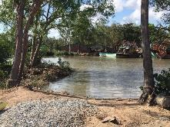  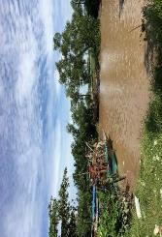  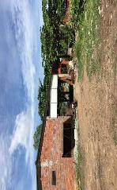 | Dust, noise, vibration during construction, especially piling activities affect households | - Clean spilled materials around the construction area near residential area to limit dust spread.  - Install walls and barriers to avoid spreading dust to the surrounding area.  - If the piling is implemented, avoid the breeding season (October-March) of many species.  - Limit the simultaneous operation of many vehicles and equipment emitting loud noise in areas with objects sensitive to noise and vibration.  - The contractors only use vehicles and machines with valid registration certificates.  - Periodic maintenance of construction machinery. When the noise becomes excessively loud or abnormal, the contractors will apply necessary measures as installing silencers or replacing some necessary parts to reduce the noise to an acceptable level.
 | Impact on existing infrastructure in the area such as power lines and roadside trees | - Clear trees by hand within the construction scope; workers are not allowed to cut trees without permission  - Restrict disturbance to the smallest extent; inform local authorities and residents of the execution time.  - Strictly follow the design specifications for the removal and impact of trees and infrastructure.  - Do not use chemicals to clear plants.  - Strictly forbid cutting down any trees that are not located in the site clearance area to serve construction.  - If necessary, install temporary fences to protect trees before starting construction.
 | Impact on waterway activities, losing the old ferry terminals of local people | - Vessels and barges must meet all safety technical requirements and inspection papers from functional agencies before being allowed to work. When operating, the vehicle owners must comply with the traffic laws; when entering the subproject area, they must follow the instructions of the operators on the direction, parking locations, loading, etc.  - Limit transportation at peak hours with high traffic density;  - Project Owner and contractors must have detailed plans to arrange time and waterway properly in the process of transporting materials and equipment for construction to avoid congestion and accidents in the area;  - At the access to the construction project area, especially in dangerous sections, there must be signs and lights to identify ships, boats and barges.  - Inform construction times and detailed construction plan 1 month before the commencement of work so that people can actively adapt  - Set up a temporary anchorage for people
 | Risk of erosion during construction, and heavy rains may be the risk of land subsidence and riverbank erosion at the bridge construction sites, affecting property and health. | - Reinforce embankment before carrying out the earthwork. Construction methods should be proposed and submitted to the competent authorities for approval before commencement of works;  - Ensure land acquisition and house relocation at the construction sites before starting construction;  - Use suitable construction methods for bridges;  - Closely monitor vibration levels;  - Construction of slope according to design;  - Give reasonable construction time in the rainy season;  - Do not arrange heavy machinery and traffic vehicles near the canals. Inspection and monitoring of the risk of subsidence should be done regularly to prepare appropriate reinforcement plans.
 | Impact on 01 house of household and 01 small business of 01 household | - Before construction, it is necessary to record and photograph the current state of houses and shops. During construction, if people’s houses or shops are damaged, adequate compensation for them must be due.  - Before construction, it is necessary to inform the authorities and households about the construction plans.
Work-item 2- Bang Cung river embankment
Aquaculture and agricultural production areas along the dike  Vessels and means of transport on the river near the embankment area  Along the dike, there are a number of households that often use the dike to travel and trade  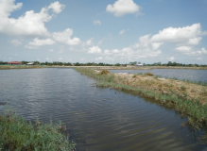 | Material spillage degrades water quality, affects aquaculture productivity and activities. | - Trap sediment and maintain it periodically to ensure that most solids present in the surface runoff are trapped in the trap before wastewater is discharged into water sources around the area  - Leaching water from sediment of excavation and backfilling must be deposited in sedimentation tanks/traps before being discharged into the river. The contractors are strictly prohibited from discharging waste into the river;  - Collect excess materials on the site every day. In case of a storm forecast, stop all construction activities, clean the area, protect construction materials and machinery;  - Do not gather construction materials as well as machinery and equipment near the river banks. Mobilize each small volume of material in accordance with the construction progress. Material must be shielded with tarpaulin, avoid wind direction and near the river.  - Prevent hazardous waste, waste oil or waste from spilling into water flow.
 | Increase the density of vehicles in waterway, causing the risk of collisions between equipment operating on rivers, obstructing traffic and transporting goods by water | - Vessels and barges must meet all safety technical requirements and inspection papers from functional agencies before being allowed to work. When operating, the vehicle owners must comply with the traffic laws; when entering the subproject area, they must follow the instructions of the operators on the direction, parking locations, loading, etc.  - Limit transportation at peak hours with high traffic density;  - Project Owner and contractors must have detailed plans to arrange time and waterway properly in the process of transporting materials and equipment for construction to avoid congestion and accidents in the area;  - At the access to the construction project area, especially in dangerous sections, there must be signs and lights to guide ships, boats and barges.
 | Risk of slipping of the dike roof when newly built, not stable, affecting property and health | - Reinforce embankment before carrying out the earthwork. This construction method should be proposed and submitted to the competent authorities for approval before commencement of work;  - Use suitable construction methods to construct Bang Cung river embankment  - Closely monitor vibration levels;  - Construction of slope according to design;  - Give reasonable construction time in the rainy season;  - Do not arrange heavy machinery and traffic vehicles near the canals. Inspection and monitoring of the risk of subsidence should be done regularly to prepare appropriate reinforcement plans;  - The CSC and the contractors must ensure regular attendance during the construction to monitor the risk of erosion and landslides and take appropriate actions if necessary.
New construction dike section from Rach Lai Cui Bridge locations to K6 + 00. The earth dike divides a number of shrimp ponds and barns of households.  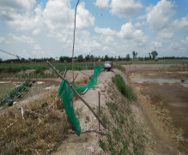 | Material spillage degrades water quality, affects aquaculture productivity and activities. | - Trap sediment and maintain it periodically to ensure that most solids present in the surface runoff are trapped in the trap before wastewater is discharged into water sources around the area;  - Leaching water from sediment of excavation and backfilling must be deposited in sedimentation tanks/traps before being discharged into the river. Contractors are strictly prohibited from discharging waste into the river;  - Collect excess materials on the site every day. In case of a storm forecast, stop all construction activities, clean the area, protect construction materials and machinery;  - Do not gather construction materials as well as machinery and equipment near the river banks. Mobilize each small volume of material in accordance with the construction progress. Material must be shielded with tarpaulin, avoid wind direction and near the river.  - Prevent hazardous waste, waste oil or waste from spilling into water flow.
 | Increase the density of vehicles in waterway, causing the risk of collisions between equipment operating on rivers, obstructing traffic and transporting goods by water | - Vessels and barges must meet all safety technical requirements and inspection papers from functional agencies before being allowed to work. When operating, the vehicle owners must comply with the traffic laws; when entering the subproject area, they must follow the instructions of the operators on the direction, parking locations, loading, etc.  - Limit transportation at peak hours with high traffic density;  - Project Owner and contractors must have detailed plans to arrange time and waterway properly in the process of transporting materials and equipment for construction to avoid congestion and accidents in the area;  - At the access to the construction area, there must be signs and lights to sign ships, boats and barges, especially in dangerous sections.
 | Risk of slipping of the dike roof when newly built, not stable, affecting property and health | - Reinforce embankment before carrying out the earthwork. This construction method should be proposed and submitted to the competent authorities for approval before commencement of work;  - Use suitable construction methods to construct Bang Cung river embankment  - Closely monitor vibration levels;  - Construction of slope according to design;  - Give reasonable construction time in the rainy season;  - Do not arrange heavy machinery and traffic vehicles near the canals. Inspection and monitoring of the risk of subsidence should be done regularly to prepare appropriate reinforcement plans;
An Thanh ferry  Located on the construction embankment of Bang Cung river, about 1.5 - 3m far from the construction sites  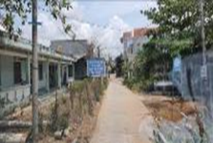 | Incidents such as landslide of dam bank when the dam has just filled and not compacted stably. | - Use construction methods suitable for each work-item.  - Closely monitor vibration levels;  - Construction of slope according to design;  - Give reasonable construction time in the rainy season;  - Do not arrange heavy machinery and traffic vehicles near the canals. Inspection and monitoring of the risk of subsidence should be done regularly to prepare appropriate reinforcement plans.
 | - Losing the boat dock of the local people. | - Inform construction times and detailed construction plan 1 month before the commencement of work so that people can actively adapt.  - Set up a temporary anchorage for people.  - Place warning signs, lights, water traffic signal buoys to ensure safety.
 | - Some trees will be cut down for the construction sites. | - Restrict disturbance to the smallest extent  - Clear trees by hand within the construction scope; workers are not allowed to cut trees without permission.
 | Disruption of water traffic. Losing the ferry dock of the local people | - Vessels and barges must meet all safety technical requirements and inspection papers from functional agencies before being allowed to work. When operating, the vehicle owners must comply with the traffic laws; when entering the subproject area, they must follow the instructions of the operators on the direction, parking locations, loading, etc.  - Limit transportation at peak hours with high traffic density;  - Project Owner and contractors must have detailed plans to arrange time and waterway properly in the process of transporting materials and equipment for construction to avoid congestion and accidents in the area;  - At the access to the construction area, there must be signs and lights to sign ships, boats and barges, especially in dangerous sections.  - Inform construction times and detailed construction plan 1 month before the commencement of work so that people can actively adapt  - Set up a temporary anchorage for people.
 | Insect attacks may damage workers | - Provide adequate PPE for workers such as workwear, gloves, helmets, boots...  - Warn and instruct workers how to handle and give first aid when attacked by insects
An Thanh CPC  Located on the transportation route to the disposal site, 5-10m from the construction sites | Dust, noise, waste and construction materials may spoil the area’s aesthetic. | - Water with moderate amount to limit dust during excavation and backfilling.  - Gather waste, construction materials to the right place and wait for the collection company to collect and transport it.  - Limit material handling within 50m from the gate of the Commune People’s Committee  - It is strictly forbidden to use construction methods that cause noise during meetings.
 | Increasing the number of machines, equipment and means of transport on the route will increase traffic risks | - Avoid gathering of materials, waste and construction vehicles that obstruct vehicles in and out of the People’s Committee  - Place warning signs, construction signs  speed signs in the construction area, with lights at night on the construction road.
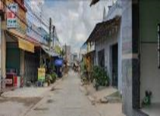  Ben Vinh Market, An Thanh Hamlet (An Thanh Commune) | Noise from dike construction activities. | - Measures to limit noise such as not doing construction at peak times and where many people gather.  - Use construction machines with low noise affecting business activities and other activities of people near the market.  - Machines and vehicles will be checked periodically and changed with lubrication to ensure working efficiency…
 | Obstruct local people from accessing the market. | - Put up signs in the construction area so that people know and do not move into the road.  - Minimize the time for temporary gathering of materials, wastes and construction machines in the market area  - Avoid loading and unloading materials and waste during peak hours.
 | Risk of community conflict. | - Avoid construction at night or consult with and notify the communities if it is not possible to avoid construction at night  - Strictly supervise the workers’ compliance with the Code of Conduct  - Avoid disturbing the market at shopping times in mornings or afternoons  - Limit construction activities during peak hours  - Manage workers to avoid conflicts with local people and business households;
Bridges on the route  Rach Nha Tho Bridge, K0 + 120, An Thanh commune, before it is a concrete bridge of 17m long and 3m wide on the embankment of Bang Cung river  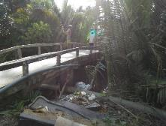  Kenh Phu Nu Bridge, K0+ 050, An Thanh commune. It was a concrete bridge of 23m long, 2.2m wide, on the embankment of Bang Cung River.  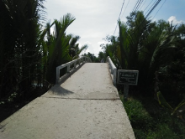  Rach Nha Bridge, K0+ 730, An Thanh commune  It was a concrete bridge of 18m long, 2.3m wide, on the embankment of Bang Cung River  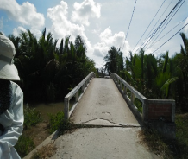  Rach Chum Giuot Bridge, K1 + 010, An Thanh commune. It was a concrete bridge of 15m long, 2.3m wide.  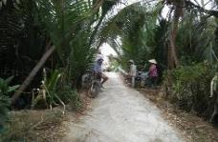  Rach Ong Hung Bridge, K1 + 265, An Thanh commune, it was a concrete bridge 22m long and 2.0m wide on the embankment of Bang Cung river  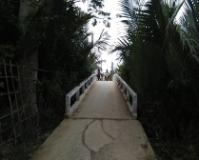  Rach Ro Bridge, K1+810, An Thanh commune, it was a concrete bridge of 26m long, 1.5m wide, on the embankment of Bang Cung river  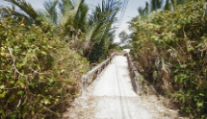  Rach Ba Pho Bridge, K3+130, An Thanh commune, it was a concrete bridge of 22m long, 1.5m wide, on the embankment of Bang Cung river  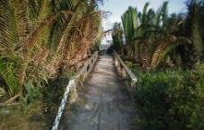  Rach Ong Phuong Bridge, K3+370, An Thanh commune, it was a concrete bridge of 17m long, 1.5m wide, on the embankment of Bang Cung river  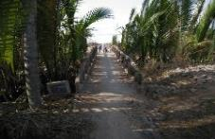  Rach Ret Bridge, K3+370, An Quy commune, before, there was no bridge, canal width 26.5m on the embankment of Bang Cung river  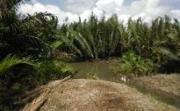  Rach Ong Nom Bridge, K4+200, An Quy commune, it was a concrete bridge of 17m long, 1.5m wide, on the embankment of Bang Cung river  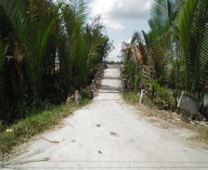  Rach Lai Cui Bridge, K4+535, An Quy commune, it was a concrete bridge of 14.5m long, 2m wide, on the embankment of Bang Cung river  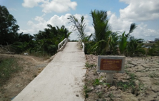  Rach Ben Gia Bridge, K4+950, An Quy commune, it was a concrete bridge of 14.5m long, 2m wide, on the embankment of Bang Cung river  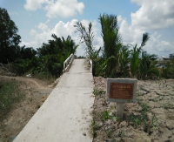  Rach Ba Can Bridge, K5+375, An Quy commune, it was a concrete bridge of 38m long, 2m wide, on the embankment of Bang Cung river  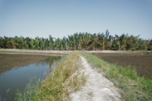  Rach An Quy Bridge (additional), K5+800, An Quy commune, there was no bridge, canal width 16 m, on the embankment of Bang Cung river  Big Rach Giao Phay bridge, K6+300, An Quy commune, there was no bridge, canal width 31,5m. on the embankment of Bang Cung river  Small Rach Giao Phay bridge, K6+700, An Quy commune, there was no bridge, canal width 30 m, on the embankment of Bang Cung river  Rach Ben Gia Bridge, DR.28, An Quy commune, The current status is a asphalt surface dam | Dust, noise, vibration during construction, especially piling activities that affect households | - Clean spilled materials around the construction area near residential areas to limit dust spread.  - Install walls and barriers to avoid spreading dust to the surrounding area.  - If the piling is implemented, avoid the breeding season (October-March) of many species.  - Limit the simultaneous operation of many vehicles and equipment emitting loud noise in areas with objects sensitive to noise and vibration.  - The contractors only use vehicles and machines with valid registration certificates.  - Periodic maintenance of construction machinery. When the noise becomes excessively loud or abnormal, the contractors will apply necessary measures as installing silencers or replacing some necessary parts to reduce the noise to an acceptable level.
 | Material spillage degrades water quality, affects aquaculture productivity and activities. | - Trap sediment and maintain it periodically to ensure that most solids present in the surface runoff are trapped in the trap before wastewater is discharged into water sources around the area  - Leaching water from sediment of excavation and backfilling must be deposited in sedimentation tanks/traps before being discharged into the river. Contractors are strictly prohibited from discharging waste into the river;  - Collect excess materials on the site every day. In case of a storm forecast, stop all construction activities, clean the area, protect construction materials and machinery;  - Do not gather construction materials as well as machinery and equipment near the river banks. Mobilize each small volume of material in accordance with the construction progress. Material must be shielded with tarpaulin, avoid wind direction and near the river.  - Prevent hazardous waste, waste oil or waste from spilling into water flow.
 | Impact on existing infrastructure in the area such as power lines and roadside trees | - The contractors will propose measures to minimize impacts and risks on trees and public infrastructure and strictly implement after being approved by the CSC.  - Inform local authorities and residents of the execution time.  - Strictly follow the design specifications for the removal and impact of trees and infrastructure.  - Do not use chemicals to clear plants.  - Strictly forbid cutting down any trees that are not located in the site clearance area to serve construction.  - If necessary, install temporary fences to protect trees before starting construction.
 | Impact on waterway activities | - Vessels and barges must meet all safety technical requirements and inspection papers from functional agencies before being allowed to work. When operating, the vehicle owners must comply with the traffic laws; when entering the subproject area, they must follow the instructions of the operators on the direction, parking locations, loading, etc.  - Limit transportation at peak hours with high traffic density;  - Project Owner and contractors must have detailed plans to arrange time and waterway properly in the process of transporting materials and equipment for construction to avoid congestion and accidents in the area.  - At the access to the construction area, there must be signs and lights to sign ships, boats and barges, especially in dangerous sections.
 | Disruption of business activities, limited access to business establishments by the people | - Inform households near the bridge about construction activities and potential impacts such as waste, dust, noise, traffic and construction progress at least 02 weeks before commencement of construction;  - Arrange safe and convenient entrances for households such as placing thick wood or thick steel plates or steel plates on ditches or pits;  - Do not collect materials and waste within 20m from business households and shops;  - Do not use machines that cause great noise and high vibration near business households;  - Water sufficiently to reduce dust during dry and windy days at least three times a day near business households;  - Arrange staff to guide traffic during construction, transportation and handling of construction materials and wastes to protect against high-risk operations;  - Clean up construction areas at the end of the day, especially the construction areas in front of stores;  - Manage workers to avoid conflicts with local people and business households;  - Compensation for goods and products damaged due to construction activities of the subproject;  - Immediately resolve any problems caused by construction activities and household businesses.
The locations for taking earth embankment at the route sections:  K3+250 – K3+450, K3+600 – K3+990, K4+150 - K4+340, K4+550 - K4+750, K4+830 - K4+900, K5+260 – K5+600, K5+650 – K5+900, K6+165 – K6+450, K6+580 – K6+700  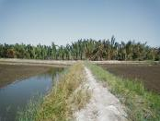  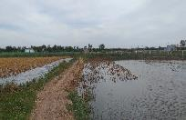  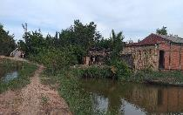 | Dust, noise, vibration during construction affect households.  Material spillage degrades water quality, affects aquaculture productivity and activities.  Disruption of aquaculture activities.  Affect people’s travel and cultivation  Risk of landslide of shrimp pond after excavation | - Limit the simultaneous operation of many vehicles and equipment emitting loud noise in areas with objects sensitive to noise and vibration.  - The contractors only use vehicles and machines with valid registration certificates.  - Periodic maintenance of construction machinery.  - Trap sediment and maintain it periodically to ensure that most solids present in the surface runoff are trapped in the trap before wastewater is discharged into water sources around the area.;  - Leaching water from sediment of excavation and backfilling must be deposited in sedimentation tanks/traps before being discharged into the river.  - Do not gather construction materials as well as machinery and equipment near the river banks. Mobilize each small volume of material in accordance with the construction progress. Material must be shielded with tarpaulin, avoid wind direction and near the river.  - Prevent hazardous waste, waste oil or waste from spilling into water flow.  - Choose the construction time in dry seasons and between aquaculture seasons. Inform farming households of construction activities and potential impacts such as waste, dust, noise, traffic and construction progress at least 2 weeks before commencement of construction;  - Do not arrange heavy machinery and traffic vehicles near the canals. Inspection and monitoring of the risk of subsidence should be done regularly to prepare appropriate reinforcement plans;  - When excavating soil, it is required to ensure roof slope, limit landslide of shrimp ponds.
Waste dumping sites | Dust, noise, and waste may cause loss of landscape in the area.  Stagnation of water creates an environment for mosquitoes to grow.  Waste spilled out in disposal sites causes loss of aesthetics and dust, dirt. | - The height of the dumping site must not be larger than the existing ground level.  - Waste dumping site must have a drainage system.  - Because the disposal sites are land areas planned for the construction of the Commune People’s Committee or the planning for building a village culture house, near the road, after dumping, there should be rolling, leveling, ensuring that sand does not overflow out onto the street and the surrounding area.  - If necessary, build retaining walls at disposal sites.
Domestic water supply system
The People’s Committees of the communes of An Thuan, An Quy, An Nhon and the People’s Committees of Thanh Phu town  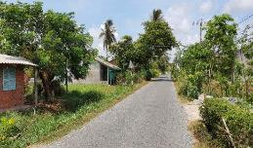  Provincial road 57 - Construction of water supply pipeline with the largest diameter (D=31.5cm) | Dust, noise, waste and construction materials may spoil the area’s aesthetic. | - Water with a moderate amount to limit dust during excavation and backfilling.  - Gather waste, construction materials to the right place and wait for the collection company to collect and transport it.  - Limit material handling within 50m from the gate of the Commune People’s Committee.  - It is strictly forbidden to use construction methods that cause noise during meetings.
 | Increasing the number of machines, equipment and means of transport on the route will increase traffic risks | - Avoid gathering of materials, waste and construction vehicles that obstruct vehicles in and out of the People’s Committee.  - Place warning signs, construction signs speed signs in the construction area, with lights at night on the construction road.
An Thanh Primary School, An Thuan Primary School  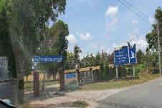  An Thanh Primary School  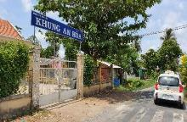  An Thuan Primary School | Noisy due to worker concentration affects the learning of students | - Do not let machines or vehicles run idle for more than 2 minutes  - Avoid disturbing areas during rush hours to school and after school  - Workers must strictly follow the code of conduct when working in the area, do not argue, swear  - Limit construction activities during class time and after school
 | Noise and dust from waste transportation to dumping sites. | - Take measures to limit noise such as closing glass doors, windows.  - Machines and vehicles will be checked periodically and changed with lubrication to ensure working efficiency…  - Truck drivers must refrain from honking their horns when approaching schools
 | Workers’ inappropriate languages and behaviors may affect students | - Workers must strictly follow the code of conduct when working in the area, do not argue, swear
 | Traffic risks when picking students | - Place warning signs, construction signs, speed signs in construction areas with lights at night at construction road sections.  - Limit construction activities during busy times of students such as opening school, going to school, after school, festival...
Work-item 3 - Embankment of Khau Bang sea dike
Starting point: near Khau Bang river  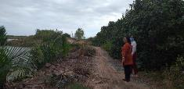  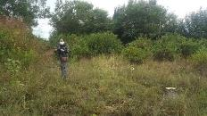  Material gathering area at the beginning of the work  Shrimp squares in Thanh Loc hamlet, Thanh Phong commune, 400m from the beginning of the dike, 10-20m from the construction sites  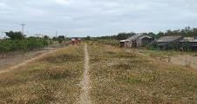  Some households are living near the end of the route  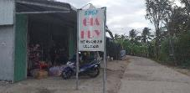  A grocery store next to a dumping site planned as Thanh Loc hamlet cultural | +Disturb residents, road traffic, people’s travel during construction  + Trees and plants may be overexposed | - Avoid construction in peak seasons  - Place signs in construction areas at beginning and end points and material areas so that people know and do not move into the dike.  - Each section is not too long and the tapering work is implemented section by section.  - Prohibit clearing trees outside the construction scope.
 | + Dike material and leachate possibly spill into ponds, causing damage to crops or affecting aquaculture productivity.  + Insect, snakes, bee may attack workers | - Insect, snakes, bee may attack workers;  - Collect excess materials on the site every day. In case of a storm forecast, stop all construction activities, clean the area, protect construction materials and machinery;  - Do not gather construction materials as well as machinery and equipment near the river banks. Mobilize each small volume of material in accordance with the construction progress.  - Gather materials on bare land near the beginning of the work and 20m far from shrimp ponds.  - Organize construction in the dry season to limit rainwater to sweep materials into shrimp pond and river.  - Prevent hazardous waste, waste oil or waste from spilling into water flow.  - Construction material unused are transferred to a disposal site in Thanh Loc hamlet (approved by the local authorities).
 | + Loss of vegetation, damage to trees, cutting trees too much over the scope of construction | - Clear trees by hand within the construction scope; workers are not allowed to cut trees without permission  - Restrict disturbance to the smallest extent  - Supervise workers’ compliance with the Code of Conduct
 | + Risk of insect attack that possibly injuries workers. | - Provide adequate PPE for workers such as workwear, gloves, helmets, boots...  - Warn and instruct workers how to handle and give first aid when attacked by insects.
 | + Impact on stores when transporting spoil to dumping sites about 2-5 km far from the site. | - Inform the business households along the dike about construction activities and potential impacts such as waste, dust, noise, traffic and construction progress at least 02 weeks before commencement of construction;  - Do not use machines that cause great noise and high vibration near business households;  - Water sufficiently to reduce dust during dry and windy days at least three times a day near business households;  - Arrange staff to guide traffic during construction, transportation and handling of construction materials and wastes to protect against high-risk operations;  - Clean up the area in front of the store (if spillage is present);  - Manage workers to avoid conflicts with local people and business households;  - Compensation for goods and products damaged due to construction activities of the subproject.

Measures to minimize subproject impacts that cause risks and incidents
- Labor safety measures
- The contractors will build up labor safety rules during the construction process and disseminate them to all workers to understand;
- Construction machinery and equipment must be periodically checked before being put into use;
- Develop and implement a program of periodic health checks for officials and employees on site;
- When working at high altitude, they must be equipped with all necessary labor protection equipment and means. Safety belts and tools must be compact and easy to operate. Working at high altitude when it is getting dark or there is fog, rain, thunderstorms or lightning is not permitted. Workers operating on the ground must wear helmets and stay away from dangerous locations;
- When hoisting materials and equipment, check the safe distance with electric area, and arrange ligaments and cables carefully. The manipulation workers are not allowed to stand under the working reach of crane;
- Install electrical equipment with safety measures for people and equipment not to be scratched or damaged;
- Install danger signs and prohibit energizing operation in necessary locations;
- Establish a full communication system to ensure connection between officers, supervisors and construction workers in all cases;
- Train and provide workers with information on occupational hygiene;
- The contractors will make rescue plans when an occupational accident occurs: medical facilities will be used in emergency: The Medical Center of Thanh Phu district, the General Hospital of Thanh Phu district...
- Emergency measures when an accident occurs during construction
- Take all measures to bring victims out of the danger zone and isolate the danger zone (if any);
- Give first aid and transfer victims to the nearest medical center and hospital (if necessary);
- Notify the Site Steering Committee, contractors and Project Owner.
- Fire and explosion prevention and response measures
- Fully equip fire-fighting tools on site such as sand, CO2 cylinders, shovels, ... with attached fire-fighting rules and commands;
- Train officials and workers on site in the use of firefighting equipment and specific handling measures in each case;
- Check, maintain and inspect construction equipment and fire protection equipment periodically to be ready to respond when an incident occurs.
- Measures to respond to explosions on construction sites:
- Notify everyone on the construction sites to participate in fire extinguishing as far as possible and under the circumstances;
- When there is a fire and explosion incident, quickly disconnect circuit breakers in the area where the fire occurs;
- Use fire protection equipment on the site such as sand, CO2 cylinders, shovels, ... and water from the fire hydrant tank to extinguish the fire;
- Immediately report to the local fire protection force to take timely measures for fire-fighting (if necessary);
- Quickly notify the site commanding office, construction contractors and Project Owner.
- Waterway safety measures
- Vessels and barges must meet all safety technical requirements and inspection papers from functional agencies before being allowed to work. When operating, the vehicle owners must comply with the traffic laws; when entering the subproject area, they must follow the instructions of the operators on the direction, parking locations, loading, etc.
- Limit transportation at peak hours with high traffic density;
- The contractors must have detailed plans for reasonable arrangement of time, diversion and division in the process of transporting materials and equipment in service of construction to avoid traffic congestion or accidents in the area.
- At the access to the construction project area, especially in dangerous sections, there must be signs and lights to guide ships, boats and barges.
- The fuel leak prevention and response measures
Measures are taken to prevent and minimize fuel leak as follows:
- The guards on duty on the sites must regularly check the fuel storage in each shift. When there are any signs of leakage, they must immediately notify the site commanding office for taking measures;
- Fuel storage for foundation construction must be concreted, elevated above the construction sites and surrounded by shielding and roofs;
- Tanks and cans containing DO and gasoline must be technically sound (no punctures, cracks and lids must be provided); when stored, it must not exceed the permissible capacity;
- Fuel-transporting vessels must be technically sound and have safety shielding. When transporting fuel tanks or cans, they must not be bent or tilted to avoid spillage;
- The contractors must have specific plans on hauling time, avoiding peak hours to limit the risk of collisions or accidents.
- Responding to incidents:
- Quickly notify the site steering offices, contractors and Project Owner when a fuel leak occurs;
- Immediately isolate the site (if necessary), take measures to transfer fuel from leaking tanks and cans to backup tanks and cans. Use absorbent paper or rags to thoroughly handle the leaked fuel on the surface (absorbent paper, rags will be handled according to hazardous waste disposal measures on site);
- Conduct an environmental damage assessment by surveying, sampling and analyzing the environmental impact after the incident;
- Make a report on incident developments, environmental damage and counter measures to the Project Owner and the functional agencies.
- Measures to minimize pollution caused by the construction process that potentially affects the shrimp ponds of people around the construction area.
- Contractors must cover up so that soil, sand ... does not fall to people's shrimp ponds
- Contractors must make construction schedules and notify people so that they can take water suitably.
- Conduct the stream to prevent rainwater from overflowing the site, affecting the shrimp ponds.
- Measures to prevent and respond to epidemics that arise
- It is necessary to have measures to ensure the health and preventive control when an epidemic occurs for workers and managers on site;
- Regularly communicate with the district preventive medicine center to get informed about disease situation inside and outside the construction sites;
- The food processing area for workers must be located far away from the waste gathering areas on the construction sites to avoid flies sitting on food, spreading diseases to people in the area;
- When an epidemic disease appears in a construction site of the subproject, it must be zoned and organized to prevent it from spreading on a large scale. At the same time, immediately contact the medical centers or the general hospital of Thanh Phu district, Mo Cay Nam to have prevention and treatment plans.
  - Mitigation measures in operation phase
To ensure occupational safety, the following measures should be taken:
- Every year, the PPMU and Ben Tre Water Source One Member Limited Company must organize training on labor safety for the inspection, monitoring, maintenance of works for officers and employees involved in the maintenance;
- All tasks in the operation process must be done with a "Worksheet" and logs to monitor operations;
- It is necessary to fully equip protective equipment: clothes, helmets, shoes, reflective clothes when performing the monitoring, repair, maintenance of bridges and dikes;
- When repairing, maintaining, tools must be kept in specialized bags, not pockets. Not tossing or throwing tools when working;
- Employees must be in good health, strictly prohibit drinking alcohol and other stimulants while on duty;
- Workers must concentrate while at work, not play around, work carefully in accordance with the process, technique, prudence and accuracy;
- It is strictly forbidden to work in contravention of functions, duties, work without a "Worksheet" or work orders, to operate improperly with technical processes;
- If encountering problems, difficulties or abnormalities while at work, they must immediately stop working and report them to their superiors for appropriate solutions;
- Give warnings and suspensions for employees committing violations that endanger other employees during working and for those around them.
- NON-STRUCTURAL WORKS
  - Environmental protection measures for non-structural works
    - Mitigation measures in reforestation leveling design
The excavation and leveling activities in the reforestation design area are the key sources of dust. Therefore, measures to minimize the sources of pollution scattered around the area include:
- Construction machinery and equipment that do not meet safety standards; equipment is not tested for labor safety according to the instructions;
- Construction sites which are full of vehicles in and out which may cause accidents;
- Construction barges to be sunk, overturned due to failure to comply with the technical requirements in the construction process;
- Create/supply humidity to reduce dust spread during construction;
- Prioritize hiring local workers in the subproject area so that workers can make use of their toilets at home and a number of agents brought in by immigrant workers will be reduced.
- Fully equipped with labor protection equipment for construction workers.
Experiences of professional construction contractors along with strict compliance with occupational safety regulations during construction and equipment installation as well as strict supervision and prompt response can minimize the loss of life and property.
    - Aquaculture pond design
- Properly design shrimp ponds including separate water supply and drainage systems, which is a major factor influencing the sustainable development.
- The water condition in the ponds is always optimal and ensures the quality of the water supplied. The water depth in the ponds, as well as the oxygen concentration, should be controlled because the water depth will affect the shrimp culture management (good water depth is 1.5-2.0m).
- Strictly monitor the water quality suitable for shrimp farming: DO> 5 mg/l, pH 7.0-8.3, salinity 15-20 mg/g, NH₃ <0.1 mg/l, H₂S < 0.03 mg/l, water degree <30 - 45 cm.
- Treat feeding water to ponds (e.g., with chlorine) to remove pathogens and diseases and the use of related chemicals.
- Treat water in ponds and water recirculation by design technology with tauparin and RAS model for shrimp ponds.
- Filter water with materials and equipment such as fins and nets to eliminate pathogens and diseases in the ponds during the pond preparation and supplement water during culture.
- One method of water treatment is to maintain regular aeration. The aerator should be properly installed to maintain the shrimp's living conditions and reduce soil leaching into ponds.
- Pond cleaning/or proper preparation is done before starting a new crop.
    - Minimize pollution
Management of foods
- Pollution due to organics and nutrients in ponds are directly related to the feed conversion rate, which is in turn depends on the feed quality and the method of feeding.
- Feed quality, quantity, timing and feeding locations. This is for the highest efficiency of shrimp feed, completely reduces nutrients and organic waste in the pond and cuts the cost. Low-pollution diets (especially low-phosphorus diets) can also be used to reduce these types of pollution.
The feeding management is as follows:
- Foods meet standard 28 TCN 102: 2004.
- When high-quality foods are consumed regularly, pollution is reduced; waste in the ponds is decreased, and water quality is improved.
- Feed with low fishmeal content will reduce pollution, lower the cost of fishmeal and reduce the price of the product.
- Shrimp farmers need to regularly check the quality of foods. In practice, it is recommended to feed at 1-2 kg/100,000 shrimps/day depending on stocking density and a number of varieties and natural foods available in ponds. The daily diet increase is fixed at 0.5-1 kg/100,000 shrimps/day until shrimps reach the age of 15-20 days. Shrimp feeding tests should be performed using a screen that we can adjust the appropriate feeding rate according to the results of the feeding screen test.
- Arrange separate food storage. Storage areas should be dry, clean, and in appropriate conditions to maintain food quality, i.e., temperature, and prevent diseases from spreading rats, birds and other animals.
- Fresh food is used only when necessary. If it is used, it must be managed appropriately to prevent water pollution. Prevention is the most suitable approach to control and maintain good health for shrimps. Health management can reduce stress and maintain normal growth and high survival rates. Testing shrimp health, feed quality, water quality and turbidity management are all part of the health management process.
- Providing the right amount of high-quality feed at the right time during the culture period can significantly reduce feed and metabolic wastes.
Water management
- Poor water quality affects not only shrimps in concerned ponds but also neighboring ponds as well as the life in the adjacent water areas. Disease outbreaks and spread are often linked to poor water quality, and become harmful outbreaks in the entire region.
The water management is as follows:
- Careful management of soil quality through appropriate treatment including frequent liming or placement of lateritic soils in ponds can improve pond water quality and reduce stress and disease for shrimps;
- Strict management of post-harvest water quality and use of settling ponds to reduce nutrients and organic matter loads before being discharged into the environment;
- Wastewater and sludge contain high concentrations of nutrients, microorganisms, phytoplankton, and other substances. A large proportion of nutrients exist as suspended solids and are relatively easy to remove about 50% by simple settling ponds. The importance of settling ponds during the harvest stage cannot be overstated.
- Treatment of solids by drying method to oxidize organic substances and other suitable methods. In most cases, settling pond is a simple and low-cost treatment method and the effluent efficiency and post-treatment quality is acceptable.
- Good agricultural management practices will reduce wastewater and improve water quality. Some direct removal of ammonia can also occur during the artificial aeration. Settling pond is needed as it is suitable for water circulation for shrimp culture and post-harvest water treatment.
- Apply industrial and semi-industrial shrimp culture; make extensive water circulation system. With insignificant water change, water treatment with settling pond and waste treatment will limit the direct discharge of water into the surrounding environment to prevent water pollution.
- Water treatment pond is used for treatment and management of wastewater to improve water quality. Efforts will be made to improve the quality of water to meet the legal standards. Wastewater is not discharged into canals of fresh water and cultivated land.
Biological method: After being treated with biological method, wastewater from the culture pond is discharged through the pond sluice gate. The cycle for wastewater discharge is 10 days.
Biochemical method: This method can be used at the end of the harvest period due to the limited storage volume of the wastewater storage system. Depending on the characteristics of waste water, a combination of biochemistry is used. Wastewater is stored for 24 hours with the support treatment with Al₂ (SO₄)₃ or Fe₂(SO₄) with the concentration (1- 5 g/m³). CaOCl2 with the concentration of 500 - 800 mg/m3 can be added for wastewater treatment.
Wastewater quality is treated or controlled before being discharged into the environment. The wastewater parameters must ensure the water quality as follows: (1) pH 5.5 - 9. (2) COD <50 mg/l. (3) SS <100 mg/l. (4) Coliform not exceeding 5,000 MPN/100ml (QCVN 02-19/2014/BNNPTNT: National Technical Regulation on Brackish Water Shrimp Culture - Veterinary Hygiene Conditions, Environmental Protection and Food Safety).
In case of disease, it is strictly forbidden to discharge water into canals. It needs to be treated in the pond. The irradiation and CaOCl₂ concentration from 20-30 mg/l are the best. In addition, some of the above chemicals of appropriate dosages are used to treat the water before discharging it into the canals.
Sedimentation and wastewater management is carried out with appropriate water treatment ponds to avoid environmental impacts.
Pond sediment: sediment from ponds, canals and reservoirs are reused or discharged without causing environmental impacts. Pond sediment will be stored in a manhole (with waterproof) for treatment and concentration. Strict pond sediment treatment will aid in oxidation and decomposition which will significantly reduce nutrients and organic matters into the environment. Sediment discharge does not cause environmental impact. Sediment can be reused for other purposes that residents in the area are using well.
Prevent saline intrusion into neighboring agricultural areas, groundwater, or freshwater irrigation systems. Lining ponds and dikes will reduce leakage and salinity.
Use a strainer or mesh at the inlet and outlet of the pond to prevent shrimp escaping.

4.4.4 Minimize chemical effects
Minimum and correct use” are two fundamental principles that are applied to the use of chemicals in aquaculture. This can minimize the incidence of shrimp diseases. Correct use depends on effective information dissemination and communication, including agricultural extension and other training. Shrimp farming generates significant profits; therefore, other sectors can be able to finance to improve information and training. However, the provision of consultation at the facilities is of concern. The recommendations are as follows:
Knowledge and skills in disease identification and treatment will significantly reduce the incidence and combination of chemicals.
Adhering to a chemical elimination time and stopping the use of antibiotics before harvesting to eliminate chemical residues in shrimp will improve the marketing and enhance the shrimp value in the market.
Reduce diseases and unwanted chemical use;
Regularly check shrimp health and water quality. If shrimp health problems are detected, the disease must be diagnosed, analyzed, and treated as soon as possible.
Do not use drugs that are banned in animal feeds according to Decision No.07/2005/QD-BTS dated February 24, 2005 and other relevant laws.
Veterinary drugs, chemicals, antibiotics and probiotics in shrimp farming are considered as the ultimate solution for shrimp health management. Veterinary drugs and some chemicals used to treat the disease can remain in the shrimp, posing a health risks to consumers. In fact, rather than curing, improving the pond environment is the best way to improve shrimp health. The prevention and treatment of the disease depends on the specific cause of the disease.
The recommendations for prevention are as follows:
Regularly maintain water flow in and out of canals to reduce soil and sediment leaching.
Use organic fertilizers from organic agricultural farms to increase natural food and reduce overfeeding.
Quickly detect and treat the disease correctly at the earliest to prevent the spread of disease. Correct and timely treatment will also reduce the environmental impact of many chemicals and drugs used in the disease control.
Immunization: The prevention and treatment of the disease depends specifically on the cause of a particular disease; the recommendations are as follows:
- Use veterinary drugs that have been approved by the competent authorities.
- Do not use veterinary drugs on the banned aquaculture list under the regulations of Vietnam and the importing countries. Limit use of the antibiotic according to the manufacturer's instructions as well as the expiration date.
- Veterinary drugs must be labelled and stored according to the manufacturers’ instructions. Veterinary drugs are prescribed by a veterinarian and kept separately.
- Use antibiotics according to the prescription or professional treatment regimen. Expired veterinary drugs on the label will not be used. The handling or disposal of expired veterinary drugs shall comply with the regulations of the management agency.
- If shrimps die or get sick, find the cause and treatment immediately. At the same time improve water quality, reduce feeding or increase aeration to reduce shrimp stress. If mortality continues to increase, shrimp should be harvested early.
- When detecting a disease, measures to isolate and prevent the infection of the disease between the farming units and from the farm to the outside should be taken.
- When a disease on the list of aquatic diseases that are subject to outbreak declaration occurs, the farmer must notify the nearest aquatic or veterinary authority and apply measures to stamp out the disease and disinfect where the disease occurs.
    - Energy and fuel management
Raw fuels, lubricants and greases for machines such as water pumps, aerators and other farm machines are commonly used in shrimp farms. Some of these fuels are flammable/explosive by nature. Farm owners should pay close attention to the potential hazards to workers. Furthermore, the fuel spread effect could harm shrimp and pollute a larger area. The recommendations are as follows:
- Fuels and lubricants must be labelled and stored away of flammable, explosive materials and beware of transmission effects.
- Use lubricating oil carefully and avoid leakage or spread.
- Clean fuel when it is spilled on the ground.
- Regularly monitor the maintenance of water pumps and spill prevention equipment to protect water sources and save energy.

4.4.6 Farm sanitation management
Shrimp farms often have large amounts of waste which can be a source of pollution. If waste is not properly managed, it produces odors or substances that endanger the health of people living on the farm and the surrounding area. Kitchen waste, expired food and other waste can carry animal diseases. In this regard, farm sanitation is essential for maintaining the good quality of shrimp. Daily sanitation on the farm will contribute to the farm management in accordance with the standard requirements. The recommendations are as follows:
- Waste is kept separately and disposed of to prevent contamination in culture ponds.
- Store production inputs, supplies and equipment so that sick animals are nourished.
- Bathrooms and toilets are not located near ponds and do not discharge wastewater directly into ponds causing pollution. The toilet trashes cannot leak. Besides, waste water and exhaust gas from the surrounding area are also well managed.
- Fresh chicken or cow manure will not be used as fertilizer on shrimp farms. If necessary, fertilization will be treated to prevent pollution in the pond.
- Do not allow pets to enter the pond area. Where it is necessary to protect the dogs, care should be taken to remove the dog feces regularly.
- Hazardous waste management in the farm environment. In the farm environment due to aquaculture activities such as biosafety vannamei shrimp, the use of chemicals should be minimized. Instead, use breeds with high disease resistance. Therefore, hazardous wastes are mainly chemical shells/packages for disinfection purposes, oil shells/packages for water pump motors or waste oil wipes, electric light bulbs... so the amount of hazardous waste is not much, but it is necessary to manage this amount of hazardous waste and business households/cooperatives need to sign contracts with functional units to treat and arrange separate storage facilities in compliance with Circular No.36/2015/TT-BTNMT on hazardous waste management. Particularly, pond sludge is not hazardous waste because farming activities limit the use of chemicals, so pond sludge only includes excess food, shrimp manure and groups of microorganisms in the pond environment. Although pond sludge is not hazardous waste, if it is not managed but discharged into the environment, it will affect the environment, so pond sludge must be managed (in pond sediment).
- Disease incidents also need a treatment process so as not to affect the outside environment (the handling measures will be specified in the environmental risk incident section).
    - Labor management
- Workers working in shrimp farms should be aware of the risks involved in using potentially hazardous equipment and hazardous materials.
- Workers should be provided with adequate accommodations and drinking water, domestic water, medicine cabinets and other facilities.
- Provide a safe working environment as well as a well-ventilated living environment; Provide full bathrooms and toilets.
- Workers are fully trained in occupational safety and accident first aid measures from electric shock, bleeding, drowning and other emergency first aid.
    - Addressing environmental risks
* Preventing the spread of diseases
- When a disease is detected in a pond or in a canal, immediately close the water supply gates. Do not continue to change water. Report to the responsible authority for consideration, treatment, and avoid the spread of the disease. Maintain a high dose of chlorine (concentration of 30 ppm) for 7 days. Pick out shrimp to destroy disease. Disinfect and clean tools, feet and hands before contacting with other ponds. Disinfect polluted water sources before discharging them.
When a disease occurs on a large scale, the following additional precautions are needed:
- Close the sluice gate to completely isolate the pond from the outside environment. Remove all dead shrimps and handle them in a safe way like burying diseased fish. The bag is made of HDPE insulation material with a thickness of σ = 1.5mm. Depending on the amount of dead shrimp to be treated, the bags have different sizes. The bag handling 200 kg of dead shrimps has a dimension of 1 x 0.75 x 0.75m. Mix antibiotics in the food and feed the shrimps continuously for 10 days/time in the form of food tablets such as Furazon: 0.25 g/kg food; oxytetracycline: 1.8g/kg food.
* Prevention to overcome salinity change
Heat and sunshine can sometimes last longer in dry seasons. Water evaporation increases the salinity in the pond which is beyond the tolerance level of shrimp, causing shocking death. Care should be taken to monitor the weather forecast every day with the plan to store brackish water in the canal, or to observe the appropriate time to open freshwater culverts to canal in the aquaculture area. In each aquaculture area, reserving a large freshwater pond should be maintained to prevent this incident.
In rainy seasons, the salinity drops dramatically and leads to shrimp death. It is necessary to establish a backup pond to contain water to stabilize the pond water when necessary.

ENVIRONMENT MANAGEMENT AND MONITORING PROGRAM
Based on discussed negative impacts and proposed mitigation measures, this section presents an environmental monitoring program, with implementation arrangements, in accordance with the Government's regulations on social and environmental management plans and the World Bank's Safeguard Policy, including the World Bank Group's Environmental, Health and Safety Guidelines.

5.1. ENVIRONMENTAL MONITORING PROGRAM
The main objective of the environmental monitoring program is to ensure that (a) negative impacts of the subproject are minimized; (b) the ESMP is effective; and (c) the ESMP is sufficient to minimize negative impacts. The monitoring of the RAP implementation will be conducted separately. The environmental monitoring program will include (a) monitoring the contractors’ compliance with the safeguard requirements during the site clearance and construction, (b) monitoring environmental quality, and (c) monitoring the effectiveness of the ESMP implementation.

5.1.1. Monitoring the contractors’ compliance with the safeguard policy
The monitoring of the contractors’ compliance with the safeguard policy will be through 3 levels: regular monitoring, periodic monitoring and community-based monitoring as follows:
- Regular monitoring: carried out by the Construction Supervision Consultant (CSC) under the designation of Ben Tre PPMU. The CSC will report the regular monitoring results in the progress report of the subproject.
- Periodic monitoring (every 3 months): carried out by the Environmental Monitoring Consultant (EMC) every 3 months and reported to Ben Tre PPMU and the WB.
- Periodic monitoring (every 6 months): carried out by the Independent Environmental Monitoring Consultant (IEMC) every 6 months and reported to the CPMU and the WB.
- Community supervision: Community supervision boards are established according to the Government's regulations and under the support of Ben Tre PPMU.

5.1.2. Environmental monitoring program
To ensure an acceptable level of environmental quality, the monitoring of dust, noise, vibration, air quality, water quality, and pollutant content in sediment will be carried out on sites that are likely to be significantly affected by construction activities or at the specific request of local authorities and communities. The EMC will be responsible for implementing the environmental quality monitoring program at the construction sites. The details of important issues and monitoring scope will be considered in the implementation of the monitoring program:
- General impacts during construction: local inundation; traffic management, especially in the residential clusters on the banks of Bang Cung river; air, noise and dust pollution in residential clusters; and upstream and downstream water quality affected in the construction sites (on the banks of Bang Cung and Co Chien rivers), especially impacts on local people.
- Other impacts: Based on agreements with local authorities and communities in the preparation period of the monitoring program.
The environmental monitoring program and estimated cost for monitoring during construction will be planned. The monitoring cost is included in the ESMP. Selected monitoring criteria are pursuant to the Vietnamese regulations.

Table 5 - 1: Environmental monitoring program of the subproject
No. | Content | Specific requirements | Applicable standards
I | Construction phase
1 | Monitoring surface water quality |  | QCVN 08-MT:2015/BTNMT -Column B
 | Monitoring parameters | pH, DO, TSS, BOD₅, COD, Amoni, Grease and oil, Coliform.
 | Monitoring locations | 02 locations at the embankment Co Chien river and 04 locations at the embankment Bang Cung river (6 locations)  Monitoring locations are presented in the APPENDIX of the report.
 | Monitoring frequency | 03 month/time
2 | Monitoring the quality of the surrounding air |  | - QCVN 05:2013/ BTNMT  - QCVN 26:2010/ BTNMT
 | Monitoring parameters | Total dust, noise, CO, NO_{x}, SO₂, H₂S
 | Monitoring locations | 02 locations of each work (6 locations)  Monitoring locations are presented in the APPENDIX of the report.
 | Monitoring frequency | 03 month/time
3 | Monitoring sediment and soil quality
 | Monitoring parameters | pH, Salinity, As, Cd, Cu, Pb, Zn, Cr | - QCVN 43:2012/ BTNMT (saltwater and brackish water sediments)  - QCVN 03:MT-2015/BTNMT (agricultural land)
 | Monitoring locations | 02 locations of each work (6 locations)  Monitoring locations are presented in the APPENDIX of the report.
 | Monitoring frequency | 03 month/time
4 | Monitoring erosion, landslide and cracking of works
 | Monitoring parameters | Monitoring earthwork locations
 | Monitoring locations | All works
 | Monitoring frequency | During construction
5 | Environmental incident/risk monitoring
 | Monitoring locations | All works
 | Monitoring parameters | In the event of an environmental incident (e.g., discharge to water or oil into aquifers)
 | Monitoring frequency | During construction
II | Operation phase
 | Monitoring surface water quality |  | QCVN 08-MT:2015/BTNMT -Column B
 | Monitoring parameters | pH, DO, TSS, BOD5, COD, Amoni, Grease and oil, Coliform, pesticides
 | Monitoring locations | 1 sample in the area of designing the forest shrimp model;  2 samples at the design area of a large clam farming model in Thanh Phong and Thanh Hai communes.
 | Monitoring frequency | Every 03 months.
The cost estimate for the implementation of the environmental monitoring during the construction and operation of the subproject is presented in the following table.
Table 5 - 2: Funding for environmental monitoring of the subproject
No. | Analysis index | Unit | Quantity | Unit (VND) | Total
 |  |  |  |  | (1 USD = 22.279,8 VND)
 |  |  |  |  | VND | USD
1 | Air, noise | Samples | 48 | 1,383,050 | 66,386,400 | 2,980
2 | Surface water (including construction and operation phase) | Samples | 120 | 2,752,770 | 330,332,400 | 14,826
3 | Soil | Samples | 6 | 2,395,600 | 14,373,600 | 645
3 | Making report | Samples | 4 | 15,000,000 | 60,000,000 | 2,693
 | TOTAL |  |  |  | 471,092,400 | 21,144

5.1.3. Community supervision
Community supervision is voluntary by people living in the communes in the subproject area according to Decision No.80/2005/QD-TTg and other relevant legal regulations. Commune-level supervision boards are liable and responsible for supervising construction activities, negative environmental impacts caused by construction activities, and assure that effective measures to minimize potential negative impacts are addressed by the contractors. In the event of environmental problems affecting communities, people will communicate with the Construction Monitoring Consultant (CSC) and/or the PPMU.

5.2. ROLE AND RESPONSIBILITIES IN ESMP IMPLEMENTATION

5.2.1. Organization of implementation
Roles and responsibilities for ESMP implementation are shown in Figure 5.1 and Table 5.3.
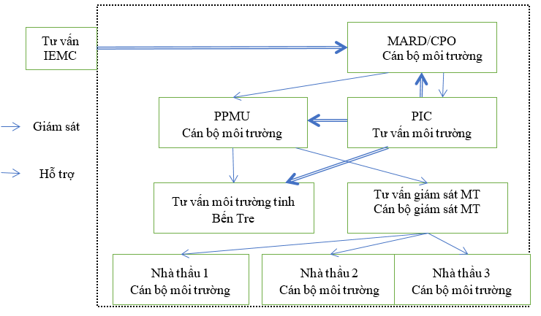
Figure 5.1: Diagram of subproject environmental management system
Table 5 - 3: Roles and responsibilities of environmental management organizations
Unit | Responsibility about the environment
Project implementation agency (CPMU) | - The CPMU is responsible for overall monitoring of the subproject implementation, including subproject environmental compliance.  - CPMU will have ultimate responsibility for the ESMF implementation and project's environmental effectiveness in both construction and operation phases.
Provincial Project Management Unit (PPMU) | - Responsible for overall monitoring of the subproject implementation, including subproject environmental compliance.  - Ensure that the environmental management system is in place with sufficient resources to implement the ESMP.  - The PPMU will: i) work closely with local authorities to ensure the community participation in the subproject preparation and implementation; ii) monitor the implementation of ESMP, including integrating ESMP into detailed technical design and bidding documents and contracts; iii) ensure the establishment and effective operation of the environmental management system.  - Appoint an officer in charge of environmental, safeguard and health issues – Approve the C-ESMP.
Officer in charge of Environment (under PMU) | - Regularly monitor the environmental, social, safety and health (MXAS) issues of the subproject; direct the CSC and contractors to implement mitigation measures according to C-ESMP and measures.  - Check, comment the C-ESMP, periodic and extraordinary reports on MXAS submitted by the CSC and contractors.  - Provide information, join field visits with inspection teams.
Officers in charge of Resettlement and Social safeguards | The PMU will appoint at least one resettlement and social safeguard officer to deal with the Project's social and resettlement issues and monitor the compliance with the Resettlement Policy Framework and the Resettlement Action Plan, and participate in understanding and resolving complaints related to land acquisition and social issues.
Environmental Monitoring Consultant (EMC) | - Support Ben Tre PPMU in preparing the content to disclose information on the site, preparing the ESHS terms in the bidding documents and participating in the negotiation of construction contracts during the subproject implementation.  - Instruct the construction contractors to make site environmental management plans (C-ESMP), review and inspect the C-ESMP formulation before submitting them to the PPMU for approval.  - Instruct the construction contractors and the CSC to record in construction logs, monitoring logs and environmental safeguard compliance reports to serve the PPMU reports and provide them as required by the CPO/CPMU/EMC and managed by the CPO/CPMU (IEMC).  - Support the PPMU to monitor and prepare periodic environmental assessment and compliance reports to CPO/CPMU/WB.  - Contact the PPMU for guidance on monitoring and reporting.  - Check the Contractor's implementation of mitigation measures and give instructions on taking remedial measures.  - Report the ESMP implementation status to the PPMU and prepare to give comments on environmental monitoring during construction.
Construction supervision consultant (CSC) | - Review and evaluate the implementation of environmental management.  - Check and review the contractors’ environmental management plans before submitting them to the PPMU for approval.  - Regularly inspect the site, evaluate the environmental protection measures in accordance with the regulations of the CESMPs and contract documents. Evaluate the effectiveness of mitigation measures and implementation of subproject environmental management activities.  - Direct the contractors to take remedial measures when they are not yet in compliance.  - Prepare monthly reports on environment, society, safety and health and submit them to the PPMU.  - In the event of unforeseen issues in the C-ESMP or ESMP of the subproject, the CSC should work closely with the contractors and the PPMU's environmental and social officer to find solutions, instruct the contractors to update C-ESMPs, instruct the implementation and training for contractor staff.
Independent monitoring consultant (IEMC) | - Support the PPMU to set up and operate an environmental management system.  - Train and build capacity for the stakeholders in the implementation and monitoring of C-ESMP implementation in both construction and operation phases.  - Monitor the compliance with EHS, make recommendations on adjustment and addition of mitigation measures.
Contractors | - Carry out all licensing procedures (traffic control and flow, excavation, labor safety, etc.) before constructing works in accordance with the current regulations.  - Comply with relevant legal requirements on environment, safety and public health.  - Appoint officers in charge of MXAS.  - Implement measures to mitigate environmental and social impacts according to the subproject ESMP and conditions stated in bidding documents/construction contracts.  - Assign representatives to participate in the field monitoring process organized by CSC's environmental safeguard (ES) staff to promptly grasp and handle non-compliance issues.  - Implement corrective actions under the direction of the environmental officers (ECO) of the PPMU and ES.
Local communities | According to Decision No.80/2005/QD-TTg, communities living in the subproject area where construction activities are involved will participate in environmental monitoring.
Ben Tre Department of Natural Resources and Environment | Check according to the State management function for the implementation of environmental protection measures of the subproject.
World Bank | ESMP compliance monitoring

5.2.2. Environmental compliance framework

5.2.2.1. Contractors' environmental responsibilities
Firstly, the contractors are responsible for minimizing impacts that may arise from construction of the subproject. Secondly, the contractors are responsible for applying the mitigation measures stated in the C-ESMPs to prevent harms and affects to the local community and the environment caused by construction activities.
The contractors' responsibilities include, but are not limited to:
- Comply with relevant legal requirements regarding the environment, safety, and public health;
- Work according to contractual requirements, bidding terms and conditions;
- Assign representatives of construction teams to participate in the construction sites inspection organized by environmental supervision officers of the Construction Supervision Consultant;
- Make any corrective actions required by the PMU Environment Officer and the Environmental Monitoring Officer;
- In the event of discrepancy/noncompliance, investigation and proposal of mitigation measure must be conducted and corrective actions should be taken to address environmental impacts;
- Stop construction activities causing serious impacts as directed by the Environmental Officer and the Environmental Monitoring Officer.
- Propose and implement corrective and alternative construction measures, if required, to minimize environmental impacts. The contractors will be suspended from construction if they fail to comply with mitigation measures and will be suspended until they resolve non-compliance issues as approved by the Environmental Officer and the Environmental Monitoring Officer.
- After signing contracts, the contractors must develop contractors’ social and environmental management plans (C-ESMPs) for each package, based on the ESMP regulations and contractual terms, and submit them to the PPMU for review and approval.
- In case the contractors propose raw materials, which are not mentioned in the subproject ESMP, they must report to the CSC, PPMU and coordinate with them to perform assessments with high responsibility on the environmental aspects of these materials to assess if the compliance with Vietnam's environmental requirements is ensured.

5.2.2.2. Contractors' Environment and Safeguard Officers (SEO)
The contractors must appoint a qualified individual to be an Environment and Safeguard Officer (SEO) at the contractors' sites. The SEO must be the one that got training in environmental management and have necessary skills to impart knowledge of environmental management to all contracting personnel. The SEO will be responsible for monitoring the contractors’ compliance with the ESMP and environmental specifications. The SEO’s duties include, but are not limited to:
- Conduct on-site environmental monitoring to evaluate and audit the contractors' field practice, construction tools and methods related to pollution control and adequacy of the implementation of mitigation measures to environmental impacts;
- Monitor the compliance with environmental protection measures, pollution prevention measures, control measures, and contractual requirements;
- Monitor the implementation of environmental mitigation measures;
- Make an audit report on environmental monitoring data and environmental conditions of the construction sites;
- Investigate complaints and make recommendations about any corrective actions that needs to be taken;
- Advises the contractors on environmental improvement, awareness raising measures and proactively preventing environmental pollution;
- Propose appropriate mitigation measures for contractors when detecting non-compliance; perform additional monitoring of noncompliance as directed by the ECO/ES;
- Inform the contractors and the ECO/ES of environmental issues; submit C-ESMP implementation plans to the ECO/ES and the relevant agencies, if required;
- Keep detailed records of all site activities that may be related to the environment.

5.2.2.3. Independent Environmental Monitoring Consultant (IEMC)
The IEMC is responsible for assisting the PPMU in implementing the ESMP. This also includes advising CSC, contractors and communities on environmental compliance and implementation of monitoring programs in accordance with the Government’s and the World Bank’s regulations and processes. After the PPMU and the WB have finished discussing the implementation of detailed environmental monitoring program activities, the IEMC is responsible for checking every 6 months and assisting the PPMU staff to monitor the general activities of the subproject to ensure that the environmental protection policies of the Government of Vietnam and the World Bank (WB) are applied and monitored throughout the subproject implementation. The IEMC is responsible for: (1) training and capacity building in construction management to the PMU/ESU staff, including field engineers and/or CSC consultants about the supervision of contractors’ implementation of C-ESMPs; (2) ensuring active participation of local communities in the subproject area, and (3) develop environmental training programs.
Specifically, the IEMC’s responsibilities are as follows:
- Evaluate the effectiveness of mitigation measures provided by the contractors and the CSC during the implementation process; provide recommendations to the PPMU on necessary improvements and additions to meet the requirements of environmental protection.
- Report periodically (6 months) to the CPMU on the compliance and the effectiveness of the ESMP implementation during the subproject implementation.
- Establish standard procedures, methods and forms to assist the PPMU and the CSC in assessing contractors’ construction progress in implementing monitoring measures and minimizing impacts on the environment.
- Assist the PPMU staff in evaluating and checking relevant parts in contract documents of subproject construction works to ensure the compliance with the environmental protection policy and mitigation requirements and environmental impact monitoring.
- Assist in preparing documents and implementing training programs on environmental monitoring for contractors, CSC and PPMU staff (environmental officers and package coordinators).
- Through the PPMU, discuss with relevant contractors (if necessary) to find appropriate solutions to unexpected risks related to environmental sanitation.

5.2.2.4. Environmental Monitoring Consultant (EMC)
At the subproject level, the EMC will support the PPMU during the ESMP implementation, including monitoring of environmental quality and preparing safeguard policy reports to the PPMU. The EMC will provide professional technical services (consulting services) to monitor the compliance of the subproject activities based on the regulations outlined in the Environmental and Social Management Plan (ESMP) approved for the subproject. The EMC will advise the CSC, the contractors and the communities on the environmental compliance and the implementation of the monitoring program pursuant to the regulations and procedures of the State and the World Bank. The EMC will be in authority for quarterly monitoring and inspections and assisting the PPMU staff to monitor the overall subproject activities to ensure the consistency in the environmental protection policies of the Government and the World Bank which are applied throughout the subproject implementation process. The EMC's duties are as follows:
- Assist Ben Tre PPMU in drafting contents of information disclosure on the sites; preparing ESHS terms in bidding documents and participating in negotiations of construction contracts during the subproject implementation.
- Instruct the contractors to prepare contractors’ site environmental management plans (C-ESMPs), review and inspect the C-ESMP formulation before submitting them to the PPMU to approve C-ESMPs.
- Instruct the contractors and the CSC to record in construction logs, monitoring logs and environmental safeguard compliance reports to serve the PPMU reports and provide information as required by the CPO/CPMU/IEMC managed by the CPO/CPMU (IEMC).
- Support the PPMU to monitor and prepare periodic environmental assessment and compliance reports to the CPO/CPMU, WB/CPO.
- Work with the PPMU for guidance on monitoring and reporting.
- Check the implementation of the contractors’ measures to minimize environmental impacts and give instructions on remedial measures.
- Report the ESMP implementation status to the PPMU and present comments on environmental monitoring during construction.

5.2.2.5. Construction Supervision Consultant (CSC)
During the construction phase, the Construction Supervision Consultant (CSC) must have at least one environmental officer in charge of the environmental supervision as part of the construction supervision task. The CSC is accountable for inspecting and monitoring all construction activities to ensure that the mitigation measures stated in the C-ESMPs are fully implemented and negative environmental impacts of the subproject are at the minimum. Specifically, the environmental officer will:
- Represent the PMU to review and evaluate the construction design meeting the requirements of the mitigation and management measures of the ESMP;
- Check and confirm environment monitoring process, parameters, locations, equipment and monitoring results with the PPMU;
- Supervise the contractors’ site environmental management system, including the contractors' operation, experience, and handling of environmental issues on site and provide instructions for corrections if necessary;
- Make reports on the ESMP implementation to the PPMU and prepare environmental monitoring reports during the construction phase;
- Consider claims of payment in relation to the costs associated with minimizing environmental impacts, if any.

5.2.2.6. Comply with legal requirements and contractual requirements
The construction activities must comply with not only the pollution control and environmental protection requirements but also the requirements of the Government of Vietnam's laws and regulations on pollution control and environmental protection.
All reports on construction measures submitted by the contractors to the ES for approval will be sent to EMC, EO to review whether they reflect pollution control and environmental protection measures or not. At the same time, the ES will review the construction progress and program to ensure there are no violations of relevant environmental laws and regulations and possibly prevent any potential violations.
The contractors must copy appropriate records and submit them to EO, EMC and ES. Records should at least include progress reports, up-to-date construction measures, and application for permits of the environmental protection laws and regulations and all valid permits of relevance. EO, EMC and ES should also have access to construction logs, if required.
After reviewing documents, EO, EMC or ES will advise the contractors any noncompliance with the legal requirements and contractual requirements on pollution control and environmental protection in order that the contractors will take appropriate measures. If EO, EMC or ES conclude that the license application and any preparations for pollution control and environmental protection may not comply with the measures of the works or could lead to a breach pf the requirements for pollution control and environmental protection, EO, EMC or ES will notify the contractors.
5.2.2.7. Organization of making report
The monitoring ESMP performance and reporting requirements are summarized in the Table below.
Table 5 - 4: Report requirements
No. | Report makers | Submission | Reporting frequency
1 | Contractors report to the PPMU | Provincial Project Management Unit | Contractors are obliged to report periodically once a month and irregularly (when there is an incident) to the PPMU
2 | Construction Supervision Consultant (CSC) | Provincial Project Management Unit | CSC is obliged to report periodically once a month and irregularly (when there is an incident) to the PPMU
3 | Environmental Monitoring Consultant (EMC) | Provincial Project Management Unit | EMC is obliged to submit periodic reports to the PPMU every 3 months
4 | Environment and Social Monitoring Consultant (IEMC) | CPMU | IEMC is obliged to submit reports to CPMU every 6 months
5 | Community supervision | Provincial Project Management Unit | When the community has any complaints about the subproject’s safeguard implementation
6 | Provincial Project Management Unit | DONRE,  CPMU | PPMU is obliged to submit reports to DONRE every 3 months according to the Government’s regulations  PPMU is obliged to submit reports to CPMU every 01 month
7 | Provincial Project Management Unit | World Bank | PPMU is obliged to submit reports to WB every six months according to Section II of the Loan Agreement
The PPMU reports should cover the implementation/compliance with the environmental safeguards policy to submit to the World Bank prior to the support meeting for each subproject, and should mainly include: (i) preparation and publication of environmental safeguard policy tools for subprojects; (ii) inclusion of ESMPs of new subprojects in bidding and contract documents; (iii) supervising contractors’ ESMP implementation, construction supervision; and (iv) difficulties and challenges for the implementation of CSAT, solutions and lessons learned.

5.2.2.8. The system of environmental complaints and sanctions
According to the compliance framework, if CSC/ES detects that the environmental regulations are not complied with, during the construction supervision phase, 2% of the mid-term payment values of that month of such contractors will be halted. The contractors will have a grace period (determined by CSC/ES) to correct their violations. If they fix violations within the grace period (as confirmed by CSC/ES), there will be no penalty and the withholding amount will be disbursed. However, if they fail to remedy violations within the grace period, they must pay a third party to correct such violations (to be deducted from the withholding amount).
In case CSC/ES does not detect any violations of contractors in compliance with the environmental regulations, they will be responsible for paying for correcting violations.

5.2.3. Recommended training program
The table below provides a typical safeguard policy training program. The training program will be developed and implemented by the Technical Assistance team to implement the safeguard policy for the PPMU. The PPMU/IEMC with the help of the Technical Assistance team will provide training for the contractors, CSC and other groups.
- Groups of trainees: PMU staff, ESU staff, site engineers (FE), Construction Supervision Consultant (CSC), construction contractors, stakeholders' representatives and local communities in the subproject area. The contractors are responsible for training their workers and drivers.
- Training schedule: The training will be at least one month before the first construction contract. Follow-up training sessions can be revised to fit the construction schedule of the subproject components.
- Training frequency: The basic training programs given in the table below will be provided every 6 months and the content will be updated and in accordance with the items to be implemented. The training program for PPMU staff is scheduled in the first years of the project. The 03-day training for the CSC and the contractors is also expected to take place twice a year for at least 2 years.
Table 5 - 5: Program to improve environmental and social management and monitoring capacity
1. Subjects | PPMU
Training content | Monitor and report environmental problems
Participants | Technical officers and environmental officers
Training frequency | Immediately after the subproject starts but at least 1 month before the first construction activities
Number of training days | 2 times/year and 2 days/time and take place every year during the subproject implementation
Training content | − The general environmental management related to the subproject includes the requirements of WB, Department of Natural Resources and Environment and coordination with stakeholders.  − Requirements for environmental monitoring.  − Monitor the implementation of mitigation measures; participation in environmental monitoring.  − Guide and supervise contractors, CSC and communities in the implementation of environmental monitoring.  − The forms used in environmental monitoring.  − Risk control and response.  − Safeguard policy forms and how to submit reports.
In charge of training | CPMU/CPO, IEMC under the support of the Safeguard Policy Technical Staff.
2. Subjects | CSC, contractors
Training content | Implement measures to minimize environmental and social impacts, monitoring methods and recording forms
Participants | CSC; field construction managers, contractors' environmental officers
Training frequency | Determined after bidding and changed according to actual requirements
Number of training days | 2 times/year, 2 days/time
Training content | − Overview of environmental monitoring  − Requirements of environmental monitoring  − Roles and responsibilities of contractors and CSC  − Content and environmental monitoring methods  − Risk response and control  − Disseminate the types of monitoring and instructions on how to fill out risk reports and forms  − Prepare and submit reports
In charge of training | PPMU, IEMC, EMC under the support of the Safeguard Policy Technical Staff.

5.3. COST ESTIMATION
The funding for the ESMP implementation includes (a) the costs of implementing the contractors’ impact mitigation measures, (b) CSC's supervision cost, (c) salary of the PPMU's safeguard officers, (d) subproject environmental monitoring cost, (e) the costs for the Environmental Management Consultant (EMC) including environmental quality monitoring, (f) the technical assistance cost for training safeguard policy and technical services. All costs will be included in the subproject costs. The details are as follows.
- The costs for implementing mitigation measures during the construction will be part of the contract costs. The CSC's supervision costs are specified in the construction supervision contracts.
- The costs for the EMC and environmental quality monitoring during the construction are included in the subproject cost.
- The costs for the activities related to the implementation of the ESMP of the PPMU are included in the management cost of the subproject.
- The technical assistance cost to train safeguard policy and technical services to mitigate negative impacts during construction and operation including consultation with water user groups and main stakeholders.
- The technical assistance cost to mitigate impacts of operating livelihood models, especially (a) support for poor farmers, including socio-economic surveys, support for product development, on-shore training on aquaculture models and building farmer networks, and (b) establish a quality registration system for aquatic products.
The cost estimate for the EMP implementation (excluding the costs of implementing environmental protection measures by the contractors and the cost of implementing RAP) is provided in the following table.
Table 5 - 6: Estimated cost of EMP implementation for the entire subproject
Activities | Funding sources | Cost (VND)
a). Mitigation measures during construction | Part of a construction contracts
(b). Safeguard monitoring during construction (24 months x 10 million VND/month x 2 officers) | Included in the scope of work and contract value of construction supervision consultants | 480,000,000
(c). Safeguard Officer of PPMU | Part of the cost of the subproject
(d). Environmental monitoring for the entire subproject | Part of contract for environmental monitoring package | 471,092,400
(e). Environmental Monitoring Consultant (50 months x 15 million VND/month) | Part of contract for environmental monitoring package | 750,000,000
(f). Technical assistance cost for safeguard policy training and technical services to minimize negative impacts during construction and operations. Training contents include capacity training on environmental protection, training on environmental monitoring, training on occupational safety and environmental safeguard measures. | Part of the cost of the subproject (8 classes x 20 million/class) | 160,000,000

5.4. GRIEVANCE REDRESS MECHANISM (GRM)
As regulated in the Vietnamese Legal Framework, citizens have the right to complain. Therefore, in order to ensure people's right to complain about subproject's issues, there will be a grievance redress mechanism (GRM) for the subproject. This mechanism makes it easy for people to access and provide information about the subproject. All complaints will be quickly resolved at the lowest level. This mechanism will provide a framework for quickly resolving environmental complaints and addressing safeguard issues.
The GRM will be completed in the final period of the project design and posted appropriately prior to construction.
During the construction phase, the GRM will be executed by the contractors under the supervision of the CSC. The contractors will notify affected communities where their complaints are settled. This will be through the public consultation and disclosure process that the contractors can be in regular dialogue with affected communities and local authorities through meetings (at least once a quarter), and monthly documents will be published, through local media announcing the upcoming plans of the subproject.
All complaints and actions taken by the contractors will be recorded in the safeguard monitoring reports of the subproject. How to submit complaints and claims for damages is as follows:
- Verbal: directly speaking to contractors' EHS officers or contractors' representatives at the project offices;
- Writing: addressing writing complaints to specified addresses (pursuant to the complaint order at the levels of commune people's committees - Thanh Phu District People's Committee - Ben Tre Province People's Committee);
- By phone, fax, e-mail: to CSC, EHS officers or contractors' representatives.
Upon receipt of complaints, CSC and EHS officers or contractors' representatives will record them in grievance redress logs/records and maintain logging of the events related to such complaints until they are resolved. Immediately after receiving complaints, 03 copies of each must be photocopied. The original copy will be filed and 3 copies will be sent 1 for the contractor’s EHS officer, 1 to CSC, and 1 to the PPMU within 24 hours.
Information to be kept in grievance redress logs:
- Dates and times to receive complaint;
- Names, addresses and contact details of complainants;
- Brief description of complaints;
- Actions to be taken to address complaints include: who was contacted and results of each step in the grievance redress process;
- Dates and times of contacting complainants during the grievance redress process;
- Final treatment solutions;
- Dates and times and how to notify complaints settlement results;
- Complainants’ signatures when receiving results.
Insignificant complaints will be resolved within one week. For large complaints written responses will be sent to complainants within the first 2 weeks (and then weekly) by directly delivery, posting, fax, email on the complaint resolution until the final documents are finalized.
The main objective of this mechanism is to resolve complaints as quickly as possible by simple means, involving as few people as possible and at the lowest level as possible. Only when an issue that cannot be resolved on a simple basis and/or within 15 days, other authorities will be involved. These are the situations when damages are claimed and the amounts paid are unable to address such damages and the sources of such damages are unknown.
Grievance Redress Service (GRS) of the World Bank. Communities and individuals who believe that they are being affected by World Bank-financed projects can file their complaints with the project-level grievance redress agencies or the GRS. The GRS ensures that complaints received are promptly reviewed to resolve project-related complaints. Communities and individuals affected by the project can file their complaints with the World Bank's Independent Inspection Committee which will determine whether damages occur or not that originate from the non-compliance of related procedures. Complaints can be filed at any time after they have been filed with the World Bank, and the World Bank's Manager will respond to this. For information on how to file a complaint with to the GRS, please visit www.worldbank.org/grs. For information on how to file a complaint to the World Bank's Independent Inspection Committee, please visit www.inspectionpanel.org.

PUBLIC CONSULTATION AND INFORMATION

  - SUMMARY OF PUBLIC CONSULTATION ORGANIZATION
During the subproject's environmental and social impact assessment, the public consultation and disclosure of environmental information were implemented to ensure the consensus of local authorities, organizations and local communities, who are affected directly by the subproject. Through community consultation, adverse environmental impacts were confirmed and mitigation measures were proposed and communicated to communities to give them the opportunity to comment. The consultation results were recorded and included in the Environmental and Social Management Plan.
Objectives of public consultations
The subproject’s public consultation required during the ESMP implementation was undertaken. The community involvement and consultancy meetings were held to: provide useful information, better understand the subproject and its potential impacts, and improve the subproject as needed; allow discussion of controversy issues; facilitate quick problem resolution; facilitate the establishment of transparent procedures to implement the proposed subproject and create the accountability and awareness on local ownership during the subproject performance. The affected groups and local NGOs were notified in accordance with the WB's Operation Policy (OP 4.01) on EIA and EPP; and the involvement was required during the subproject preparation to some extent and regularly recommended as a part of the implementation.
Methods of public consultations
The meetings were held with the concerned commune people’s committees, Vietnam fatherland front committees, and veteran unions, women’s unions, youth unions, households to be directly affected by the subproject, PPMU and consultants. Opinions were released after the Project Owner reported: Overview of the contents and main work-items of the subproject and financial resources for implementation. The Consultant presented the environmental and social impacts (ESIs) of the subproject. The Consultant also presented the ESMP, including mitigation measures and implementation plans. The environmental and social impacts in the past were consulted.
The main contents of the public consultation and information disclosure include:
− Consultations with the participation of local authorities and people in the subproject area in the preparation and implementation of the ESMP to provide necessary information for local authorities and communities to understand more about the subproject, negative impacts of the subproject implementation and measures to minimize these negative impacts;
− Clarify discussed issues in the early stages of the subproject;
− Announce benefits achieved when implementing the subproject;
− Responsibilities of local authorities and awareness of stakeholders and beneficiaries in the subproject area during the subproject implementation;
− Encourage community participation in determining environmental impacts of the subproject.
− Gather information on needs as well as messages of local people and authorities in construction and proposals to minimize environmental impacts; consider design adjustments in the engineering design phase.
Public consultation results and responses of the Project Owner
The Subproject Owner conducted consultations from 11 – 20 May 2020 with the representatives of the mass organizations in the subproject communes/wards and the households affected on their environment and social conditions: ward people's committees, fatherland front, mass organizations (invalids unions, women's unions, youth unions) and households with environmental and social impacts in each subproject area. The community consultation was carried out through consultation meetings in the following communes:
Table 5 - 7: Community consultations
No. | Work-items | Locations for community consultations
1 | Work-item 1: Upgrading embankments of Co Chien river pair, combined as rural traffic road grade A | An Thuan
 |  | Binh Thanh
2 | Work-item 2: Upgrading embankments of Bang Cung river pair, combined as rural traffic road grade A | An Qui
 |  | An Thanh
3 | Work-item 3: Reinforce the sea dike surface combined as plain-V road | Thanh Phong
4 | Work-item 4: Mangrove Ecoregion, about 4000 ha | An Dien
5 | Work-item 5: Zone 2 - Mangrove Ecoregion, about 14000 ha | An Nhon  Giao Thanh
Local authorities and people in the subproject communes/wards wholeheartedly agreed with the subproject implementation because it will bring socio-economic and environmental benefits. There are 05/18 communes affected by infrastructure construction, which necessitates environmental sanitation during construction, particularly limiting dust, gas, and road damage and completing quickly to ensure the progress. The results of public consultations in 05 communes are provided in the following table.
Table 5 - 8: Public consultation results and responses of Project Owner
Works/Communes | Participants’ opinions | PPMU’s responses
Work-item 1: Upgrading embankments of Co Chien river pair, combined as rural traffic road grade A | An Thuan commune  The compensation for site clearance must be adequate to affected people.  The environmental impacts must be minimized when there is excavation of soil.  It is a hope that the subproject will be implemented soon. | The compensation, assistance and resettlement must be implemented according to the project policy.  The Subproject Owner committed to seriously taking environmental mitigation measures set out in the ESMP.
Work-item 2: Upgrading embankments of Bang Cung river pair, combined as rural traffic road grade A | An Quy commune  The compensation for site clearance must be adequate to affected people in case of there is land acquisition for the subproject.  During hot days, it is necessary to water the roads for construction, and to keep dust to a minimum.  Ensure temporary drainage to avoid waterlogging during construction.  An Thanh commune  During the construction, there must be a way for people’s movement.  The subproject should early implement the construction works.  There must be planned for embankment against landslide. | The compensation, assistance and resettlement must be implemented according to the subproject policy.  The Subproject Owner committed to seriously taking environmental mitigation measures set out in the ESMP.  During construction, temporary ditches and sedimentation pits will be excavated to drainwater, avoiding water pollution.
Work-item 3: Reinforce the sea dike surface combined as plain-V road | Thanh Phong commune  Agree on the construction of works but it needs to protect the environment via waste management, dust reduction, and traffic safety when transporting materials.  Before construction, they must notify farmers 1 month in advance to arrange appropriate production. | The Subproject Owner committed to seriously taking environmental mitigation measures set out in the ESMP.  Hire trucks for watering twice a day to reduce dust emission.  Material transportation trucks shall be registered and move on registered roads, the trucks will be covered to prevent dust and drops on the roads.  The Subproject Owner will work with the Commune People's Committees on the construction plans to promptly notify people.
Work-item 4: Mangrove Ecoregion, about 4000 ha | An Dien commune  The construction works of the subproject should be early implemented.  The construction must comply with the schedule.  Comply with environmental protection measures. | The Subproject Owner will try to complete the implementation of activities in accordance with the subproject implementation plans.  The Subproject Owner committed to seriously taking environmental mitigation measures.
Work-item 5: Zone 2 - Mangrove Ecoregion, about 14000 ha. | Giao Thanh commune  The subproject is suitable and meets the expectations of the people.  The subproject should be started as soon as possible.  Comply with environmental protection measures as stated in the report.  An Nhon commune  The subproject is highly feasible and has a few environmental impacts.  It needs to guide in detail the specific production models for people.  Agree to deploy the subproject. | The Subproject Owner shall try to complete profiles and proceed procedures to soon implement the subproject.  The Subproject Owner committed to seriously taking environmental mitigation measures set out in the ESMP;  The Subproject Owner will work with the Commune People’s Committees on the construction plans to promptly notify people.

  - INFORMATION DISCLOSURE
As required by the Government and the WB on the information disclosure, Ben Tre the PPMU has announced Vietnamese draft version of the ESMP at the CPO, DARD, Provincial People's Committee, districts and communes in Ben Tre province. English draft version of the ESMP will be uploaded on the World Bank's Infoshop. The official ESMP will also be announced locally relevantly and on the Infoshop in April 2021.

CONCLUSION, RECOMMENDATION AND COMMITMENT

CONCLUSION
After Subproject "Infrastructure to Improve Livelihoods in Northern Thanh Phu Area to Adapt to Climate Change" is complete, it will finalize the objectives: mitigation and prevention of natural disasters (drought, salinity, inundation), serving people and economic development, improvement of soil and environmental, stabilization of people’s lives in the region while coping with climate changes, enabling the agricultural restructuration to develop sustainably in line with the general planning orientation of the socio-economic development of Ben Tre province.
The subproject makes basic for the development of economic livelihoods and waterway infrastructure for convenient transportation of agricultural products, reducing production costs and increasing profits for people. It will make contributions to exploiting potentials and strengths of the garden economy, making use of water surface resources for ecotourism and river tourism, and creating people's trust in the government and leaders at all levels, at the same time. The subproject is also considered a leverage for the promotion the economic development in the subproject area in particular and the whole province of Ben Tre in general.
However, in addition to positive impacts, there are more or less negatives occurring during the construction phase such as air pollution, surface water, soil... but they occur in short time of the construction phase. Therefore, general speaking, they are not very significant against the subproject’s positive effects.
During the operation phase, it is necessary to monitor impacts of likely occupational accidents, canal bed sedimentation, work subsidence... however, the above impacts will be monitored periodically and the mitigation measures are strictly complied and implemented.
Therefore, it can be seen that subproject negative impacts are trivial and mainly in the construction phase. The subproject area is sparsely populated. The subproject works are close to water sources and canals. In the operation phase it needs to keep monitoring and supervision to address negative impacts.
RECOMMENDATION
The subproject features social security and irrigation of Ben Tre province. The project investment does not bring much direct profits to the operator. However, more importantly, it facilitates daily activities and economic production of people in Thanh Phu district, Ben Tre province in particular and neighboring areas in general in an attempt to create confidence and stability in people's lives. In addition, the benefits brought about by the project's works contribute to minimizing losses of economic production, crops, and aquaculture in the region due to developments and impacts of climate change which tends to be more and more complex.
Impacts on the local natural and social environment may arise during the subproject construction. However, the response and control plans are outlined in Chapter 3 to effect environmental protection measures and smooth coordination among the parties: From the Project Owner and construction units to the local departments and mass organizations.
On the basis of the researched results and presentations in this report, the Project Management Unit of Construction and Investment Works for Agriculture and Rural Development would like to submit the competent authorities for the appraisal and approval of the ESMP of the subproject "Infrastructure to Improve Livelihoods in Northern Thanh Phu Area to Adapt to Climate Change" in Thanh Phu district, Ben Tre province to apply it to implement the subproject smoothly and on schedule.
COMMITMENTS
- General commitment:
The Subproject Owner of the “Infrastructure to Improve Livelihoods in Northern Thanh Phu to adapt to Climate Change” commits to comply Vietnam’s current provisions on the environmental protection: Law on Environmental Protection in 2014, relevant laws and sub-laws (Decree No.40/2019/ND-CP dated May 13, 2019 amending and supplementing a number of articles of the decrees regulating and guiding the implementation of the Law on Environmental Protection; Decree No.38/2015/ND-CP dated April 24, 2015 on management of wastes and scraps; Decree No.80/2014/ND-CP dated August 6, 2014 on drainage and wastewater treatment...) and a number of plans of Ben Tre province.
The Subproject Owner commits to fully implement measures to minimize environment negative impacts of the subproject in the preparation phase, construction phase and operation phase according to the content presented in Chapter 3 of this ESMP as follows:
- Commitments in the preparation phase
- The Subproject Owner commits to implement the terms of compensation for site clearance outlined in the Resettlement Plan Report (RAP) attached to the subproject.
- The Subproject Owner commits to fulfil measures to minimize impacts on the surrounding environment and socio-economic conditions in the construction area when carrying out the construction sites clearance.
- Commitments in the construction phase
- Arrange and organize construction workers and construction sites sanitation to avoid environmental pollution caused by waste generation activities from construction sites commanders, construction workers and construction machinery and equipment;
- Arrange and organize appropriate traffic to limit affecting waterway on the rivers, canals and internal areas surrounding the construction sites;
- Commit not to use overloaded means of transport and takes measures to minimize air pollution during transportation and gathering on the site;
- Collect, manage and control all kinds of waste generated such as: wastewater, exhaust gas, solid waste and hazardous waste in the construction phase to ensure the environmental sanitation in accordance with the regulations;
- Commit to transport construction waste into disposal sites only when being approved by relevant individuals and local authorities in writing, and apply environmental protection measures in disposal sites to limit impacts on the surrounding area;
- Commit to take measures to minimize effects of noise and vibration arising from construction vehicles, machinery and equipment;
- Manage and train workers working on site to communicate and keep good relationships with local people;
- The Subproject Owner commits to accomplish the environmental monitoring programs and to be responsible to the State's environmental management agencies and local authorities for environment problems during the construction phase.
- Commitments in the operation phase
- Commit to regularly maintain construction structures: ring dikes, traffic bridges and auxiliary works;
- The Subproject Owner commits to supplying adequate financial resources for the provision, installation and operation of environmental management and monitoring programs and training on environmental safeguards. This financial source is included in the subproject's investment capital;
- The subproject activities are subject to the inspection and supervision of the relevant environmental management authorities of the Department of Natural Resources and Environment of Ben Tre province, the People's Committee of Ben Tre province and relevant authorities to ensure the subproject implementation, to minimize impacts and to protect the environment.
- The Subproject Owner commits to publicizing the content of the approved subproject ESMP in the localities where the subproject is implemented to monitor the compliance with the environmental protection commitments in the ESMP as approved.
- Commitment to comply with the following environmental regulations and standards:
The Subproject Owner commits to strictly comply with the environmental regulations and standards as follows:
- For exhaust gas: Ensure to minimize exhaust gas according to QCVN 05: 2013/BTNMT: National Technical Regulation on Ambient Air Quality;
- For noise: Ensure to minimize noise generated according to QCVN 26: 2010/BTNMT: National Technical Regulation on Noise;
- For solid waste: Ensure to collect and treat thoroughly, no spillage and dispersal into the surrounding environment to meet the requirements of environmental sanitation and in accordance with Decree No.59/2007/ND-CP dated April 9, 2007 of the Government on solid waste management; Decree No.38/2015/ND-CP dated 24/04/2015 of the Government on waste and scrap management;
- For hazardous waste: Commit to complying with the guidance of Circular No.36/2015/BTNMT dated 30/06/2015 of the Ministry of Natural Resources and Environment on hazardous waste management.
- Commitment to environmental management and control
The environmental management and pollution emission control will be given with top priority during the construction and operation of the subproject.
During the operation, the Project Owner commits to fully implementing the environmental pollution management and control programs in the subproject area as described in Chapter 5 of the ESMP and the periodical reports submitted to the Department of Natural Resources and Environment of Ben Tre province.
The Subproject Owner commits to properly and satisfactorily practicing the policies on compensation and environmental pollution remediation in the event of environmental incidents and risks occur caused by the subproject implementation.

REFERENCES

- The Ministry of Agriculture and Rural Development (MARD). Protection and Development of Coastal Wetlands in the South of Vietnam. The project is financed by a concessional loan of the World Bank (WB) and a non-refundable aid of Denmark (DANIDA), 2000 - 2005.
- United Nations Environment Program (UNEP). Environmental Impact Assessment - Basic processes for developing countries. Environment Department, 1988.
- Department of Environment. A Guide to Environmental Monitoring, 1998.
- Nguyen Van Phuoc, Nguyen Thi Van Ha. Curriculum on Environmental Quality Management. Construction Publishing House, 2006.
- Dinh Xuan Thang. Engineering Curriculum on Air Pollution Treatment. VNU Publishing House, Ho Chi Minh City, 2012.
- Tran Duc Ha. Curriculum on Environmental Protection in Basic Construction. Construction Publishing House, 2010.
- Report on the Agriculture Tasks in 2019 and Plans and Directions in 2020 of Thanh Phu district.
- Summary Report on Agricultural Activities in 2019 and Orientation for Activities in 2020 of Thanh Phu district.
- Hoang Hue. Wastewater Treatment, Construction Publishing House, 1996.
- Le Van Khoa. Analysis Methods of Soil, Water, Fertilizer, Crops. Education Publishing House, 2000.
- Alexander P. Economopoulos, Assessment of Sources of Air, Water and Land Pollution, Part 1: Rapid Inventory Technique in Environmental Pollution, WHO, Geneva, 1993.
- Hernado, M., D., Mezcua, M., F-Alba, A., R., Barcelo, D., 2006. Environmental Risk Assessment of pharmaceutical residues in wastewater effluents, surface waters and sediments. Talanta, 69, 334-342.
- World Bank, Guidelines for EIA, 1989. World Bank, Pollution Prevention and Abatement, Handbook, 1996.
- Central Project Office of Irrigation Projects - CPO, 2014. Mekong Delta Integrated Climate Resilience and Sustainable Livelihoods (MD-ICRSL)
- Central Project Office of Irrigation Projects - CPO, 2016. Developing Stable Livelihoods for People in the Coastal Areas of Ba Tri District, Ben Tre, Adapting to Climate Change.

APPENDIX

APPENDIX 1: EIA APPROVING DECISION
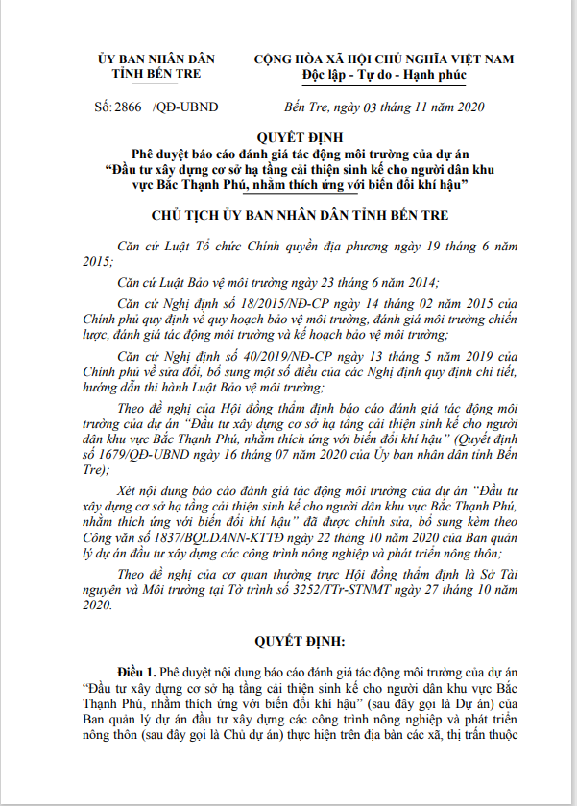

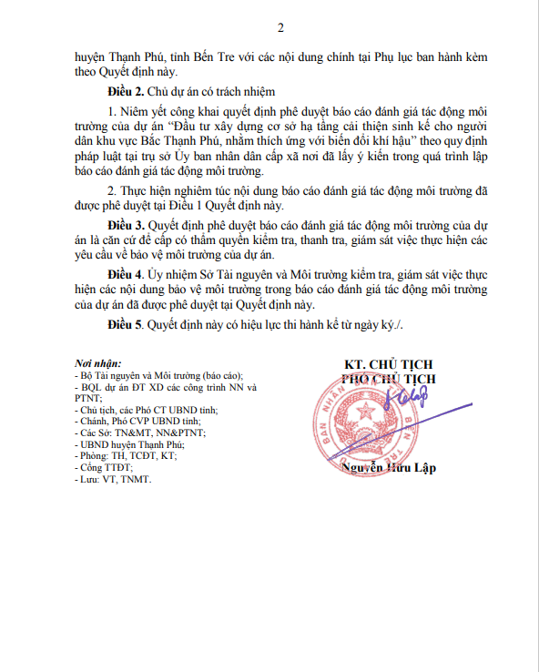

APPENDIX 2: SAMPLING CHART FOR ENVIRONMENTAL MONITORING
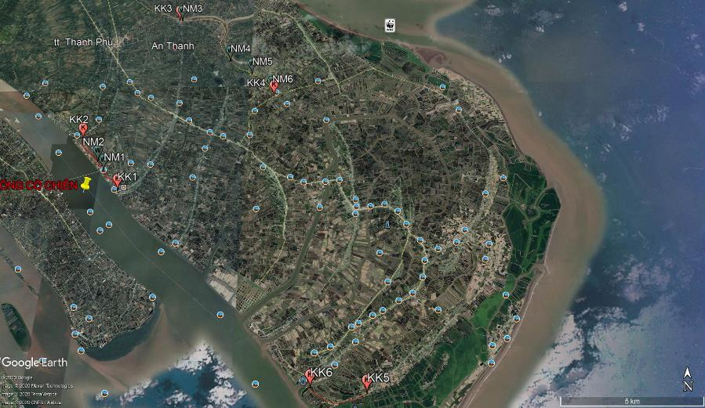

APPENDIX 3: SOME CONSULTATION MINUTES AND WASTE DISPOSAL AGREEMENTS
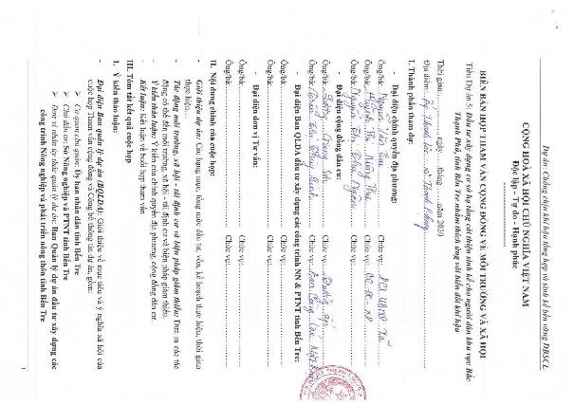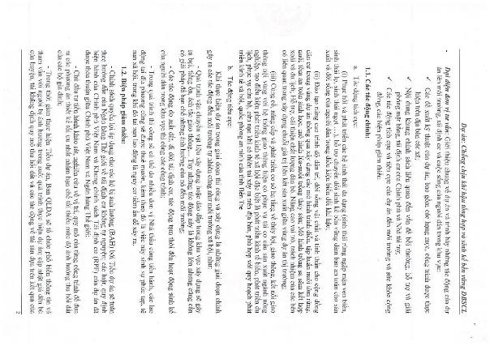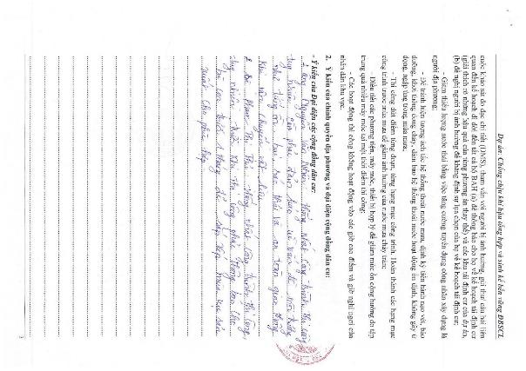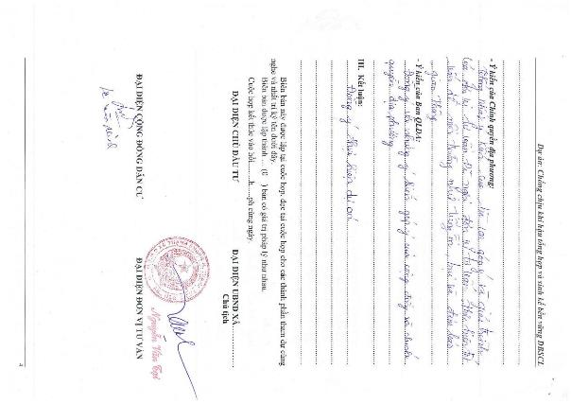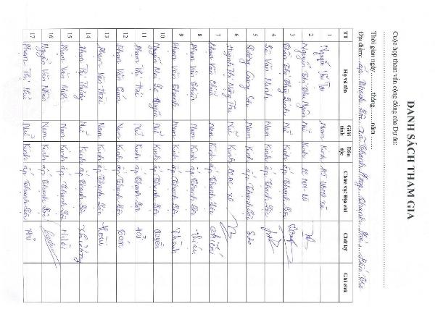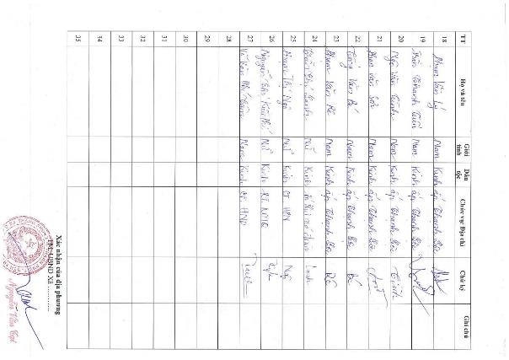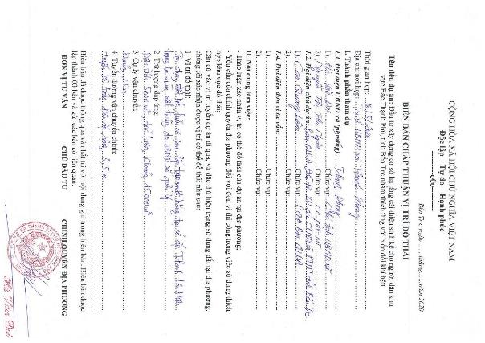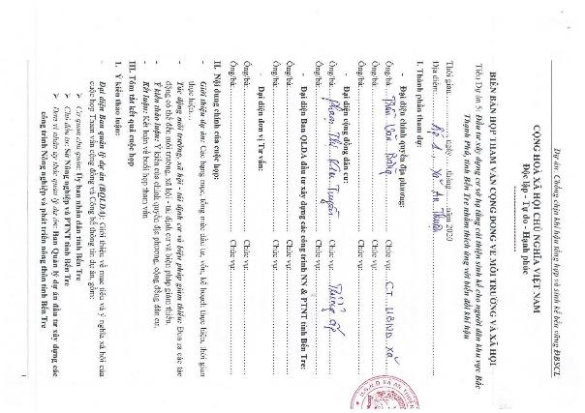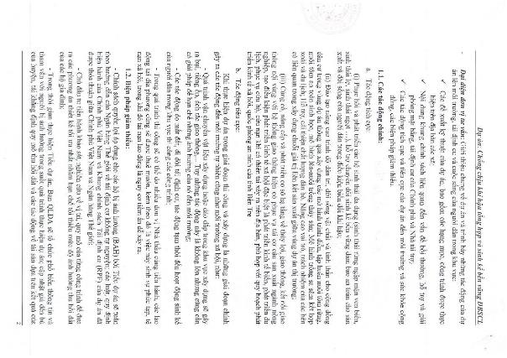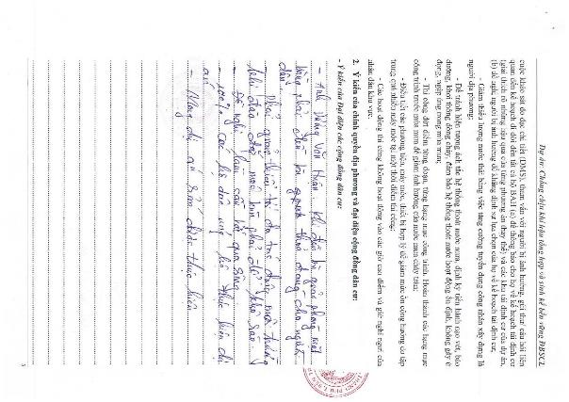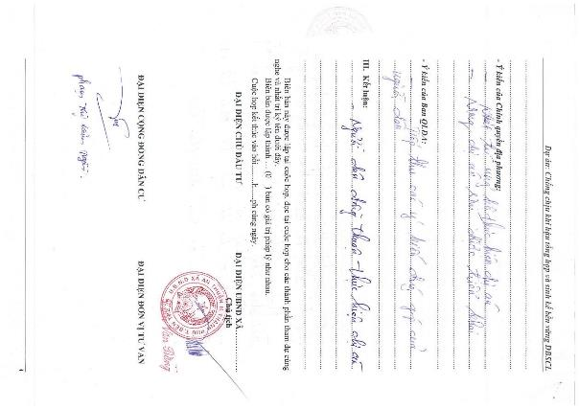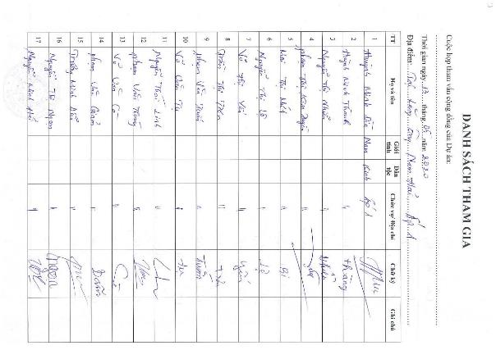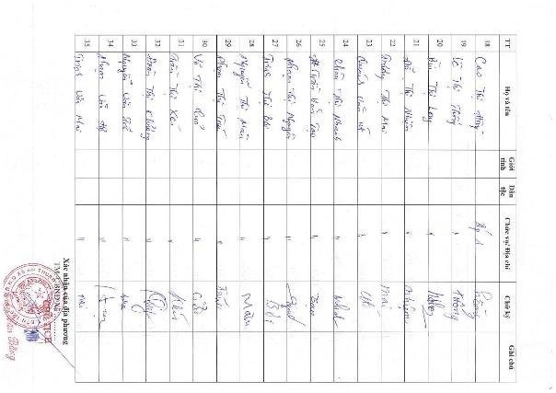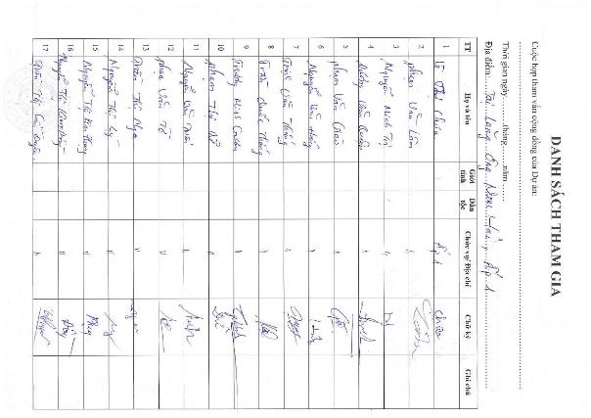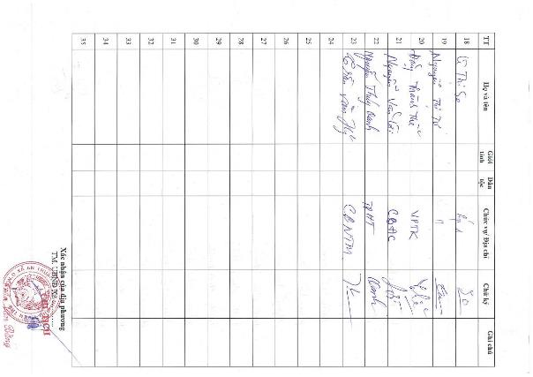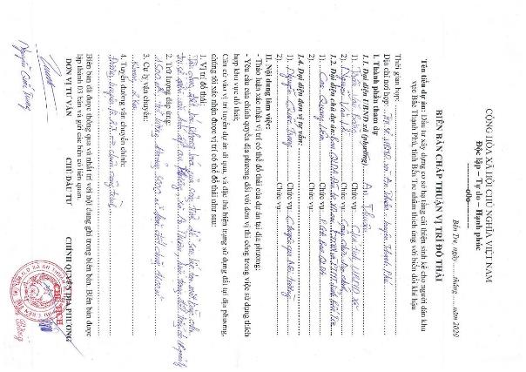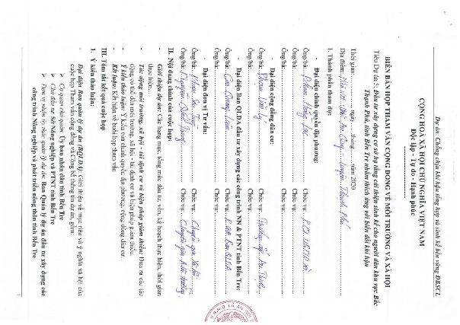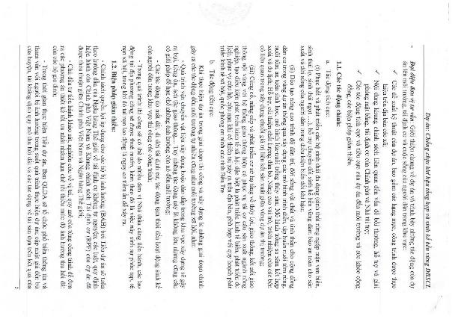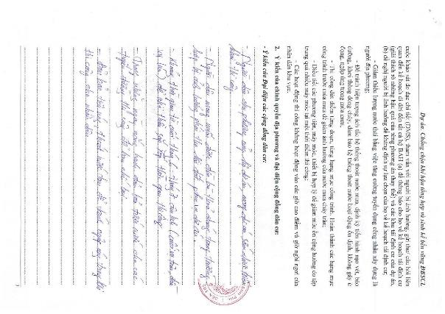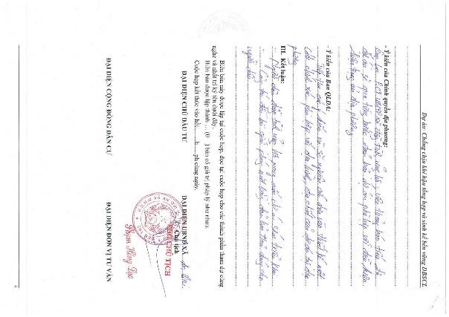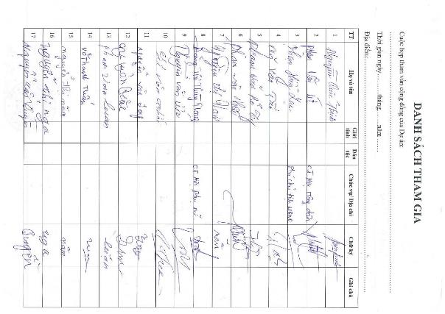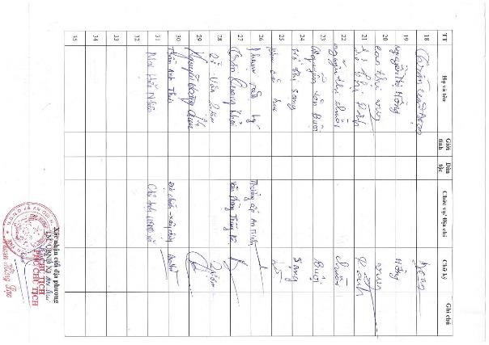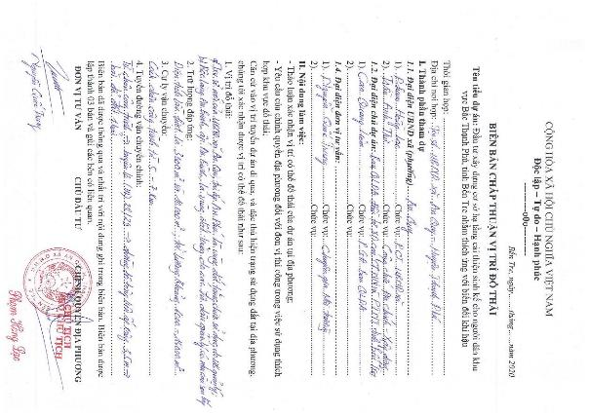

APPENDIX 4: RESULTS OF ENVIRONMENTAL MONITORING OF SUBPROJECT WORKS
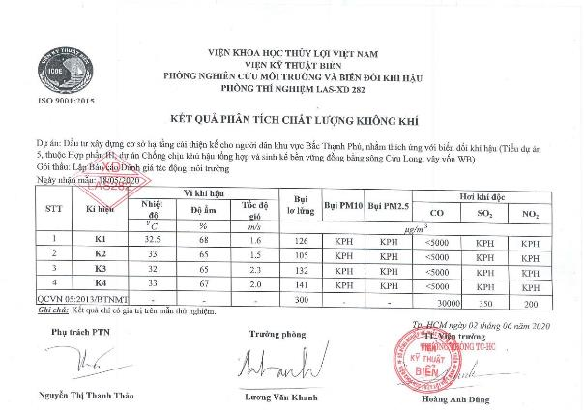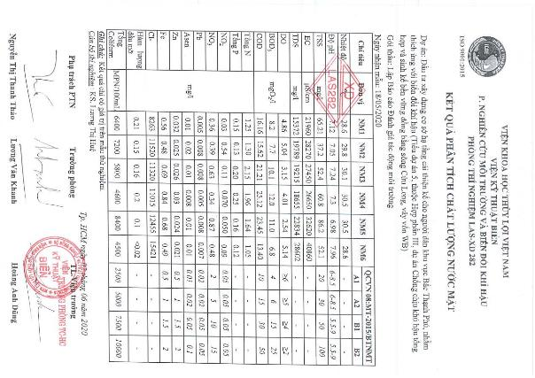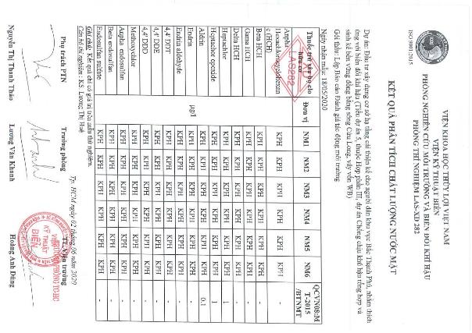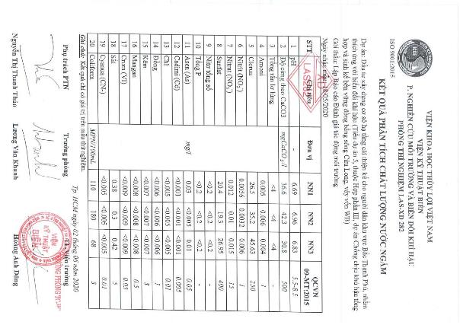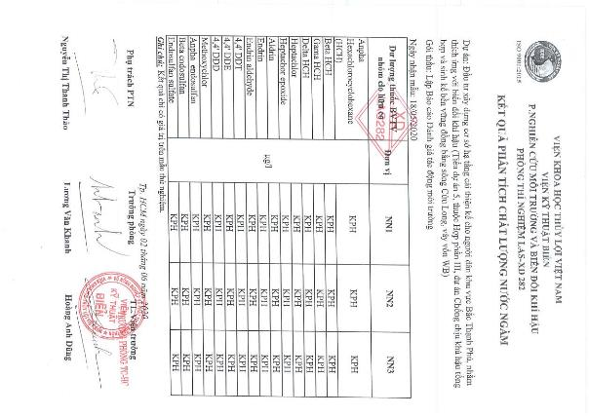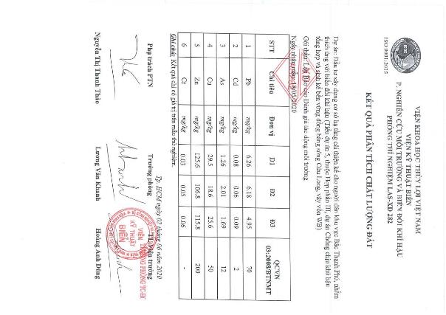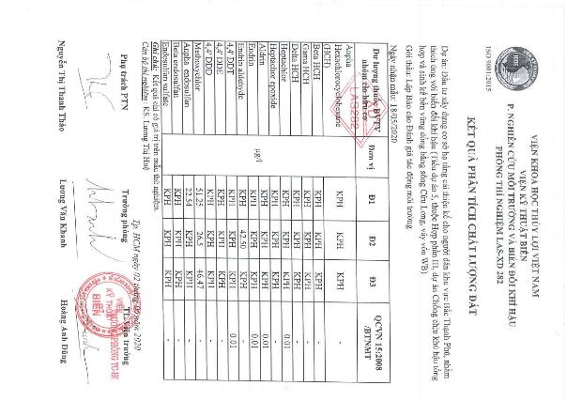

RESULTS OF SURVEY, MEASUREMENT AND ANALYSIS OF AQUATIC SAMPLES
Species structure of Phytoplankton in the survey area
No. | Species | Number of species | %
1 | Cyanophyta | 4 | 6.9
2 | Bacillariophyta | 34 | 58.6
3 | Chlorophyta | 4 | 6.9
4 | Charophyta | 1 | 1.7
5 | Euglenophyta | 15 | 25.9
Total |  | 58 | 100
Density and dominant species at sampling points in the subproject area
Symbol | Dominant species | Number of species | Total | Number of dominant species | %
TS-01 | Oscillatoria sp. | 42 | 3825 | 1300 | 34.0
TS-02 | Oscillatoria sp. | 36 | 3261 | 1800 | 55.2
TS-03 | Oscillatoria sp. | 21 | 2730 | 1800 | 65.9
TS-04 | Oscillatoria sp. | 37 | 2900 | 1230 | 42.4
TS-05 | Oscillatoria sp. | 30 | 3668 | 2200 | 60.0
Species structure of Zooplankton in the survey area
No. | Species | Number of species | %
1 | Rotifera | 7 | 38.9
2 | Cladocera | 1 | 5.6
3 | Copepoda | 6 | 33.3
4 | Larva | 4 | 22.2
Total |  | 18 | 100
Density and dominant species at sampling points in the subproject area
Symbol | Dominant species | Number of species | Total | Number of dominant species | %
TS-01 | Copepoda nauplius | 17 | 105617 | 55833 | 52.9
TS-02 | Copepoda nauplius | 10 | 125500 | 83333 | 66.4
TS-03 | Copepoda nauplius | 7 | 219500 | 212500 | 96.8
TS-04 | Copepoda nauplius | 10 | 102200 | 86667 | 84.8
TS-05 | Copepoda nauplius | 12 | 203033 | 196667 | 96.9
Species structure of Benthic in the survey area
No. | Phylum | Number of species | %
 | Mollusca
1 | Gastropoda | 6 | 40.0
 | Annelida
2 | Polychaeta | 7 | 46.7
 | Arthropoda
3 | Insecta | 2 | 13.3
Total |  | 15 | 100
Density and dominant species at sampling points in the subproject area
Symbol | Dominant species | Number of species | Total | Number of dominant species | %
TS-01 | Notomastus sp. | 3 | 100 | 50 | 50.0
TS-02 | Nephtys polybranchia | 6 | 170 | 90 | 52.9
TS-03 | Chironomus sp. | 5 | 490 | 260 | 53.1
TS-04 | Namalycastis sp. | 5 | 90 | 50 | 55.6
TS-05 | Laonice cirrata | 5 | 160 | 70 | 43.8

APPENDIX 5: SOME PHOTOS OF THE COMMUNITY CONSULTATION MEETING

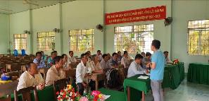  An Qui commune | 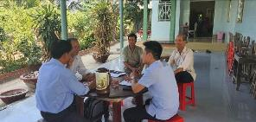  An Thanh commune
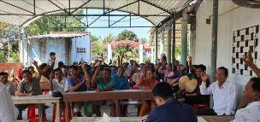  An Thuan commune | 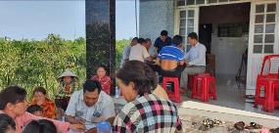  Thanh Phong commune
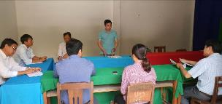 | 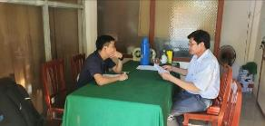
Binh Thanh commune

APPENDIX 6: LOCATIONS OF ENVIRONMENTAL BASELINE SAMPLING
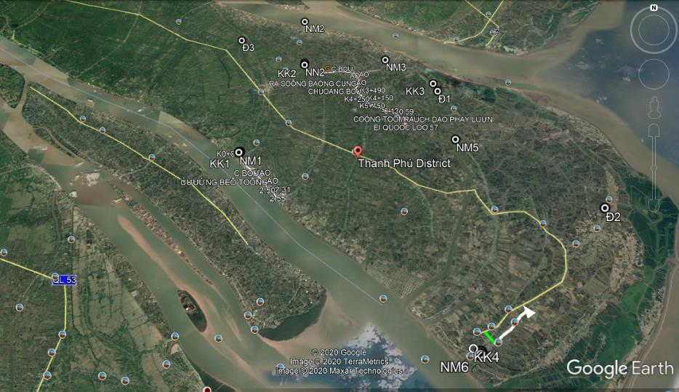

APPENDIX 7: INTEGRATED PEST MANAGEMENT PLAN (IPM)
1. Objectives
a, General objective
Strengthening the flora protection at the local level, reducing pesticide use in the field, increasing prevention efficiency, managing pesticide and pesticide use processes to reduce the risk of pesticide contamination in the environment and affect human health.
b, Specific objective
- Supporting the Plant Protection Station of Thanh Phu district, Ben Tre province to strengthen the pest management and pesticide management in line with the national action plans on food safety and hygiene, food security, climate change response and relevant international conventions ratified by the Government.
- Strengthening the environmental protection, food safety and hygiene through strengthening the role of natural enemy parasites; reduction of pesticide residue, insurance of food hygiene and safety; reduction of environmental pollution (water, soil, air).
- Improving farmers' knowledge: distinguish the major pests, secondary; identifying predators and their role in the field; clearly understanding the two-side effect of pesticides, property use of pesticides, know how to survey pest and use threshold control; understand and apply pest control measures in the IPM to increase income for farmers.
2. Fundamentals of an Integrated Pest Management Plan
The following principles will be applied to the Subproject:
- "Prohibited list": When defined in the screening criteria in Environmental and Social Management Framework (ESMF), the subproject will not finance the purchase of pesticides in large quantities and hence do not trigger OP 4.09 because the project targets in the rehabilitation of key structures to improve the dam safety but not cause the irrigation storage and downstream irrigation area increasingly. However, if there is a serious infestation of pests in the region, the project will support purchasing small quantities of pesticides. The acquisition, pesticides, storage and transportation will be subject to the provisions of the Government. The list of banned pesticides will not be used and circulated.
- The Integrated Pest Management Program and project supports: Support for the IPM implementation is part of the Environmental and Social Management Plan for the subprojects. The subproject will provide technical assistances (consulting) to implement non-chemical options and prioritize support for extension services, including increasing operation costs. WB funds for the implementation of the Integrated Pest Management Plan of the subproject through part of the Environmental and Social Management Plan. An estimated budget has been allocated to implement integrated pest management programs for downstream households. Detailed work plans will be finalized through close consultation with farmers, local agencies and organizations/NGOs.
- The subproject will apply the IPM as a method to minimize potential negative impacts of the increasing use of fertilizers and pesticides. However, the enhancement of knowledge and experience in the use of fertilizers and pesticides requires researches and on-the-job training on safe selection and use of pesticides such as non-chemical options and other techniques, which are being investigated and/or applied in Vietnam. The National Integrated Pest Management Program has also summarized implementation results and lessons learned. The subproject will apply the results of the National Integrated Pest Management Program and provide detailed technical guidance.
- The Subproject's Integrated Pest Management Program can be established to support the implementation of the Government policies focusing on reducing chemical fertilizer and pesticide use.
- In normal circumstances, if pesticide use is deemed appropriate, only the pesticides approved by the Government and recognized internationally are accepted and the project will provide technical and economic information for chemical demand. Chemicals that are not toxic and can reduce reliance on the use of pesticides should be seen as choices for chemical management. The measures will be incorporated into the project design to reduce risks related to the handling and use of pesticides to allowed possible level and managed by users.
The planning and implementation of mitigation measures and other activities will be close with the relevant authorities, authorities and stakeholders, including chemical suppliers, to facilitate the coordination and mutual understanding.
3. Approaches of integrated pest management
Focus on the risks of abuse and excessive use of chemical pesticides.
Focus on community education. Initial surveys will be incorporated into the task with the aim of clarifying the root cause of the abuse and excessive use of plant protection products and the associated risks. Support the capacity building of IPM instructors (trainers). Existing programs will need to be reviewed and new modules will be added to strengthen the parts involved in reducing the risk of pesticides. The training program will be enriched with the integration of many activities such as System Rice Intensification (SRI), minimum tillage, production community and use of bio-products replacing plant protection chemicals the training activities, the application will be made in the wide area application of the model.
To do this content, the following steps are required:
- Step 0: Recruitment of consultants: A team of consultants (Integrated Pest Management Program consultants) will be hired to assist the PPMU in implementing the integrated pest management programs including both results assurance and collaboration between agencies, farmers and stakeholders. The tasks for the consultants will be assigned at an early stage of the subproject implementation.
- Step 1: Establish farmers’ basic requirements and program registration. This step should be as soon as possible with appropriate questionnaires to establish a basis for fertilizer and pesticide use in the subproject areas. Consult with key agencies on how to conduct training, register to participate in the farmers’ programs.
- Step 2: Set up objective of the Integrated Pest Management Program and prepare workplan. Based on the results of the questions and consultations in Step 1, a workplan and a schedule will be prepared, including the budget and target audience. The workplan will be submitted to the PPMU for approval and the World Bank for review and comment.
- Step 3: Implementation and annual review. After the work-plan is approved, the activities will be implemented. The implementation progress will be included in the project progress reports. An annual assessment report will be made by the PPMU and the Plant Protection Department.
- Step 4: Impact assessment. An independent consultant will be hired to perform the impact assessment. This is to evaluate project performance and provide lessons learned. The PPMU will hire one national consultant to undertake the impact assessment of the Integrated Pest Management Program.
4. The implementations in the subproject
(i) Information collection and solution selection
Before implementing the IPM program, the consultants must take initial surveys to get necessary information as follows:
- Survey to collect data on: staple crops that have economic significance in the subproject area: seeds, crop, growth characteristics, and farming techniques.
- Survey to collect data on soil conditions, pedology, local climate.
- Investigate the situation of the pest, harmful rule arises, their economic damage causing on the major crops in the subproject area.
- Investigate the role of natural enemies parasitic of pests on the major crops in the subproject area.
- Investigate the actual situation of pest control measures, pesticide use and their effect at the local communities.
- Investigate the socio-economic conditions: income, technical knowledge, and practices.
On the basis of these findings, a proposal to evaluate IPM measures will apply on specific crops in regions and localities implement the subproject through the following measures:
  - Cultivation methods: Soil, field sanitation, crop rotation, intercropping, crop seasons, reasonable sowing and planting density, rational use of fertilizers; appropriate caring measures.
  - Using seeds: the tradition seeds and the proposed seeds in use.
  - Biological measures: taking advantage of available natural enemies in the field, using probiotics.
  - Determination of the level of harm and prevention threshold.
  - Chemical measures: safe using with natural enemies, the economic threshold; 4 correct use of medicines.
(ii) Training for Integrated Pest Management Program staff
TOT (Training of trainers) and Farmer Field School (FFS):
- Workshops and staff training for IPM will be organized for each subproject. The training includes the following topics:
  - Distinguish the major and secondary pests.
  - Identify natural enemies of pests and diseases in the field.
  - Investigate methods to detect worms and diseases.
  - Understand the two-sided effects of pesticides and how to use them properly.
  - The techniques pest control under IPM principles.
  - Advanced farming techniques.
    - The knowledge must be trained in theory and field application. The above contents can be trained in groups of topics: cultivation topics, identification topics and investigation methods to detect pests, diseases and their natural enemies, topics on management techniques pests in production...
    - Trainees: The technical staff of the Department of Agriculture, Sub-department of plant protection, agricultural extension of districts, communes, and cooperatives. These trainees will train farmers in the subproject area, the implementing of models.
    - The size of each class is from 20 to 30 trainees, held in each commune. Learning time depends in each stage. According to the thematic training session, each session may last 3-5 days on both theory and practice.
    - Lecturers: hire experts from University/Research institute/Agricultural Extension Center...
(iii) Coaching and training farmers
The Training of Farmers (TOF) follows Farmer Field School (FFS):
- Method: Combine theoretical training and practical fields of farmers and demonstration model on demonstration IMP in the pilot field.
- Contents are the same as IMP staff training.
- Participants: farmers participating in the subproject, farmers who directly implement the models, and other farmers who are interested.
- Classes are organized in each commune.
- Lecturer: Trainees of TOT classes.
(iv) Evaluate and visit the field based on of demonstration models and field applied of IPM following the models of farmers
Organize visiting conferences in the field; farmers performing the demonstration models are reporters; farmers directly implement ​​the models with the participants; visiting farmers will calculate, compare economic performance and identify lessons, limitations and the work being done and not being done.
(v) Scientific conferences, result assessment, exchange of experience and information, model expansion
Invite experts from relevant fields to participate in the analysis and evaluation; complete the process; engage mass media and agricultural extension agencies to propagate and widely transfer results and technical advances to farmers in production areas with similar conditions.
5. Expected results
It is expected that the subproject will achieve the following results:
- Food insecurity and environmental hazards are minimized through the implementation of the current regulations in the management, trading and use of pesticides, and other regulations in the national policies and enforcements.
- The capacity of Thanh Phu District Plant Protection Station and farmer trainers enhances to meet the training of the Integrated Pest Management Program; the dissemination of integrated pest management practices is maintained.
- Support farmer groups to keep experiments after learning the Integrated Pest Management Program to identify technical advances that are more effective in production and disseminated to communities.
- Support the commune level to strengthen the management of pesticides, including the implementation and enforcement of legal documents on pesticide control; develop and distribute a short list of specific pesticides proposed for use in safe vegetable and rice production.
6. Organization of implementation of IPM programs
Currently, Vietnam is implementing the National Integrated Pest Management Program, so the subprojects should plan to coordinate and integrate with the program for more effective implementation within the scope of each subproject.
- PPMU:
  - Develop and organize the implementation of the IPM program.
  - Responsible for the preparation of periodic reports on the implementation and submit to the CPO and the WB. Final plan and budget will be completed and discussed with the CPO. All documents will be achieved in the subproject profile.
    - The Sub-Department of Plant Protection of Ben Tre province:
      - Provide policy and technical guidelines for the implementation of the IPM program.
      - Join coaching and training IPM.
      - Coordinate with IPM staff to implement coaching and training farmers to perform the IPM through the approach and provision of knowledge; support farmers on the safe use of pesticides when necessary.
      - Guide the list of banned pesticides.
      - Examine the facilities that provide pesticides to ensure the provision of safe pesticides for farmers.
        - CPCs in the subproject area:
Organize farmers to maintain the routine IPM which is formed from a training course by organizing IMP-clubs or groups of farmers with the different levels of organization and structure, along with many activities (including the integration of the contents of cattle, credit, market access, etc.).
- Households in the subproject area:
  - Implement integrated pest management according to a trained program.
  - The members of the integrated pest management clubs work together and support each other to develop their collective agricultural practices. They also play a central role in the task of organizing integrated community pest management programs as well as general agricultural planning in the communes and districts.
- Environmental Safeguard Monitoring Consultant:
      - Monitor the implementation of the IPM program of the subprojects;
      - Guide local PMU in the implementation;
      - Recommend measures to improve the efficiency of the implementation of the IPM program of the subprojects.
7. Funding for IPM program
The cost estimates of the subprojects implementing the IPM program includes the following:
- Training IPM staff: Calculated for the organization of class in each commune = unit price x number of communes in each subproject.
- Training farmers: Calculated for the organization of class in each village = unit price x number of classes in each subproject.
- Assessment and field visiting based on demonstration models and fields applying IPM following models of farmers. Each commune holds a conference for shore tour in 1 day.

APPENDIX 8: TEST RESULTS OF SUPPLY WATER
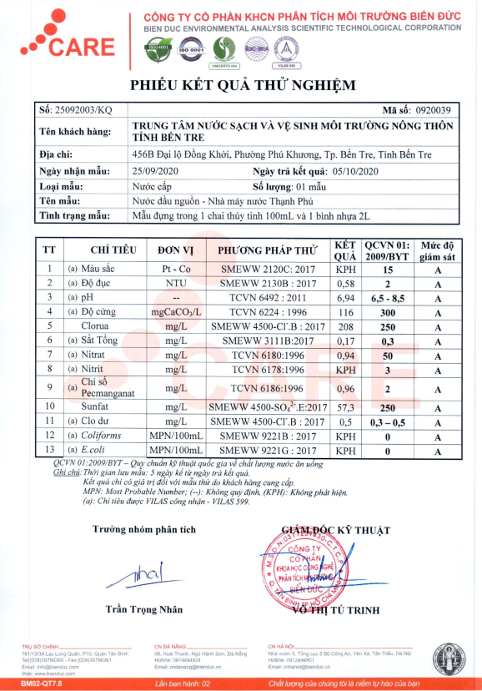
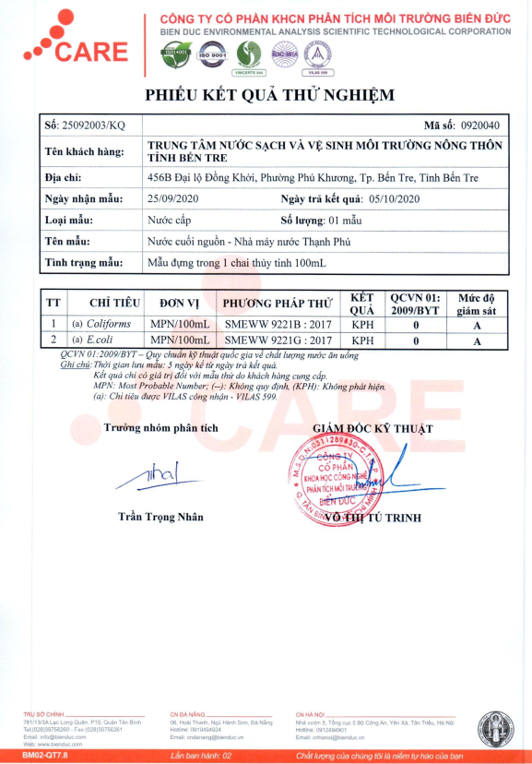

Full description of OP/BP 4.04 is available at http://web.worldbank.org/WBSITE/EXTERNAL/PROJECTS/EXTPOLICIES/EXTSAFEPOL/0,,contentMDK:20543912~menuPK:1286357~pagePK:64168445~piPK:64168309~theSitePK:584435,00.html
Full description of OP/BP 4.36 is available at http://web.worldbank.org/WBSITE/EXTERNAL/ PROJECTS/EXTPOLICIES/EXTSAFEPOL/0,,contentMDK:20543943~menuPK:1286597~pagePK:64168445~piPK:64168309~theSitePK:584435,00.html
Detail of OP/BP 4.12 is available at http://web.worldbank.org/WBSITE/EXTERNAL/PROJECTS/EXTPOLICIES/EXTSAFEPOL/0,,contentMDK:20543978~menuPK:1286647~pagePK:64168445~piPK:64168309~theSitePK:584435,00.html
The EHS Guidelines can be consulted at www.ifc.org/ifcext/enviro.nsf/Content/EnvironmentalGuidelines.

